Google certifications - Associate Cloud Engineer
Program details:
https://services.google.com/fh/files/misc/associate_cloud_engineer_exam_guide_english.pdf

Courses:
Cloud infrastructure: Foundation
Introduction
Virtual Network
Virtual Machines
Cloud Infrastructure: Core Services
IAM
DATA STORAGE
Resource manager
Resource Monitoring
Cloud Infrastructure: Scaling and Automation
Interconnecting Networks
Load Balancing and autoscaling
Infrastructure automation
Managed Services

Metadata
Cohort ID: ACE02-GETCERT/2024.11.26
From C:\google_certification\EXT_ACE02-GETCERT-2024.11.26\RESOURCES\1-ACE02-GETCERT_2024.11.26_KICKOFF Deck

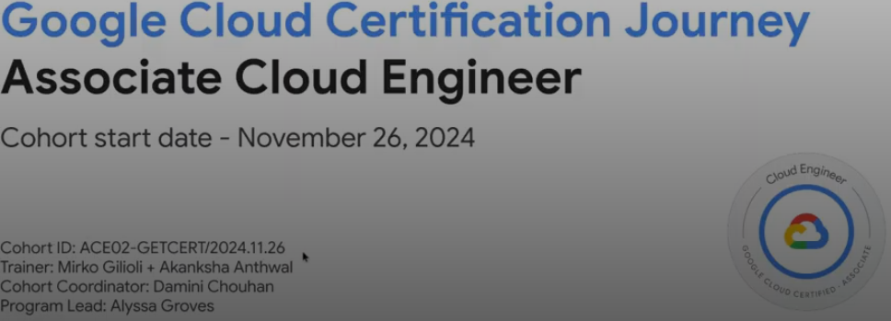

Earn 6 badgsans prepare for the exam:
Program elements Exam voucher information Get your exam voucher by filling this form. Please allow 24-72 hours to receive the voucher (from the request date)
. Please attempt the exam by 24th Feb, 2025. Technical mentorship provided by a dedicated trainer in a format of: ●
Need to complete 6 out of 6 LABS – those with stars * before Feb/6/2025
Test should be 24th Feb, 2025

Support
Qwiklabs support can be reached via: a. Email: support@qwiklab.com b. Qwiklabs Support Portal c. Chat support 2. While contacting Qwiklabs support please provide the following: a. Your login email address b. Description of an issue to be solved c. Screenshots of the issue (if needed)

For peer to peer support and a direct communication channel with your trainer. ace02-getcert_q4_2024@ googlegroups.com

Other mail
Also bhalamish20@gmail.com
A Google Cloud project is an organizing entity for your Google Cloud resources. (like resource group?)
A project associates objects and services with billing.

like azure creating credits, + starting module
Cymbal superstore =~ eshopOnWe (Azure)
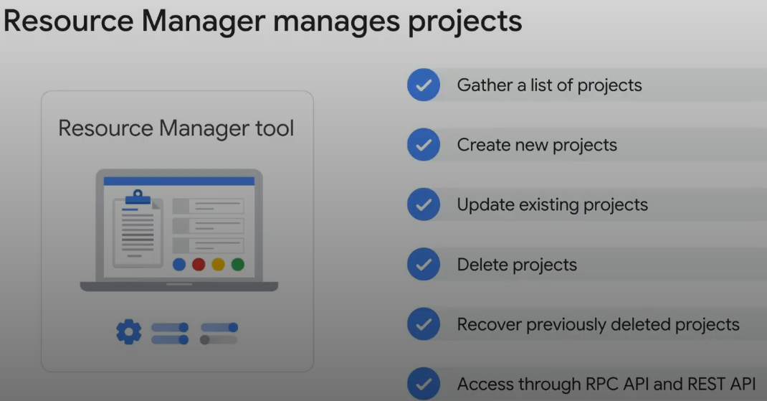
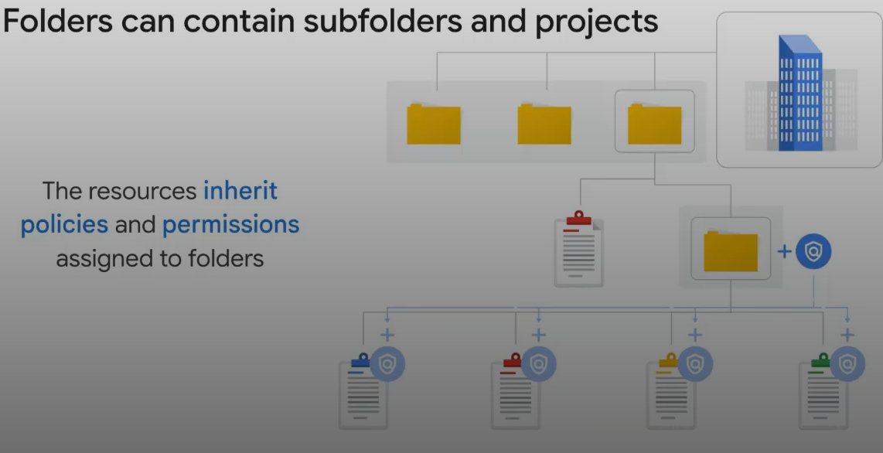
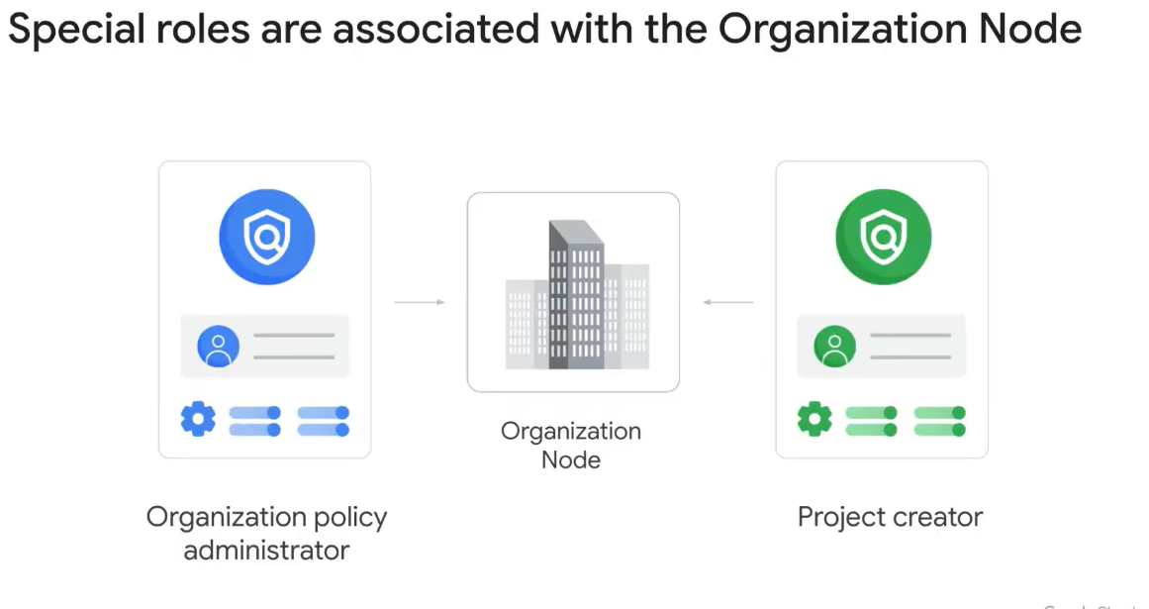
Good advice to create project create role

Apendix A
Firestore, or Cloud Firestore, is a scalable and fully managed NoSQL document
Google Cloud DNS is a scalable, reliable, and managed Domain Name System (DNS) service that runs on the same infrastructure as Google.
Google Cloud Bigtable is a fully managed, scalable NoSQL database service designed for large analytical and operational workloads. It offers low-latency data access and high throughput, making it ideal for applications such as real-time analytics, machine learning, and time-series data processing.
egress refers to outbound traffic leaving a network, system, or application and heading toward an external network or destination
RPC (Remote Procedure Call) API is a type of API that allows one system to execute a function or procedure in another system over a network as if it were a local function.
Google Cloud Run is a fully managed platform that allows you to deploy and run containerized applications. It abstracts away infrastructure management, enabling developers to focus solely on code. Cloud Run is designed to handle stateless applications and automatically scales up or down based on traffic, ensuring efficiency and cost-effectiveness.
Cloud Run, a managed compute platform that lets you run stateless containers via web requests or Pub/Sub events.
The Cloud Foundation Toolkit (CFT) is a collection of open-source Infrastructure as Code (IaC) templates and examples provided by Google Cloud. These templates enable developers and IT administrators to deploy Google Cloud resources consistently and efficiently using industry best practices. The toolkit supports popular IaC frameworks like Terraform and Deployment Manager.
Google Cloud Spanner is a fully managed, scalable, and globally distributed relational database service designed for mission-critical applications. It combines the benefits of traditional relational databases with the horizontal scalability of NoSQL databases, offering strong transactional consistency and high availability.
TensorFlow is an open-source machine learning framework developed by Google. It is designed to build, train, and deploy machine learning and deep learning models. TensorFlow supports a wide range of tasks, from numerical computation to large-scale machine learning workflows, and is widely used for research and production environments.
Apache Spark is an open-source distributed computing system designed for processing large-scale data.
Google Cloud Dataproc is a fully managed cloud service for running Apache Spark, Apache Hadoop, and other open-source big data frameworks on Google Cloud infrastructure. It simplifies the creation, management, and scaling of clusters for big data processing, enabling users to process and analyze large datasets efficiently. (The equivalent of the big data system Hadoop, but operating as a service),

Appendix-B Good to know

Security over Hardware
server boards and the networking equipment in Google data centers are custom-designed by Google
Google also designs custom chips, including a hardware security chip that's currently being deployed on both servers and peripherals.
Google server machines use a variety of technologies to ensure that they are booting the correct
software stack, such as cryptographic signatures over the BIOS, bootloader, kernel, and base operating system image.
Service deployment layer, where the key feature is encryption of inter-service communication
Google services that are being made available on the internet, register themselves with an infrastructure service called the Google Front End, which ensures that all TLS connections
Are ended using a public-private key pair and an X.509 certificate from a Certified Authority (CA), as well as following best practices such as supporting perfect forward secrecy.
The GFE additionally applies protections against Denial of Service attacks.
The final layer is Google's Operational security layer which provides four key features.
Intrusion detection ( זיהוח חדירה ) – alerts
Reducing insider risk
Google aggressively limits and actively monitors the activities of employees who have been granted administrative access to the infrastructure.
Employee U2F use.
To guard against phishing attacks against Google employees, employee accounts require use of U2F-compatible Security Key
Stringent software development practices
requires two-party review of new code.
Libraries that prevent them from introducing certain classes of security bugs.
Vulnerability Rewards Program where we pay anyone who is able to discover and inform us of bugs in our infrastructure or applications
TensorFlow, an open source software library for machine learning developed inside Google, is at the heart of a strong open source ecosystem.
IaaS Billing: when you run an instance for more than 25% of a month, Compute Engine automatically gives you a discount for every incremental minute you use for that instance
Billing budget: budget can be a fixed limit, or it can be tied to another metric; for example, a percentage of the previous month’s spend. (Alerts are generally set at 50%, 90% and 100%, but can also be customized)
Billing quotas: Google Cloud also implements quotas, which are designed to prevent the over-consumption of resources because of error or a malicious attack, protecting both account owners and the Google Cloud community as a whole.
project level quotas:
rate quotas: example: by default, the GKE service implements a quota of 3,000 calls to its API from each Google Cloud project every 100 seconds, After that 100 seconds, the limit is reset.
allocation quotas: govern the number of resources you can have in your projects. For example, by default, each Google Cloud project has a quota allowing it no more than 15 Virtual Private Cloud networks.

Firewall policies
Link: https://cloud.google.com/firewall/docs/firewall-policies-overview
Hierarchical firewall policies
Global network firewall policies
Regional network firewall policies
Policy and rule evaluation order

Security - Hierarchical firewall policies

Policies based on hierarchy – from organization to folders to projects
You need to attach it to resource
Hierarchical firewall policy rules can be used to configure Layer 7 inspection of the matched traffic, such as intrusion prevention service.

Configure intrusion prevention service

intrusion prevention service without TLS – Layer 7 inspection - 5 steps
- Create a security profile of type Threat prevention here
- Create a security profile group with the security profile here
- Create a firewall endpoint in the same zone as your workloads where you want to enable threat prevention. See Create a firewall endpoint.
- Associate the firewall endpoint with one or more VPC networks. Make sure that you're running your workloads in the same zone as the firewall endpoint. see Create firewall endpoint associations.
- add a firewall policy rule with a security profile group configured. here

intrusion prevention service with TLS – Layer 7 inspection - 6 steps
- Create a security profile of type Threat prevention here
- Create a security profile group with the security profile here
- Create a CA pool and a trust config, and add them to your TLS inspection policy. To learn how to enable TLS inspection in Cloud NGFW, see Set up TLS inspection.
- Create a firewall endpoint in the same zone as your workloads where you want to enable threat prevention. See Create a firewall endpoint.
- Associate the firewall endpoint with one or more VPC networks. Make sure that you're running your workloads in the same zone as the firewall endpoint. see Create firewall endpoint associations.
- add a firewall policy rule with a security profile group configured. here

Appendix C – Quiz – good questions

Cloud Computing

What type of cloud computing service lets you bind your application code to libraries that Cloud Computinggive access to the infrastructure your application needs?
checkPlatform as a service (correct)
Hybrid cloud
Infrastructure as a service
Software as a service
Virtualized data centers

Connecting network to google VPC

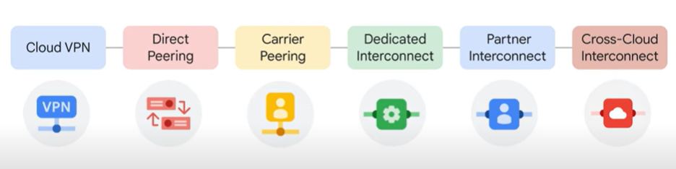
https://www.cloudskillsboost.google/course_templates/60/video/513912

core storage services options:

cloud storage - like Azure
url: https://www.cloudskillsboost.google/course_templates/60/video/513916

PROJECT < BUCKET < OBJECT )BLOB + METADAT(
Example:
gs://cloud-training/gcpfci/my-excellent-blog.png
BUCKET: cloud-training
FOLDER: gcpfci
OBJECT: my-excellent-blog.png

Create storage using gc
export LOCATION=US
student_02_6f9042fbd6bc@cloudshell:~ (qwiklabs-gcp-02-813805e53a70)$ gcloud storage buckets create -l $LOCATION gs://$DEVSHELL_PROJECT_ID
Set role read to all:
gsutil acl ch -u allUsers:R gs://$DEVSHELL_PROJECT_ID/my-excellent-blog.png

Authorization: IAM role + ACLs (Access Control List)
ACL: Scope - who can access and perform an action
Action: READ / WRITE
Iifecycle policy – similar to retention policy
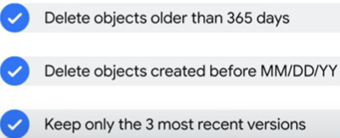

Object storage is a computer data storage architecture that manages data as “objects” and not
as a file and folder hierarchy (file storage), or as chunks of a disk (block storage).
stored in a packaged format which contains
the binary form of the actual data itself,
relevant associated meta-data (such as date created, author, resource type, and permissions), and a globally unique identifier.

Examples include
serving website content
storing data for archival and disaster recovery
distributing large data objects to end users via Direct Download.

They all packed in buckets
Immutable = do not edit them, a new version is created with every change made.
Administrators have the option to
- allow each new version to completely overwrite the older one
- keep track of each change made to a particular object by enabling “versioning” within a bucket.
Permissions:
Using IAM roles (Roles are inherited from project to bucket to object.)
access control lists (ACLs)
- a scope, which defines who can access and perform an action. This can be a specific user or group of users.
- permission, which defines what actions can be performed, like read or write.
Maintenance Cost: storing and retrieving large amounts of object data can quickly become expensive, Cloud Storage also offers lifecycle management policies.

Types
Standard Storage: considered best for
frequently accessed,
“hot,” data
data that’s stored for only brief periods of time.
Nearline Storage: considered best for
storing infrequently accessed data,
like reading or modifying data on average once a month or less.
Examples data backups, long-tail multimedia content, or data archiving.
Coldline Storage:
low-cost option for storing infrequently accessed data
meant for reading or modifying data, at most, once every 90 days
Archive Storage:
lowest-cost option,
used ideally for data archiving, online backup, and disaster recovery.
data that you plan to access less than once a year,

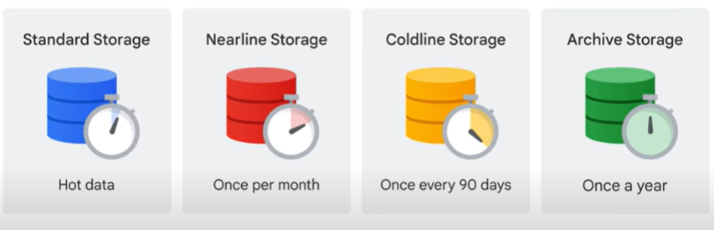

 | Standard | Neraline | Coldline | Archive
Data | Hot  frequently accessed | Once a month | Every 90 days | Once a year
Stored data | brief periods of time
Examples |  | 1. data backups  2. long-tail  multimedia content  3. data archiving |  | for data archiving, online backup, and disaster recovery
Cost |  |  | low-cost | lowest-cost

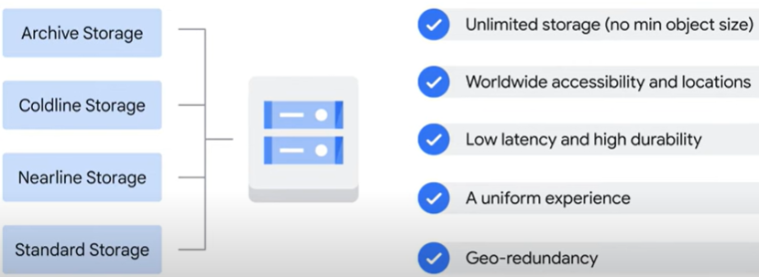

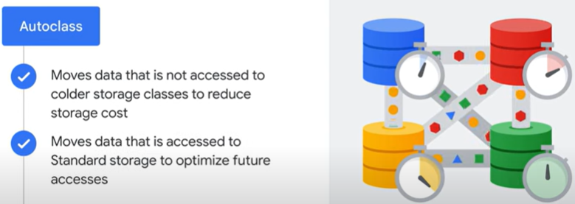

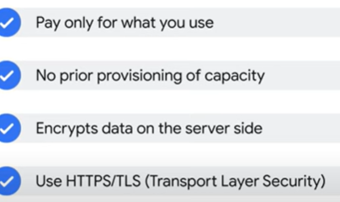
Storage Transfer:
- using gcloud command (gcp cli)
- Chrome - > drag and drop option in the Cloud Console
- Storage Transfer Service:
schedule and manage batch transfers to Cloud Storage
from another cloud provider, a different Cloud Storage region, or from an HTTP(S) endpoint.
- Transfer Appliance:
rackable, high-capacity storage server that you lease from Google Cloud
connect it to your network,
load it with data,
ship it to an upload facility where the data is uploaded to Cloud Storage.
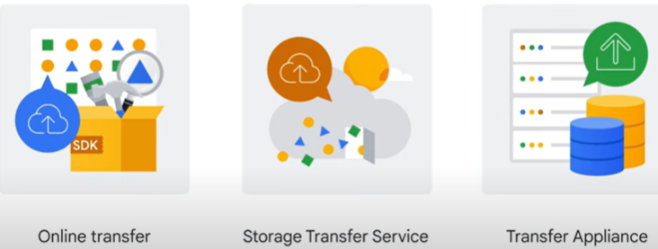

Additional storage transfer loading:
import and export tables to and from both BigQuery and Cloud SQL.

Cloud SQL - fully managed relational databases
, including MySQL, PostgreSQL, and SQL Server as a service
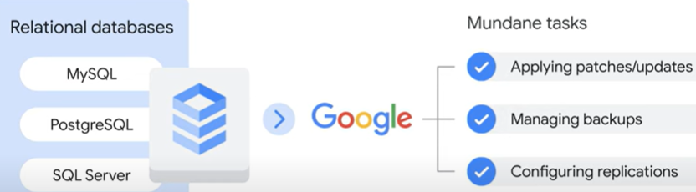
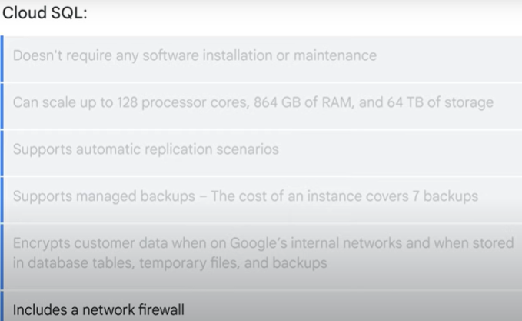

From LAB:

Spanner – fully managed relational DB
Fully managed relational database 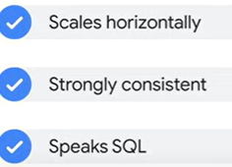
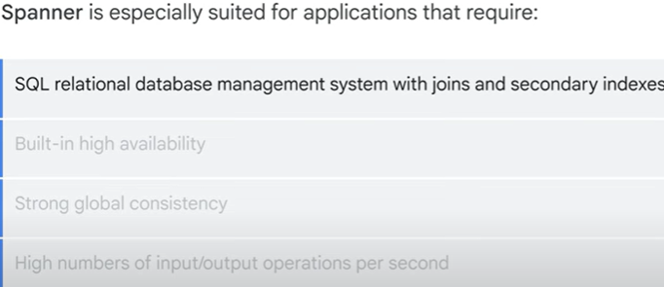

Firestore – NoSQL database - like mongodb / elastic: documents -> collection

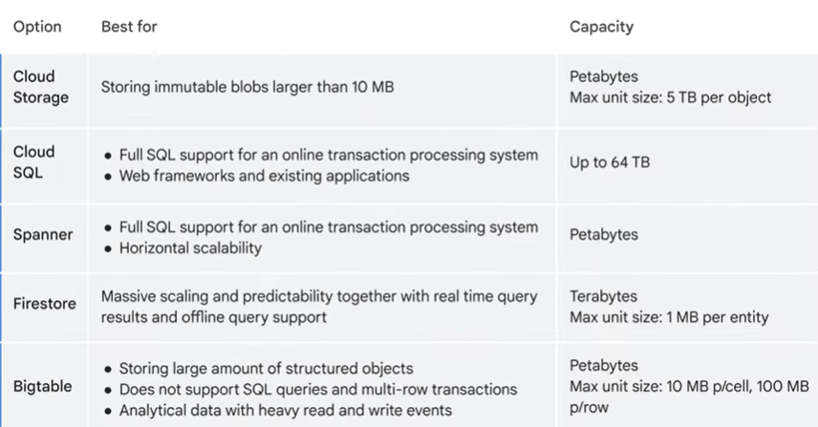

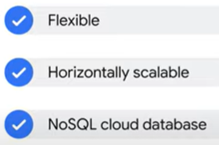
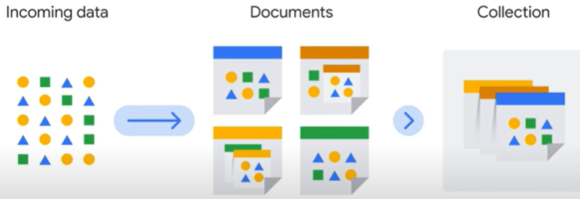

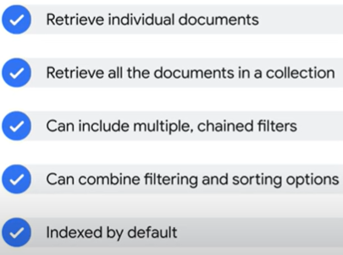
Query performance is based on results set and not data sets
It caches data – so can work in offline
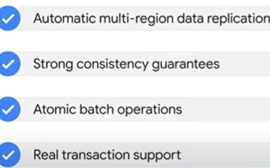

BigTable – NoSQL big data database service.

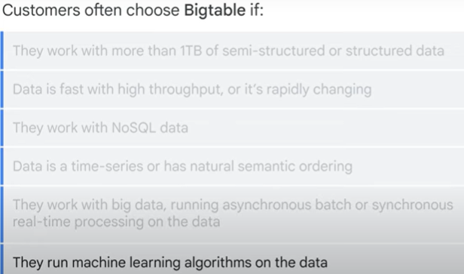

Can be
Using APIs, call REST APIs
stream data
Bacth process (like Hadoop, data flow, spark etc)

K8s – GKE
Create k1 cluster:
gcloud container clusters create k1

Developing applications in the Cloud

Cloud Run – serverless, stateless containers via web requests or Pub/Sub events

managed compute platform that runs stateless containers via web requests or Pub/Sub events.
built on Knative, an open API and runtime environment built on Kubernetes.
Take source -> build image -> deploy as pod + service
Buildpacks – like CI to build an image
Pricing module: while a container is handling web requests, with a granularity of 100ms, and when it’s starting or shutting down
use Cloud Run to run any binary, as long as it’s compiled for Linux sixty-four bit.
As long asthey server http request (include COBOL)

Development - Cloud Run functions, event-driven app
Deploy image to CloudRun
https://www.cloudskillsboost.google/course_templates/60/labs/513931

Prompt Engineering - Generative AI and LLM ( large language models)
Generative AI –
- encompasses a broader range of models capable of generating various types of content beyond just text
- capable of creating text, images, or other data using generative models, often in response to prompts (specific instruction, question, or cue given to a computer).
LLM - huge object model containing a massive dataset of text.
LLM - specifically refers to a subset of generative AI models focusing on language tasks.
- Large = The size of the training dataset, up to petabyte scale.
- Parameters = the memories and knowledge that the machine has learned during model training.
- General-purpose means that the models can sufficiently solve common problems.
LLMs are pre-trained and fine-tuned, means…
- …that they have been pre-trained for a general purpose with a large dataset…
- ...and then fine-tuned for specific goals with a much smaller dataset.
How are LLMs trained?
- When you submit a prompt to an LLM, it calculates the probability of the correct answer from its pre-trained model. – LLM often assume that the prompt is true.
- The probability is determined through a task called pre-training.
- Pre-training an LLM involves feeding a massive dataset of text, images, and code to the model so that it can learn the underlying structure and patterns of the language.
- sometimes the LLM gives a completely wrong answer.- is called a hallucination
Hallucinations הלוסיניישנס
- are words or phrases that are generated by the model that are often nonsensical or grammatically incorrect.
- they might not be aware of your business's proprietary or domain-specific data.
- OR they do not have access to real-time information.
- LLMs only understand the information that is explicitly given to them in the prompt.
- do not have the ability to ask for more context information
- LLM does not know anything outside of what it was trained on, and it cannot truly know if that information is accurate.
Reasons for hallucinations
- The model is not trained on enough data.
- The model is trained on noisy or dirty data.
- The model is not given enough context.
- The model is not given enough constraints.
Output of hallucinations
- make the output text difficult to understand.
- the model more likely to generate incorrect or misleading information.
Gemini will solve the hallucinations – Halleluiah
- access to a massive range of data,
- including Google Cloud documentation, tutorials, and samples.
prompt - is the text that you feed to the model
prompt engineering
- – a way of articulating your prompts to get the best response from the model.
- The better structured a prompt is, the better the output from the model will be.

Prompt – types
- zero-shot
- do not contain any context or examples to assist the model.
Example: What is the capital of Israel?
LLM Problem: what is capital

- one-shot
– provide one example to the model for context
Example: What is the capital of Israel?
Like Italy is the capital of Rome

- few-shot
- provide at list 2 examples to the model for context
Example: What is the capital of Israel?
Like Italy is the capital of Rome
And Tokyo is the capital of Japan

- role prompts
- a frame of reference –
what is required and in what context.
“ I am professor in the university, seeking for ….
How can I use gcloud to create VPC (context: gcloud, require: VPC)

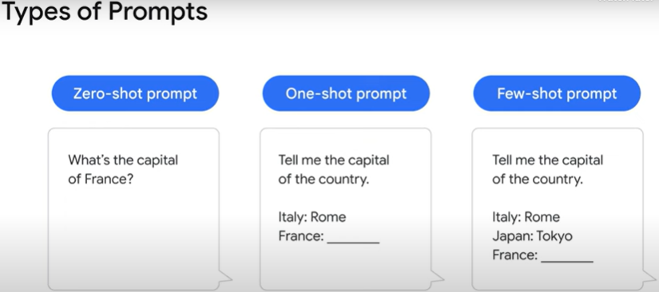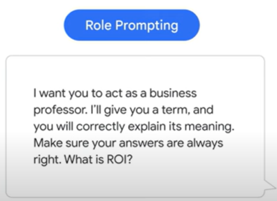

LLM parts:
Preamble: introductory text
Input: central request – (what do I want from it)

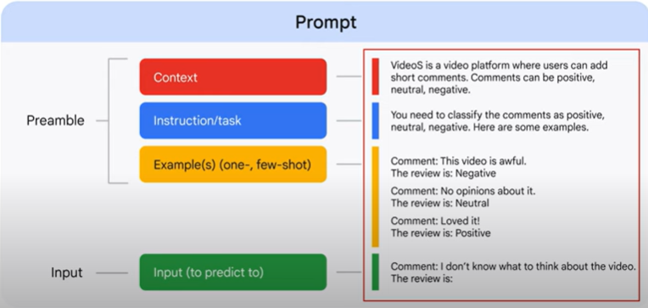

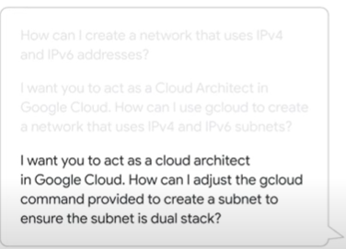
Best practices:
- write detailed and explicit instructions
- define boundaries – what to do rather than what not to do
If the model gets stuck,
give it a few 'fallback' outputs that work in various situations
something like "I'm still learning about that" to use when unsure
- adopt a persona for your input. – You’re a cloud architect
- keep each sentence concise
break long sentences into a series of shorter sentences and simpler tasks.

Example:
You're a cloud architect.
You want to build a Google Cloud VPC network that can be centrally managed.
You also connect to other VPC networks in your company's other regions.
You don't want to have many different sets of firewall policies to maintain.
What sort of network architecture would you recommend?”
Gemini proposes a hub-and-spoke network architecture – BOOM

Summarize:
https://www.cloudskillsboost.google/course_templates/60/video/513935

In module 1
you were introduced to Google Cloud and cloud computing.
Specifically, you explored:
The concept of managed infrastructure and managed services,
through IaaS and PaaS.
The Google Cloud network.
Google Cloud’s focus on security throughout our infrastructure.
How Google publishes key elements of technology using open source licenses.
Google Cloud’s pricing structure and billing tools.
In module 2
you learned about the Google Cloud Resource Hierarchy,
four levels: resources, projects, folders, and an organization node.
Defining policies and their downward inheritance.
When to use Identity and Access Management, or IAM,
four ways to access and interact with Google Cloud:
Google Cloud console
Cloud SDK and Cloud Shell,
APIs,
Google Cloud App.
In module 3
you explored how Compute Engine works,
with a focus on virtual machines and virtual networking.
The VPC, or virtual private cloud.
Compute Engine’s Autoscaling feature.
important Google Virtual Private Cloud compatibility features, like routing tables, firewalls, VPC peering and shared VPC,
all of which result in the need for less network management.
Load Balancing, a fully distributed, software-defined, managed service for all your traffic.
compared how on-premises or other-cloud networks
can be interconnected with a Google VPC.
In module 4
Google Cloud's five core storage options:
Cloud Storage, Bigtable, Cloud SQL, Spanner, and Firestore.
4 storage classes that make up Cloud Storage:
- Standard Storage, which is used for frequently accessed hot data,
- Nearline Storage
- Coldline Storage, which are used for less-frequently accessed cool data,
- Archive Storage.
In module 5
containers, which are invisible boxes around your code and its dependencies.
introduced to containers, along with: Kubernetes
Google Kubernetes Engine (GKE):
a Google-hosted managed Kubernetes service in the cloud.
In module 6
Developing applications in the cloud.
Cloud Run:
a managed compute platform
lets you run stateless containers via web requests or Pub/Sub events.
Cloud Functions:
a lightweight, event-based, asynchronous compute solution
to create single-purpose functions.
in module 7
combine Google Cloud knowledge with prompt engineering
to improve Gemini responses.
What is generative AI?
What is a large language model?
What is prompt engineering?
Identifying prompt engineering best practices.

PDF:
Module 1: Introduction to Google Cloud
Module 2: Resources and Access in the Cloud
Module 3: Virtual Machines and Networks in the Cloud
Module 4: Storage in the Cloud
Module 5: Containers in the Cloud
Module 6: Applications in the Cloud
Module 7: Prompt Engineering
Course Summary

gcloud
gcloud – get external ip:
gcloud compute instances list --filter=name:gcelab2 --format='value(EXTERNAL_IP)'
gcloud logs
https://www.cloudskillsboost.google/course_templates/648/labs/484534
LB, VM with web server:
https://www.cloudskillsboost.google/course_templates/648/labs/484535
LB and create instances based on template:
https://cloud.google.com/load-balancing/docs/network/networklb-backend-service
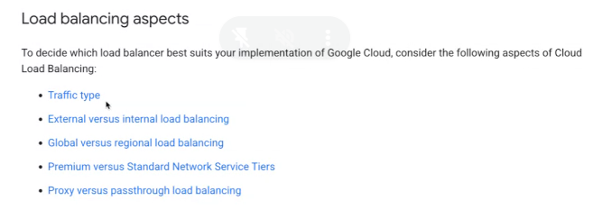

LB create
- Create a static external IP address for your load balancer:
- gcloud compute addresses create network-lb-ip-1 \
--region us-east4
Copied!
content_copy
Output:
Created [https://www.googleapis.com/compute/v1/projects/qwiklabs-gcp-03-xxxxxxxxxxx/regions/us-east4/addresses/network-lb-ip-1].
- Add a legacy HTTP health check resource:
gcloud compute http-health-checks create basic-check
Copied!
content_copy
- Add a target pool in the same region as your instances. Run the following to create the target pool and use the health check, which is required for the service to function:
- gcloud compute target-pools create www-pool \
--region us-east4 --http-health-check basic-check
Copied!
content_copy
- Add the instances to the pool:
- gcloud compute target-pools add-instances www-pool \
--instances www1,www2,www3
Copied!
content_copy
- Add a forwarding rule:
- gcloud compute forwarding-rules create www-rule \
- --region us-east4 \
- --ports 80 \
- --address network-lb-ip-1 \
--target-pool www-pool

Send traffic to your instances
- Enter the following command to view the external IP address of the www-rule forwarding rule used by the load balancer:
gcloud compute forwarding-rules describe www-rule --region us-east4
Copied!
content_copy
- Access the external IP address:
IPADDRESS=$(gcloud compute forwarding-rules describe www-rule --region us-east4 --format="json" | jq -r .IPAddress)
Copied!
content_copy
- Show the external IP address:
echo $IPADDRESS
Copied!
content_copy
- Use the curl command to access the external IP address, replacing IP_ADDRESS with an external IP address from the previous command:
while true; do curl -m1 $IPADDRESS; done

Google Cloud health checking systems (130.211.0.0/22 and 35.191.0.0/16).

Create Load Balancer and managed groups :
HL steps:
PREREQUISITS:
- instance template : configuration for the VM instances (machine type, startup script, tags, etc.).
- managed instance group (MIG) : uses the template to manage a group of instances, providing scaling, replication, and lifecycle management
- Set the Named Port - associate the name http with port 80
- Create a Firewall Rule
HTTP(S) Load Balancer:
- Create a Health Check
- Create a Backend Service
- Add the MIG to the backend service:
- Create a URL Map : The URL map routes requests to the backend service
- Create a Target HTTP Proxy: handles HTTP requests and forwards them to the backend
- Reserve a Global IP Address
- Create a Forwarding Rule: directs traffic to the load balancer - Connecting External IP to Load Balancer:

Detailed steps:
PREREQUISITS
- instance template:
gcloud compute instance-templates create lb-backend-template \
--region=us-central1\
--network=default \
--subnet=default \
--tags=allow-health-check \
--machine-type=e2-medium \
--image-family=debian-11 \
--image-project=debian-cloud \
--metadata=startup-script='#! /bin/bash
apt-get update
apt-get install -y nginx
service nginx start
sed -i "s/nginx/Google Cloud Platform - $HOSTNAME/" /var/www/html/index.nginx-debian.html'

- create managed instance group
gcloud compute instance-groups managed create lb-backend-group \
--template=lb-backend-template \
--size=2 \
--zone=us-central1-a
- Set the Named Port - associate the name http with port 80
gcloud compute instance-groups set-named-ports lb-backend-group \
--named-ports=http:80 \
--zone=us-central1-a
- Create a Firewall Rule
gcloud compute firewall-rules create allow-tcp-rule-556 \
--direction=INGRESS \
--priority=1000 \
--network=default \
--action=ALLOW \
--rules=tcp:80 \
--source-ranges=0.0.0.0/0 \
--target-tags=allow-health-check

HTTP(S) Load Balancer:
- Create Health Check:
gcloud compute health-checks create http http-health-check \
--port=80 \
--request-path=/ \
--check-interval=10s \
--timeout=5s \
--unhealthy-threshold=2 \
--healthy-threshold=2
- Create a Backend Service
gcloud compute backend-services create web-backend-service \
--protocol=HTTP \
--health-checks=http-health-check \
--global

- Add the Managed Instance Group to the backend service:
gcloud compute backend-services add-backend web-backend-service \
--instance-group=lb-backend-group \
--instance-group-zone=us-central1-a \
--global
- Create a URL Map
gcloud compute url-maps create web-map \
--default-service=web-backend-service
- Create a Target HTTP Proxy
gcloud compute target-http-proxies create http-lb-proxy \
--url-map=web-map
- Create a Forwarding Rule – connect external ip address to LB
gcloud compute addresses create web-lb-ip
gcloud compute forwarding-rules create http-content-rule \
--address=web-lb-ip \
--global \
--target-http-proxy=http-lb-proxy \
--ports=80
- Verify the Setup
gcloud compute addresses describe web-lb-ip --global --format="get(address)"
Brows or using curl to confirm the load balancer serves traffic.

DNS Load Balancing

DNS load balancing is a technique where Domain Name System (DNS) is used to distribute traffic across multiple IP addresses.
Instead of routing requests to a single IP, DNS servers return different IP addresses in response to queries, enabling traffic distribution among multiple backend services.
2. How DNS Load Balancing Works in GCP
GCP provides Cloud DNS, a managed DNS service, which supports load balancing at the DNS level. This can be done in different ways:
- Round-robin DNS:
  - Multiple A or AAAA records are configured for a domain (e.g., www.example.com → multiple IPs).
  - Clients resolve the domain and get one of the IPs in a round-robin manner.
  - This approach is simple but lacks failover (clients might cache failed IPs).
- GeoDNS / Latency-Based Routing:
  - Uses Google Cloud DNS policies to return different IPs based on the client's geographic location.
  - This directs users to the nearest or lowest-latency server.
- Weighted DNS Routing:
  - Distributes traffic proportionally based on preconfigured weightings.
  - Useful for gradual rollout of changes (e.g., 80% traffic to one backend, 20% to another).
- Failover with DNS TTL:
  - Short Time-to-Live (TTL) values allow quick updates in case of failure.
  - Requires health checks and external automation to remove failed instances.
3. When to Use DNS Load Balancing
✅ Multi-Region GCP Deployments: Direct users to the closest or least-latency region.
✅ Distributing Traffic Across Multiple Services: Use DNS to balance across multiple backend servers (e.g., multi-cloud setup).
✅ High Availability: DNS can be configured with multiple IPs to prevent single points of failure.
✅ Minimal Infrastructure Overhead: No need for GCP’s HTTP(S) Load Balancer when DNS-level balancing suffices.
4. Limitations of DNS Load Balancing
⚠️ DNS Caching: Clients and ISPs cache DNS responses, causing delays in failover.
⚠️ No Intelligent Health Checking: Unlike GCP’s Load Balancer, DNS doesn’t automatically remove unhealthy instances.
⚠️ Latency in Failover: If an instance fails, clients may continue to use its IP due to DNS caching.
Alternatives
- GCP HTTP(S) Load Balancer (Recommended for most GCP applications).
- Cloud Load Balancing (for TCP/UDP-based services).
- Traffic Director (for service mesh-based traffic control).

Global External Application Load Balancer (Global External ALB)
The Global External ALB is a fully managed Layer 7 (HTTP/S) load balancer that distributes traffic across multiple regions worldwide. It provides low-latency, high-availability, and intelligent routing for internet-facing applications.

Key Features:
✅ Global Load Balancing: Routes traffic to the nearest healthy backend across multiple regions.
✅ Layer 7 (HTTP/S) Routing: Supports advanced routing based on URL paths, headers, cookies, etc.
✅ Autoscaling & Health Checking: Automatically scales backend instances and ensures only healthy endpoints receive traffic.
✅ Built-in DDoS Protection: Integrated with Cloud Armor for security against attacks.
✅ TLS/SSL Termination: Offloads SSL encryption to the load balancer, reducing backend workload.
✅ CDN Integration: Works with Cloud CDN for caching and faster content delivery.

2. How It Works
- Users Request Your Application:
  - A user accesses your website (https://example.com).
  - The request goes to Google’s global Anycast network.
- Traffic Is Routed to the Closest Healthy Region:
  - Google’s Edge Network determines the nearest backend based on latency and availability.
  - Traffic is routed to backend instances in one of the multiple GCP regions.
- Intelligent Load Balancing Across Backends:
  - The backend services can be VM instances, GKE clusters, or serverless applications (Cloud Run, App Engine, Cloud Functions).
  - Load balancing uses round-robin, least connections, or weighted routing strategies.
- Response Sent Back via Google’s Network:
  - The response is returned to the client via Google’s private backbone, ensuring low latency.

3. Architecture Diagram
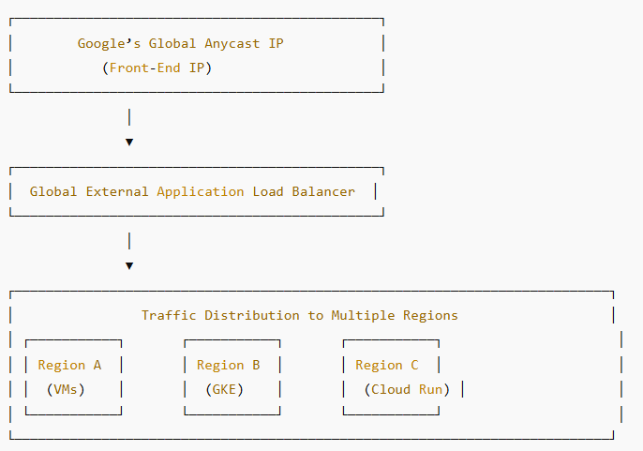

4. Use Cases
✅ Multi-Regional Web Applications
- Deploy a website globally, automatically routing users to the nearest available region.
✅ Disaster Recovery & Failover
- If one region fails, the load balancer automatically redirects traffic to another healthy region.
✅ Microservices Routing
- Direct requests to different backend services (e.g., API Gateway, Cloud Run, or GKE) based on URL paths.
✅ Secure & Scalable API Endpoints
- Expose APIs to the public while using Cloud Armor for security against DDoS attacks.
✅ CDN-Accelerated Websites
- Enable Cloud CDN to cache content globally for faster load times.

Key Benefits Over Other Load Balancers

Feature | Global External ALB | Regional External ALB | Classic HTTP LB
Global Routing | ✅ Yes | ❌ No (Only in One Region) | ✅ Yes
Multi-Region Backend Support | ✅ Yes | ❌ No | ✅ Yes
Autoscaling | ✅ Yes | ✅ Yes | ✅ Yes
Advanced Traffic Management | ✅ Yes (Traffic Steering, Failover) | ❌ Limited | ❌ Limited
Integrated Cloud Armor (DDoS Protection) | ✅ Yes | ✅ Yes | ✅ Yes
Cloud CDN Support | ✅ Yes | ✅ Yes | ✅ Yes
Backend Options | VMs, GKE, Cloud Run, App Engine | VMs, GKE, Cloud Run | VMs, GKE, App Engine

Comparison: DNS Load Balancing vs. Global External Application Load Balancer (ALB)

Feature | DNS Load Balancing | Global External ALB
Layer | Layer 3 (DNS) | Layer 7 (HTTP/S)
Traffic Routing | Returns different IPs per DNS request | Routes traffic dynamically based on policies
Health Checks | No built-in health checks (requires external automation) | Built-in health checks to ensure only healthy backends receive traffic
Failover Speed | Slower (depends on DNS TTL and client caching) | Instant failover (real-time health checks)
Routing Flexibility | Limited (GeoDNS, weighted routing) | Advanced (URL path-based, session affinity, load balancing algorithms)
Global Scaling | Global via multiple DNS records | Google’s Anycast network routes traffic to nearest healthy region
DDoS Protection | None (must use Cloud Armor separately) | Built-in DDoS protection with Cloud Armor
SSL Termination | Not possible | Offloads SSL termination to GCP (reduces backend load)
Caching & CDN | External (Cloud CDN, third-party) | Integrated with Cloud CDN for performance optimization
Cost | Lower (just Cloud DNS cost) | Higher (traffic-based pricing, but more features)

Cloud infrastructure: Foundation
Google Cloud Echo System
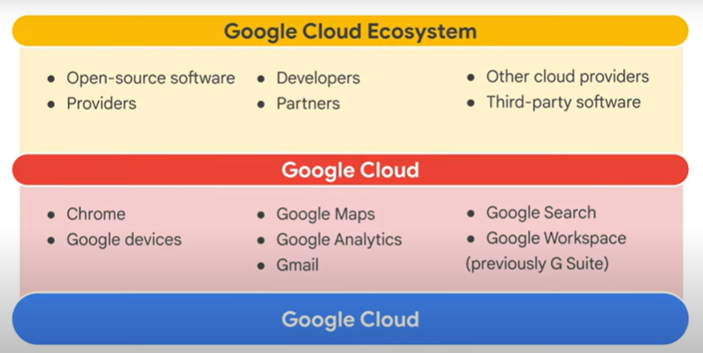

GCP itself is a computing solution platform that really encompasses three core features: infrastructure, platform, and software.

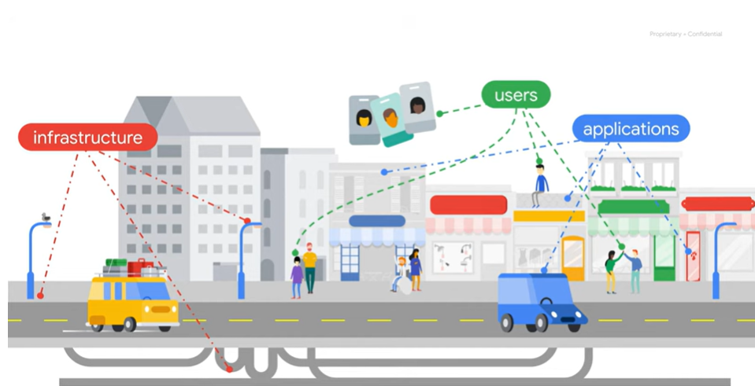

Remark:

App Engine & Cloud Functions
App Engine is GCP's fully managed platform as a service framework.
You just focus on your code and let Google deal with all the provisioning and resource management.
can be learn in “Developing Applications with Google Cloud Platform" course series.

Cloud Run
managed compute platform, serverless, that lets you run stateless containers via web requests or Pub/Sub events.
It is built on Knative, an open API and runtime environment built on Kubernetes that gives you freedom to move your workloads across different environments and platforms.
It can be fully managed on Google Cloud, on Google Kubernetes Engine, or anywhere Knative runs.

.

4 ways to interact:
REST API
Google CLI / cloudshell (tmp vm + 5 GB of persistent disk + Google Cloud CLI pre-installed.)
Mobile app
Console
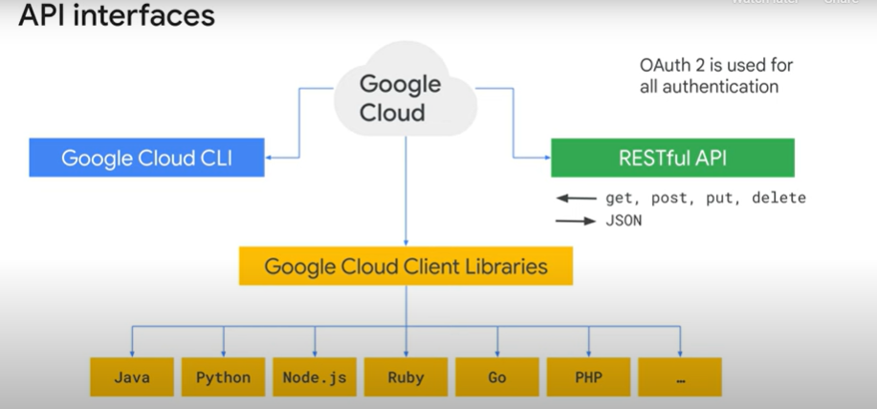
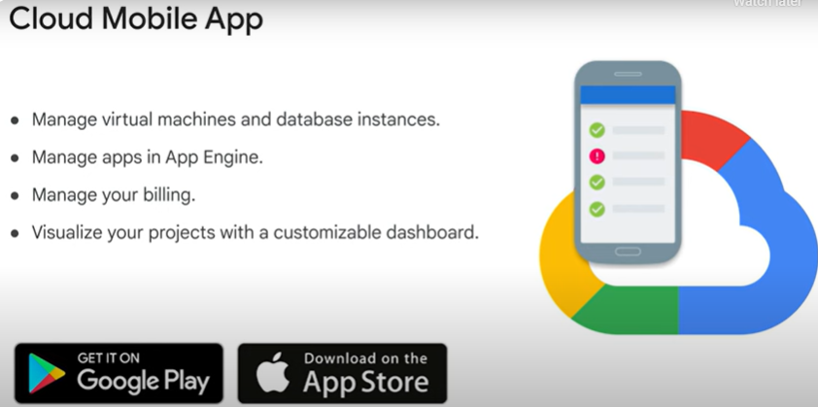

Setting cloud shell
gcloud compute regions list
INFRACLASS_REGION=[YOUR_REGION]
mkdir infraclass
echo INFRACLASS_REGION=$INFRACLASS_REGION > ~/infraclass/config
INFRACLASS_PROJECT_ID=[YOUR_PROJECT_ID]
echo INFRACLASS_PROJECT_ID=$INFRACLASS_PROJECT_ID >> ~/infraclass/config
echo ‘source infraclass/config’ >> .profile

Compare between App Engine, GKE, Cloud Run, Compute Engine

Feature | App Engine 🟢 | GKE (Kubernetes) 🔵 | Cloud Run 🟣 | Compute Engine 🟠
Management | Fully managed | Self-managed | Fully managed | Manual setup
Scaling | Auto-scaling | Auto & manual | Auto-scaling | Manual scaling
Customization | Limited | High | Limited | Full control
Stateful Apps | Not ideal | Yes | No | Yes
Traffic Splitting | ✅ Yes | ❌ No (manual) | ✅ Yes | ❌ No (manual)
Best For | Web apps, APIs | Microservices | Containers | Custom VMs, legacy apps

Google Cloud Marketplace deploy packages by providing pre-defined templates with Deployment Manager Cloud service

Marketplace – install Bitnami Jenkins
https://www.cloudskillsboost.google/course_templates/50/labs/485503

setting new project
gcloud config set project=<project id>

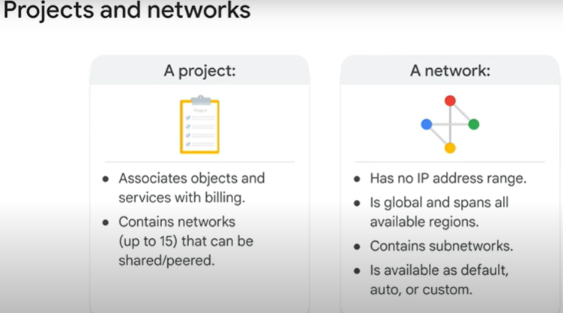

Every project is provided with a default VPC network with preset subnets and firewall rules.
Project -> Default VPC network -> firewall + subnets
Subnet -> for every region with non-overlapping CIDR blocks and firewall rules
allow ingress traffic for ICMP, RDP, and SSH traffic from anywhere
allow ingress traffic from within the default network for all protocols and ports

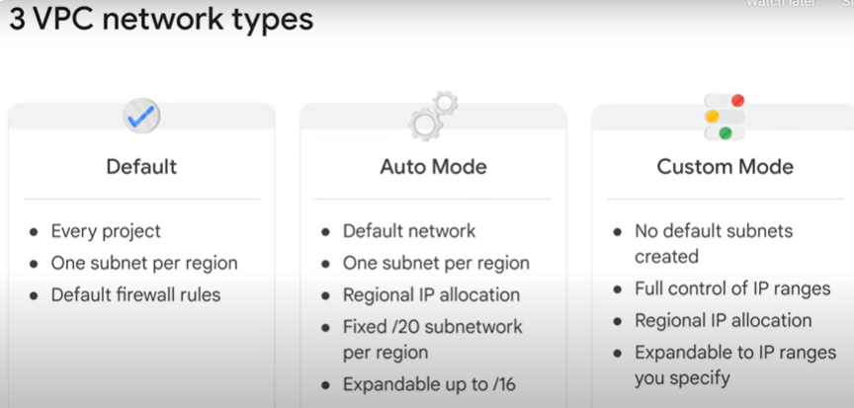
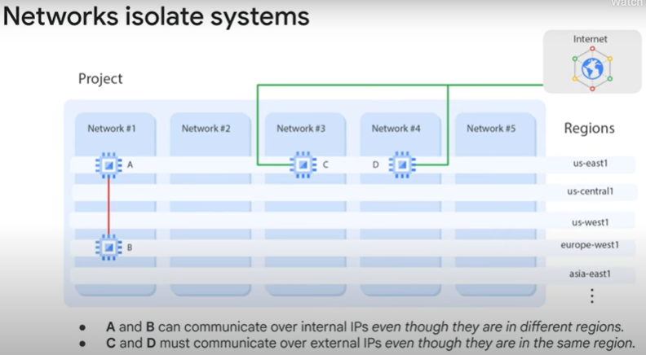
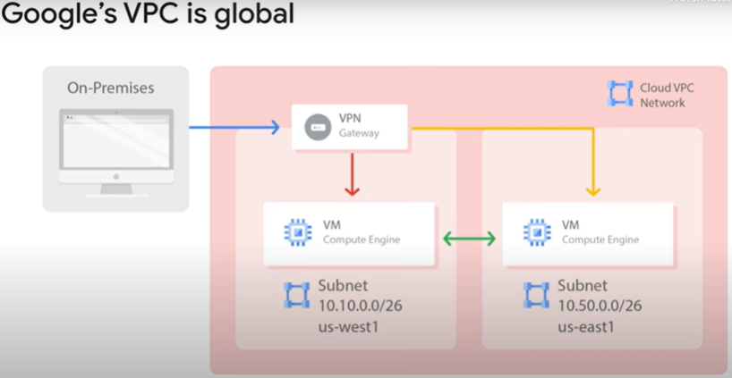
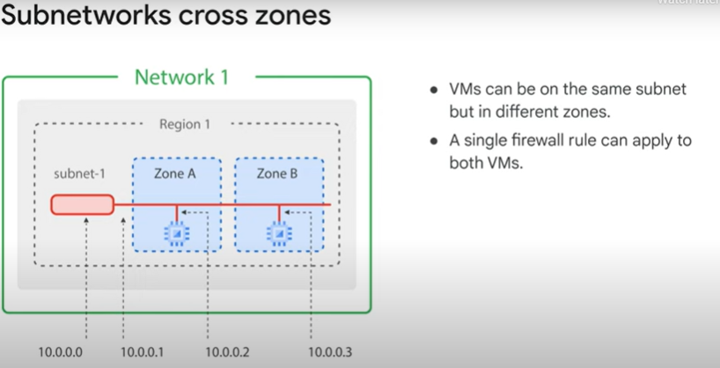

Google Cloud VPCs let you increase the IP address space of any subnets without any workload shutdown or downtime.
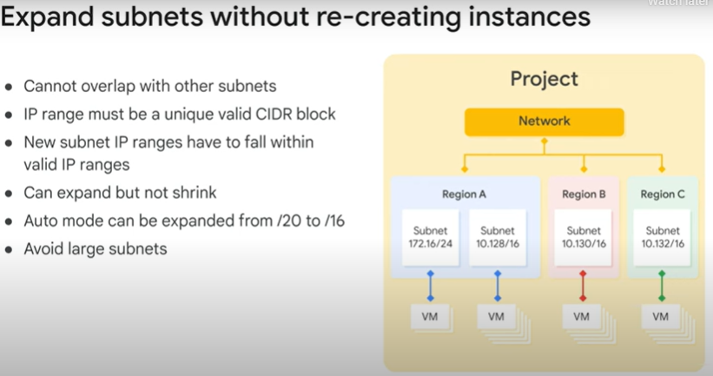

Expand subnet
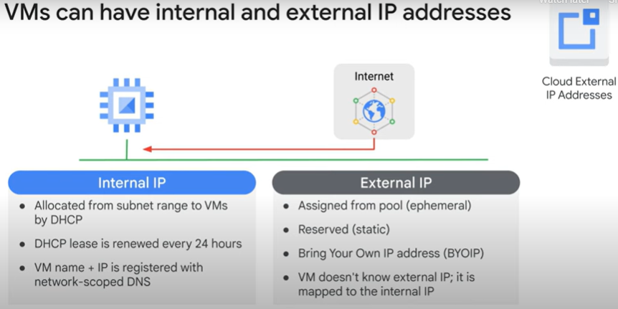

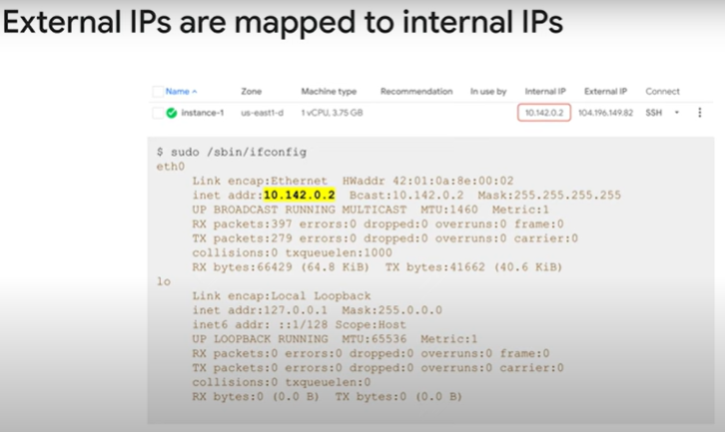
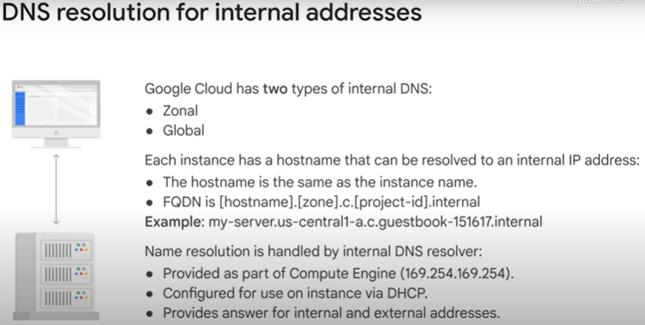
FQDN = fully qualified domain name,
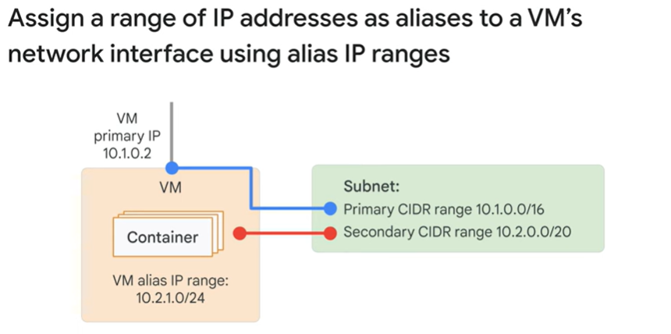
Look on IPAddressesForDefaultDomain.pdf file – for specific domains

Configure Private Google Access:
https://cloud.google.com/vpc/docs/configure-private-google-access#ip-addr-defaults

Routes and firewall Rules
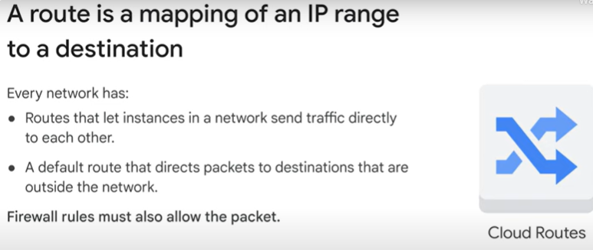
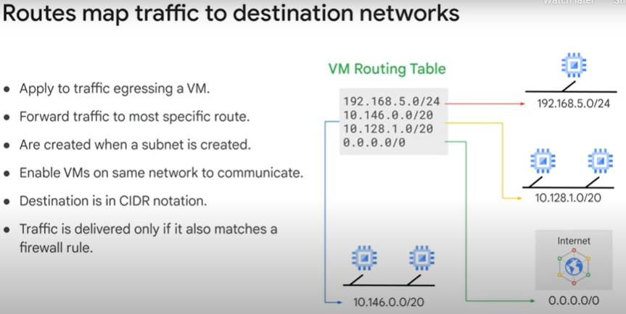

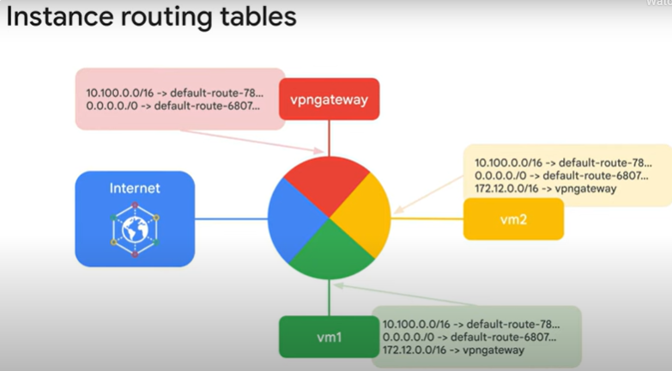

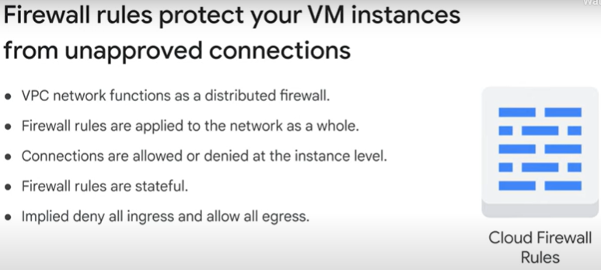
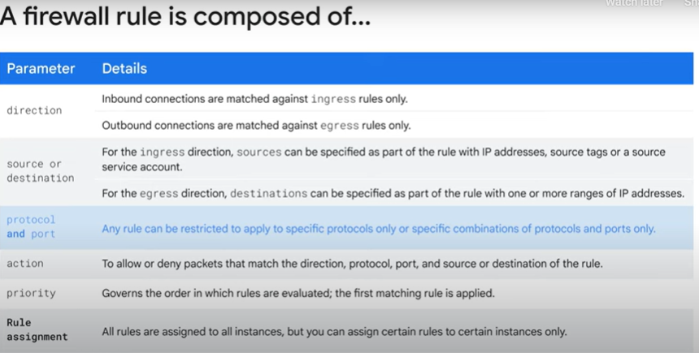

Egress firewall rules control outgoing connections
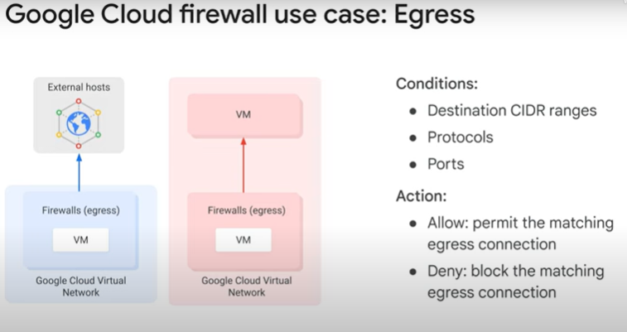
Ingress firewall rules protect against incoming connections
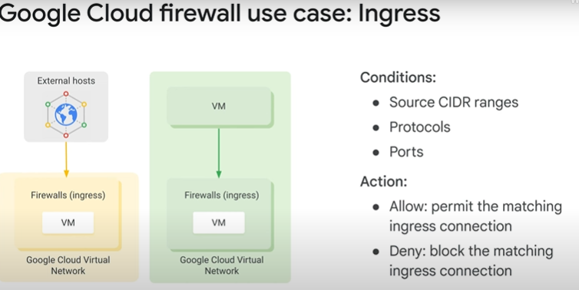

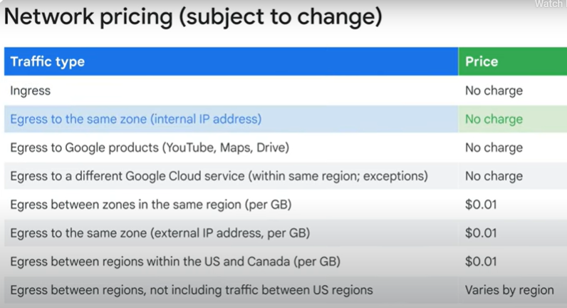

VPC networks are by default isolated private networking domains. Therefore, no internal IP address communication is allowed between networks, unless you set up mechanisms such as VPC peering or VPN.

VPC A VPC peering or VPN VPC B

LAB - Networking
https://www.cloudskillsboost.google/course_templates/50/labs/485519
https://www.cloudskillsboost.google/course_sessions/20806141/video/485520

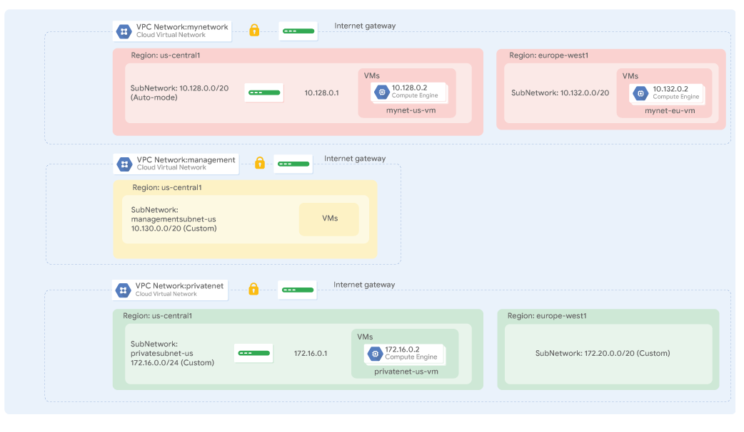
managementnet
gcloud compute networks create managementnet --project=qwiklabs-gcp-02-8f0eeb4e0cb6 --subnet-mode=custom --mtu=1460 --bgp-routing-mode=regional --bgp-best-path-selection-mode=legacy
gcloud compute networks subnets create managementsubnet-us --project=qwiklabs-gcp-02-8f0eeb4e0cb6 --range=10.240.0.0/20 --stack-type=IPV4_ONLY --network=managementnet --region=us-central1

privatenet:
student_01_58d22866e455@cloudshell:~ (qwiklabs-gcp-02-8f0eeb4e0cb6)$ gcloud compute networks create privatenet --subnet-mode=custom
Created [https://www.googleapis.com/compute/v1/projects/qwiklabs-gcp-02-8f0eeb4e0cb6/global/networks/privatenet].
NAME: privatenet
SUBNET_MODE: CUSTOM
BGP_ROUTING_MODE: REGIONAL
IPV4_RANGE:
GATEWAY_IPV4:

Instances on this network will not be reachable until firewall rules
are created. As an example, you can allow all internal traffic between
instances as well as SSH, RDP, and ICMP by running:

$ gcloud compute firewall-rules create <FIREWALL_NAME> --network privatenet --allow tcp,udp,icmp --source-ranges <IP_RANGE>
$ gcloud compute firewall-rules create <FIREWALL_NAME> --network privatenet --allow tcp:22,tcp:3389,icmp

student_01_58d22866e455@cloudshell:~ (qwiklabs-gcp-02-8f0eeb4e0cb6)$ gcloud compute networks subnets create privatesubnet-us --network=privatenet --region=us-central1 --range=172.16.0.0/24
Created [https://www.googleapis.com/compute/v1/projects/qwiklabs-gcp-02-8f0eeb4e0cb6/regions/us-central1/subnetworks/privatesubnet-us].
NAME: privatesubnet-us
REGION: us-central1
NETWORK: privatenet
RANGE: 172.16.0.0/24
STACK_TYPE: IPV4_ONLY
IPV6_ACCESS_TYPE:
INTERNAL_IPV6_PREFIX:
EXTERNAL_IPV6_PREFIX:
student_01_58d22866e455@cloudshell:~ (qwiklabs-gcp-02-8f0eeb4e0cb6)$ gcloud compute networks subnets create privatesubnet-notus --network=privatenet --region=europe-west4 --range=172.20.0.0/20
Created [https://www.googleapis.com/compute/v1/projects/qwiklabs-gcp-02-8f0eeb4e0cb6/regions/europe-west4/subnetworks/privatesubnet-notus].
NAME: privatesubnet-notus
REGION: europe-west4
NETWORK: privatenet
RANGE: 172.20.0.0/20
STACK_TYPE: IPV4_ONLY
IPV6_ACCESS_TYPE:
INTERNAL_IPV6_PREFIX:
EXTERNAL_IPV6_PREFIX:
student_01_58d22866e455@cloudshell:~ (qwiklabs-gcp-02-8f0eeb4e0cb6)$ gcloud compute networks list
NAME: managementnet
SUBNET_MODE: CUSTOM
BGP_ROUTING_MODE: REGIONAL
IPV4_RANGE:
GATEWAY_IPV4:

NAME: mynetwork
SUBNET_MODE: CUSTOM
BGP_ROUTING_MODE: REGIONAL
IPV4_RANGE:
GATEWAY_IPV4:

NAME: privatenet
SUBNET_MODE: CUSTOM
BGP_ROUTING_MODE: REGIONAL
IPV4_RANGE:
GATEWAY_IPV4:
student_01_58d22866e455@cloudshell:~ (qwiklabs-gcp-02-8f0eeb4e0cb6)$

gcloud compute networks subnets list --sort-by=NETWORK
NAME: managementsubnet-us
REGION: us-central1
NETWORK: managementnet
RANGE: 10.240.0.0/20
STACK_TYPE: IPV4_ONLY
IPV6_ACCESS_TYPE:
INTERNAL_IPV6_PREFIX:
EXTERNAL_IPV6_PREFIX:

NAME: mynetwork
REGION: us-central1
NETWORK: mynetwork
RANGE: 10.128.0.0/20
STACK_TYPE: IPV4_ONLY
IPV6_ACCESS_TYPE:
INTERNAL_IPV6_PREFIX:
EXTERNAL_IPV6_PREFIX:

NAME: mynetwork
REGION: europe-west4
NETWORK: mynetwork
RANGE: 10.164.0.0/20
STACK_TYPE: IPV4_ONLY
IPV6_ACCESS_TYPE:
INTERNAL_IPV6_PREFIX:
EXTERNAL_IPV6_PREFIX:

NAME: privatesubnet-us
REGION: us-central1
NETWORK: privatenet
RANGE: 172.16.0.0/24
STACK_TYPE: IPV4_ONLY
IPV6_ACCESS_TYPE:
INTERNAL_IPV6_PREFIX:
EXTERNAL_IPV6_PREFIX:

NAME: privatesubnet-notus
REGION: europe-west4
NETWORK: privatenet
RANGE: 172.20.0.0/20
STACK_TYPE: IPV4_ONLY
IPV6_ACCESS_TYPE:
INTERNAL_IPV6_PREFIX:
EXTERNAL_IPV6_PREFIX:

Firewalls rules:
Management:
gcloud compute --project=qwiklabs-gcp-02-8f0eeb4e0cb6 firewall-rules create managementnet-allow-icmp-ssh-rdp --direction=INGRESS --priority=1000 --network=managementnet --action=ALLOW --rules=tcp:22,tcp:3389 --source-ranges=0.0.0.0/0

privatenet:
gcloud compute firewall-rules create privatenet-allow-icmp-ssh-rdp --direction=INGRESS --priority=1000 --network=privatenet --action=ALLOW --rules=icmp,tcp:22,tcp:3389 --source-ranges=0.0.0.0/0
list all firewalls rules:

gcloud compute firewall-rules list --sort-by=NETWORK
NAME: managementnet-allow-icmp-ssh-rdp
NETWORK: managementnet
DIRECTION: INGRESS
PRIORITY: 1000
ALLOW: tcp:22,tcp:3389,icmp
DENY:
DISABLED: False

NAME: mynetwork-allow-custom
NETWORK: mynetwork
DIRECTION: INGRESS
PRIORITY: 65534
ALLOW: all
DENY:
DISABLED: False

NAME: mynetwork-allow-icmp
NETWORK: mynetwork
DIRECTION: INGRESS
PRIORITY: 65534
ALLOW: icmp
DENY:
DISABLED: False

NAME: mynetwork-allow-rdp
NETWORK: mynetwork
DIRECTION: INGRESS
PRIORITY: 65534
ALLOW: tcp:3389
DENY:
DISABLED: False

NAME: mynetwork-allow-ssh
NETWORK: mynetwork
DIRECTION: INGRESS
PRIORITY: 65534
ALLOW: tcp:22
DENY:
DISABLED: False

NAME: privatenet-allow-icmp-ssh-rdp
NETWORK: privatenet
DIRECTION: INGRESS
PRIORITY: 1000
ALLOW: icmp,tcp:22,tcp:3389
DENY:
DISABLED: False

To show all fields of the firewall, please show in JSON format: --format=json
To show all fields in table format, please see the examples in --help.

Create VMS
Create VM in managemenet
gcloud compute instances create instance-20250108-152107managementnet-us-vm --project=qwiklabs-gcp-02-8f0eeb4e0cb6 --zone=us-central1-c --machine-type=e2-micro --network-interface=network-tier=PREMIUM,stack-type=IPV4_ONLY,subnet=managementsubnet-us --metadata=enable-oslogin=true --maintenance-policy=MIGRATE --provisioning-model=STANDARD --service-account=65988263648-compute@developer.gserviceaccount.com --scopes=https://www.googleapis.com/auth/devstorage.read_only,https://www.googleapis.com/auth/logging.write,https://www.googleapis.com/auth/monitoring.write,https://www.googleapis.com/auth/service.management.readonly,https://www.googleapis.com/auth/servicecontrol,https://www.googleapis.com/auth/trace.append --create-disk=auto-delete=yes,boot=yes,device-name=instance-20250108-152107managementnet-us-vm,image=projects/debian-cloud/global/images/debian-12-bookworm-v20241210,mode=rw,size=10,type=pd-balanced --no-shielded-secure-boot --shielded-vtpm --shielded-integrity-monitoring --labels=goog-ec-src=vm_add-gcloud --reservation-affinity=any

terraform:
# This code is compatible with Terraform 4.25.0 and versions that are backwards compatible to 4.25.0.
# For information about validating this Terraform code, see https://developer.hashicorp.com/terraform/tutorials/gcp-get-started/google-cloud-platform-build#format-and-validate-the-configuration

resource "google_compute_instance" "instance-20250108-152107managementnet-us-vm" {
boot_disk {
auto_delete = true
device_name = "instance-20250108-152107managementnet-us-vm"

initialize_params {
image = "projects/debian-cloud/global/images/debian-12-bookworm-v20241210"
size = 10
type = "pd-balanced"
}

mode = "READ_WRITE"
}

can_ip_forward = false
deletion_protection = false
enable_display = false

labels = {
goog-ec-src = "vm_add-tf"
}

machine_type = "e2-micro"

metadata = {
enable-oslogin = "true"
}

name = "instance-20250108-152107managementnet-us-vm"

network_interface {
access_config {
network_tier = "PREMIUM"
}

queue_count = 0
stack_type = "IPV4_ONLY"
subnetwork = "projects/qwiklabs-gcp-02-8f0eeb4e0cb6/regions/us-central1/subnetworks/managementsubnet-us"
}

scheduling {
automatic_restart = true
on_host_maintenance = "MIGRATE"
preemptible = false
provisioning_model = "STANDARD"
}

service_account {
email = "65988263648-compute@developer.gserviceaccount.com"
scopes = ["https://www.googleapis.com/auth/devstorage.read_only", "https://www.googleapis.com/auth/logging.write", "https://www.googleapis.com/auth/monitoring.write", "https://www.googleapis.com/auth/service.management.readonly", "https://www.googleapis.com/auth/servicecontrol", "https://www.googleapis.com/auth/trace.append"]
}

shielded_instance_config {
enable_integrity_monitoring = true
enable_secure_boot = false
enable_vtpm = true
}

zone = "us-central1-c"
}

privatenet-us-vm instance
gcloud compute instances create privatenet-us-vm --zone=us-central1-c --machine-type=e2-micro --subnet=privatesubnet-us --image-family=debian-12 --image-project=debian-cloud --boot-disk-size=10GB --boot-disk-type=pd-standard --boot-disk-device-name=privatenet-us-vm

Common network designs

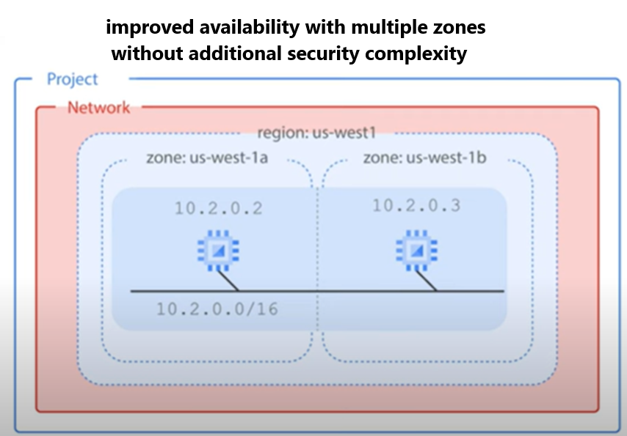
Many zones:
isolation for many types of infrastructure, hardware and software failures.
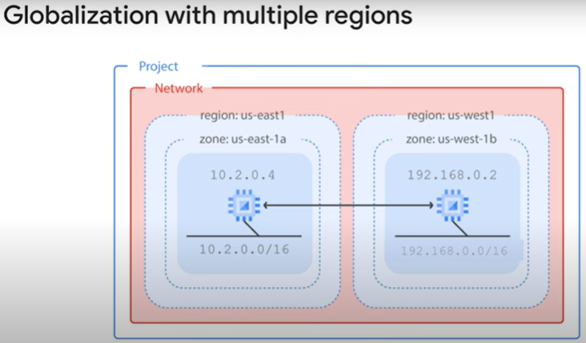
Multi region:
higher degree of failure independence.
resources spread across different failure domains.
When using a global load balancer like the HTTP load balancer, you can route traffic to the region that is closest to the user.
result in better latency for users and lower network traffic costs for your project.

Security:
security best practice, assign internal IP addresses to your VM instances whenever possible.

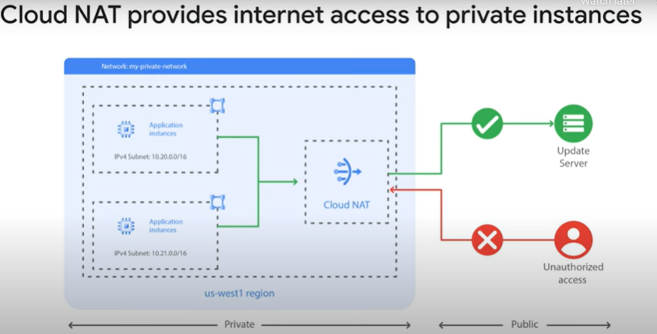
Figure 1 outbound NAT and inbound NAT - Cloud NAT does not Implement inbound NAT !!!!..
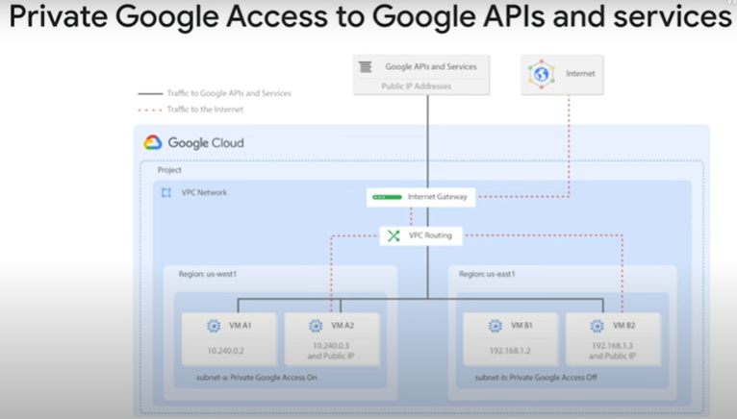

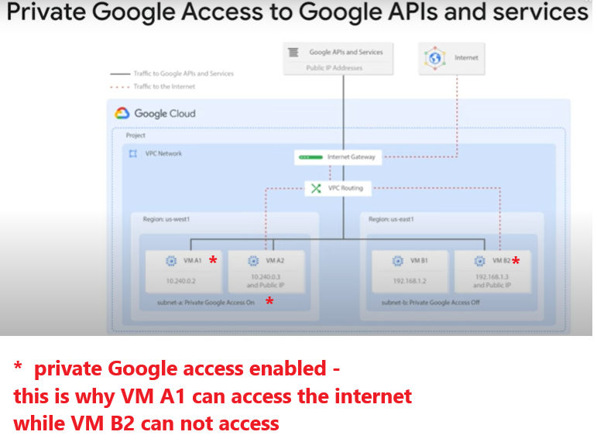
On the subnet – for internal ip addresses – where we define NAT,
If we need that the VM will be able to go out, we need to set private google access enabled on the subnet !!
Keep in mind that NAT is just outbound !!

LAB – Internal address + proxy (IAP = Identity-Aware Proxy) tunnel + NAT

https://www.cloudskillsboost.google/course_templates/50/labs/485523
https://www.cloudskillsboost.google/course_templates/50/video/485524

- Configure a VM instance that doesn't have an external IP address
- Connect to a VM instance using an Identity-Aware Proxy (IAP) tunnel
- Enable Private Google Access on a subnet
- Configure a Cloud NAT gateway
- Verify access to public IP addresses of Google APIs and services and other connections to the internet

IAP tunnel (open ssh from 35.235.240.0/20):
Note: In order to connect to your private instance using SSH, you need to open an appropriate port on the firewall. IAP connections come from a specific set of IP addresses (35.235.240.0/20). Therefore, you can limit the rule to this CIDR range.
Firewall rule on the network privatenet
gcloud compute --project=qwiklabs-gcp-01-44e78ef149da firewall-rules create privatenet-allow-ssh --direction=INGRESS --priority=1000 --network=privatenet --action=ALLOW --rules=tcp:22 --source-ranges=35.235.240.0/20

create VM with external-ip= None:
gcloud compute instances create vm-internal --project=qwiklabs-gcp-01-44e78ef149da --zone=us-west1-b --machine-type=e2-medium --network-interface=stack-type=IPV4_ONLY,subnet=privatenet-us,no-address --metadata=enable-oslogin=true --maintenance-policy=MIGRATE --provisioning-model=STANDARD --service-account=1014174709643-compute@developer.gserviceaccount.com --scopes=https://www.googleapis.com/auth/devstorage.read_only,https://www.googleapis.com/auth/logging.write,https://www.googleapis.com/auth/monitoring.write,https://www.googleapis.com/auth/service.management.readonly,https://www.googleapis.com/auth/servicecontrol,https://www.googleapis.com/auth/trace.append --create-disk=auto-delete=yes,boot=yes,device-name=vm-internal,image=projects/debian-cloud/global/images/debian-12-bookworm-v20241210,mode=rw,size=10,type=pd-balanced --no-shielded-secure-boot --shielded-vtpm --shielded-integrity-monitoring --labels=goog-ec-src=vm_add-gcloud --reservation-affinity=any

connect to this VM:
gcloud compute ssh vm-internal --zone us-west1-b --tunnel-through-iap

Note: When instances do not have external IP addresses,
they can only be reached by other instances on the network
via a managed VPN gateway or via a Cloud IAP tunnel.
Cloud IAP enables context-aware access to VMs via SSH and RDP without bastion hosts.
To learn more about this, see the blog post Cloud IAP enables context-aware access to VMs via SSH and RDP without bastion hosts.

Virtual Machines
Compute Engine service

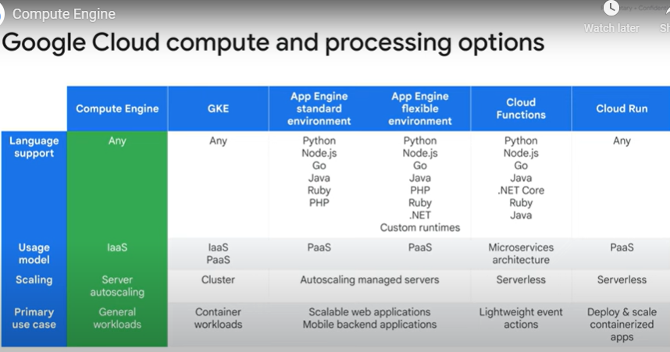

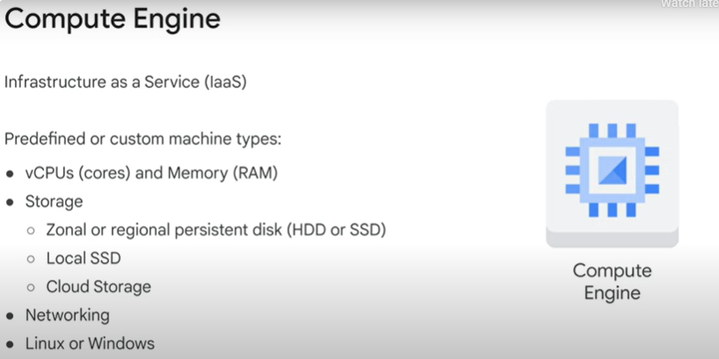
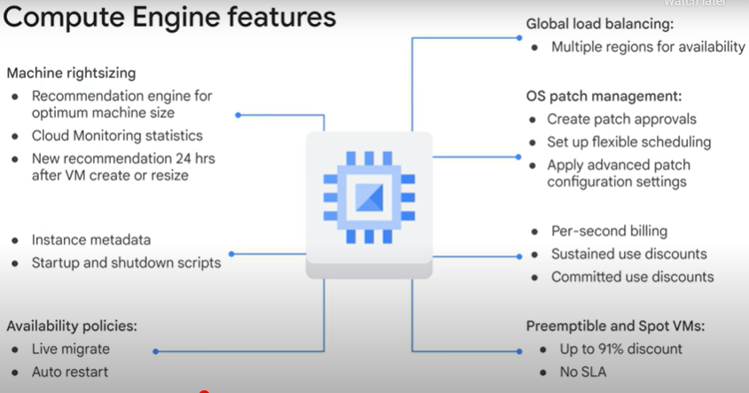

TPU
It is important to mention that hardware manufacturers have run up against limitations, and CPUs and GPUs,
can no longer scale to adequately reach the rapid demand for ML.
To help overcome this challenge, in 2016 Google introduced the Tensor Processing Unit, or TPU.
TPUs are Google’s custom-developed application-specific integrated circuits (ASICs) used to accelerate machine learning workloads.
mostly recommended for models that train for long durations and for large models with large effective batch sizes.
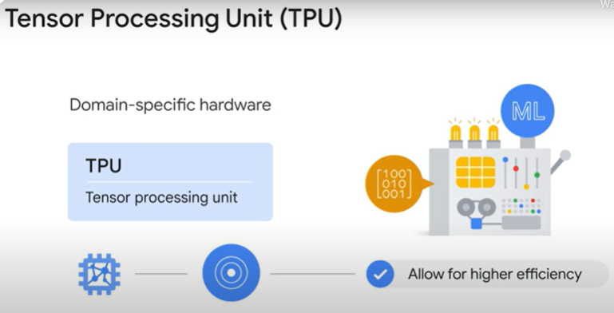

network throughput (bandwidth) is proportional to the number of virtual CPU (vCPU) cores in certain cloud environments
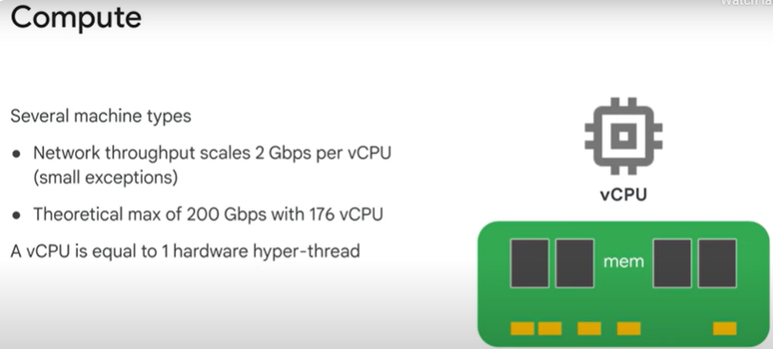
Connection between Network and vCPU:
- vCPU and Network Throughput:
  - In many cloud environments, network bandwidth is tied to the number of vCPUs in a virtual machine (VM).
  - For example:
    - A VM with 1 vCPU might have a maximum network bandwidth of 2 Gbps.
    - A VM with 4 vCPUs would scale up to 8 Gbps.
  - This scaling is typically linear but may vary depending on the VM type and cloud provider.
- Why Is Network Bandwidth Linked to vCPUs?:
  - Physical Constraints: Network performance depends on the underlying hardware. Assigning more vCPUs often means the VM is backed by more powerful physical resources, including better network interfaces.
  - Efficiency: By tying network bandwidth to vCPUs, cloud providers ensure that VMs with higher processing power also get proportionally higher network throughput, preventing resource bottlenecks.
  - Resource Balancing: This approach ensures fair allocation of network bandwidth among VMs.

Scaling vCPU vs. Network Needs:
- When You Scale vCPUs:
  - Primary Driver: You scale vCPUs based on CPU usage (e.g., when your application needs more processing power).
  - Side Effect: As you increase vCPUs, the available network bandwidth often increases proportionally.
  - Network Is Not the Main Consideration: In this case, network scaling is a secondary benefit that happens automatically.
- When You Scale for Network Throughput:
  - Primary Driver: If your application requires higher network throughput (e.g., high data transfer rates), you may need to scale the VM by increasing vCPUs to achieve the desired bandwidth.
  - CPU Usage May Not Be High: Even if your application doesn't need additional compute resources, increasing vCPUs might be necessary to get the bandwidth you need.

Why It Matters:
- Efficient Scaling: If you're only concerned about compute power, focus on CPU usage. The network will scale automatically as a side effect.
- Bandwidth-Limited Applications: For applications like media streaming, data-intensive workloads, or network-heavy tasks, you might need to scale vCPUs specifically for bandwidth, even if the CPU usage itself is low.
- Cost Implications: Tying network performance to vCPUs means that increasing bandwidth might also increase costs because you're scaling other resources (like CPU and memory) that you may not fully utilize.

Storage

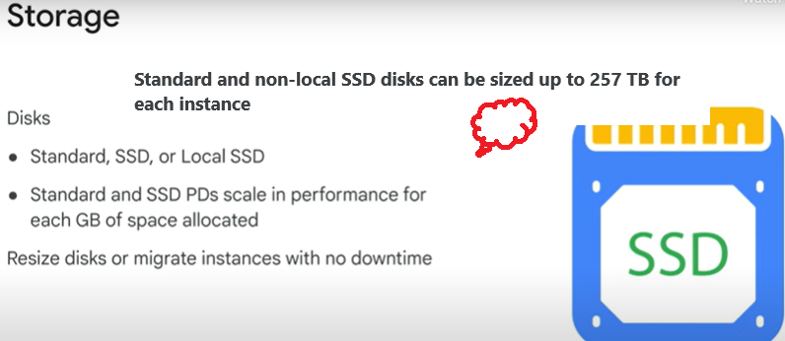

Standard and non-local SSD disks can be sized up to 257 TB for each instance.

Local SSD
the data that you store on local SSDs persists only until you stop or delete the instance.
local SSD is used as a swap disk,
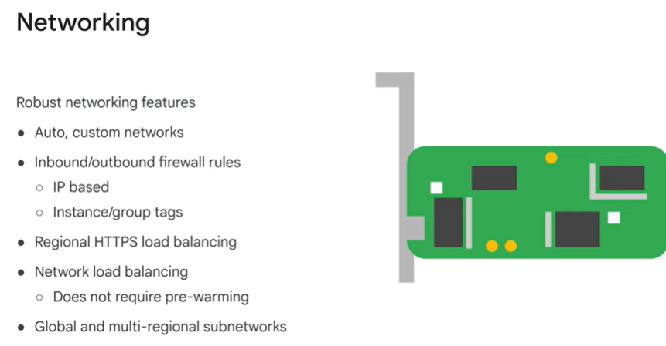

VM lifecycle

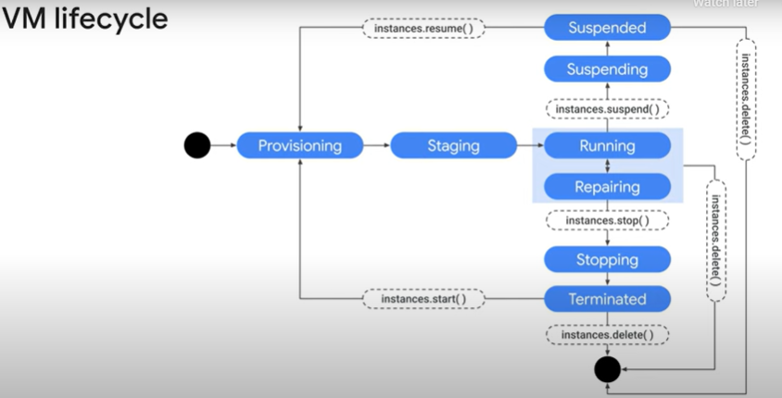

While your instance is running, you can:
live migrate your virtual machine to another host in the same zone instead of requiring your instance to be rebooted
move your VM to a different zone
take a snapshot of the VM’s persistent disk
export the system image
or reconfigure metadata.

stop your virtual machine:
to upgrade your machine by adding more CPU
Repairing occurs
when the VM encounters an internal error
or the underlying machine is unavailable due to maintenance.
Not billed

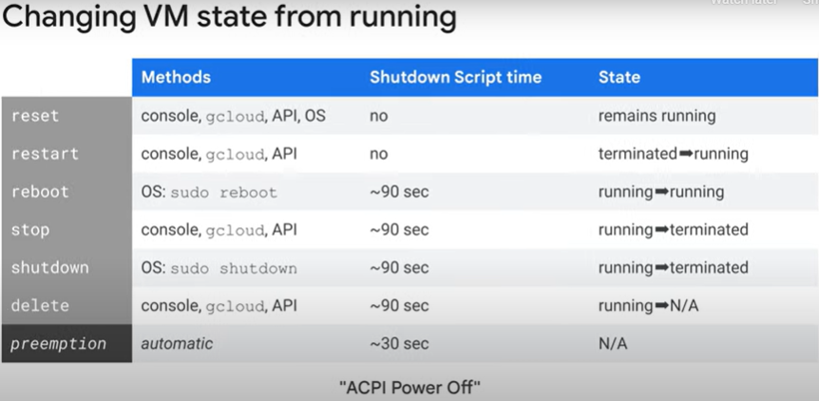
Patch management service
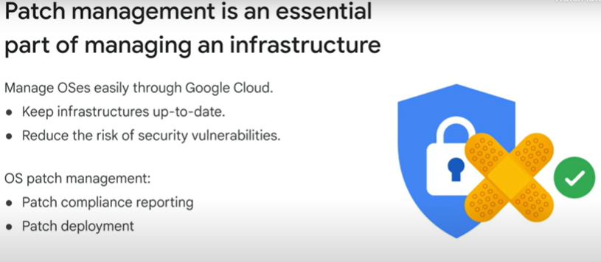

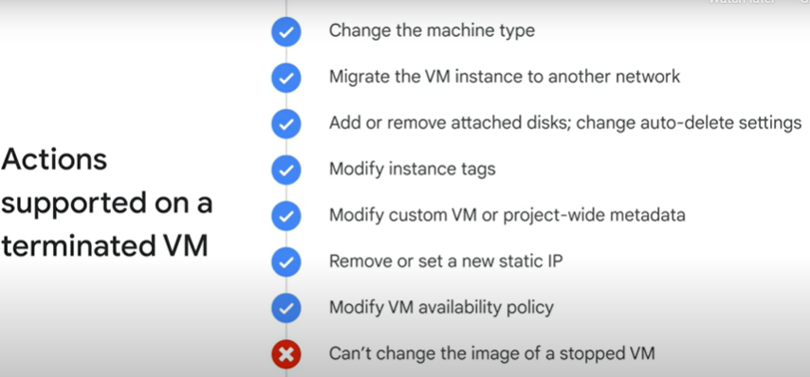

Create VM

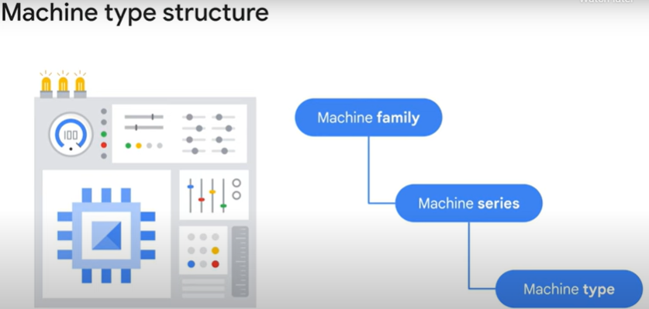

Standard E2 VMs have between 2 to 32 vCPUs with a ratio of 0.5 GB to 8 GB of memory per vCPU.

Family: general-purpose -> series: E2 machine series -> type: e2-micro / etc

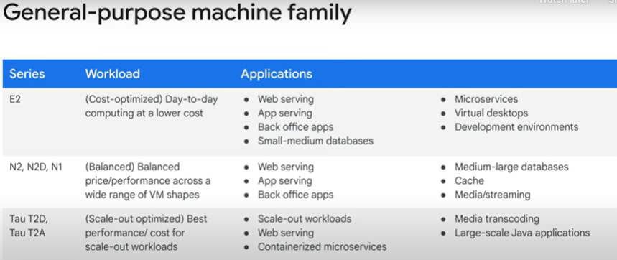

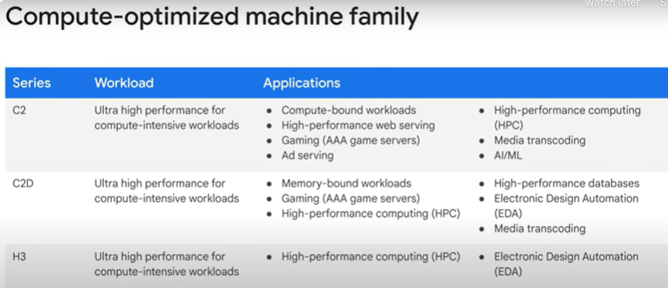

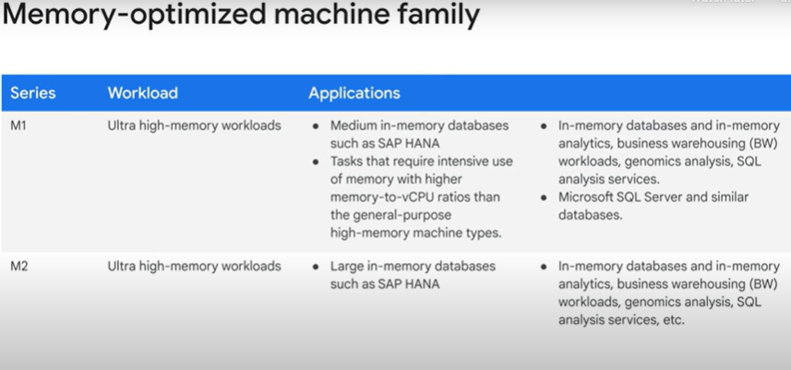

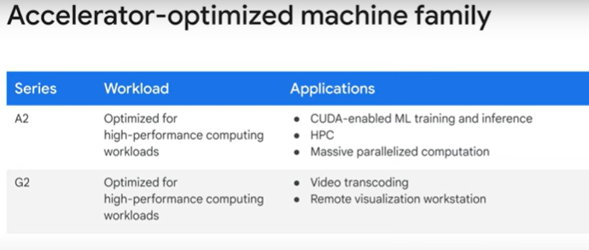
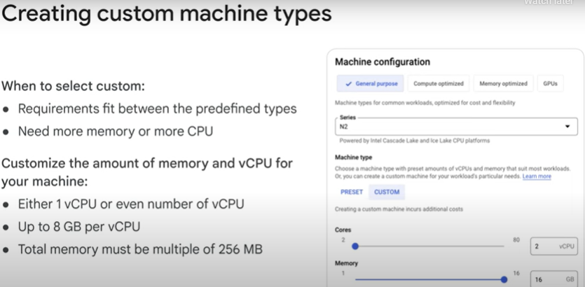
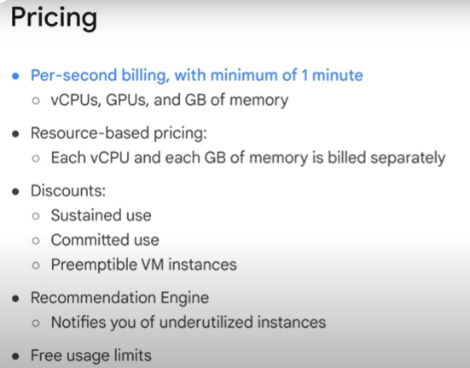

Preemptible and Spot VMs
provide cost-effective compute options

Key Differences between preemptible VMs and Spot VMs

Feature | Preemptible VMs | Spot VMs
Maximum Lifetime | 24 hours | No time limit
Pricing | Fixed | Variable (dynamic, based on resource demand)
Replacement | Cannot automatically restart after preemption | Can be automatically restarted if capacity becomes available
Use Cases | Legacy option for cost-saving VMs | Preferred option due to flexibility

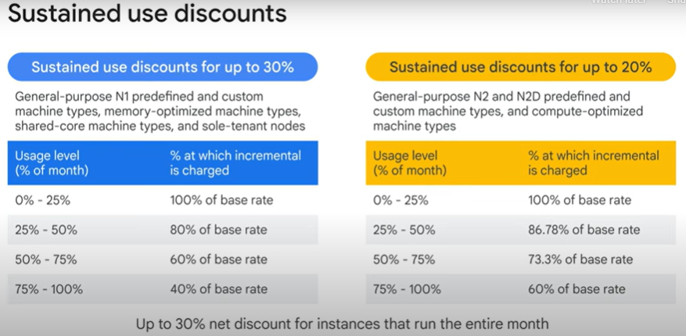

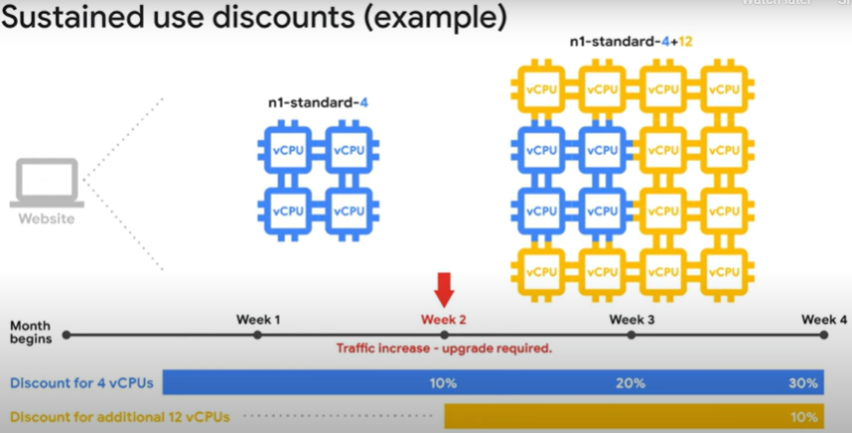

Sole-tenant nodes
Use case: payment processing workload that needs to be isolated to meet compliance requirements.

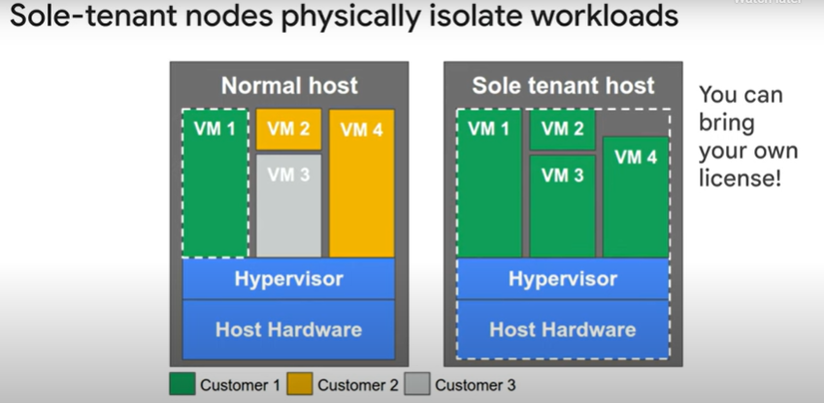

shielded VM - more secure foundation

- Verifiable Integrity:
  - Shielded VMs use integrity monitoring to detect and prevent tampering with the bootloader, kernel, and critical boot components.
  - GCP provides tools like integrity validation logs, allowing users to verify the VM’s state and confirm that it has booted in a trusted environment.
- vTPM Shielding:
  - Shielded VMs include a virtual Trusted Platform Module (vTPM).
  - vTPM generates and securely stores cryptographic keys, which can only be used if the VM passes its integrity checks.
  - This shielding ensures that data or keys cannot be accessed or misused if the VM is compromised.
- Secure Boot:
  - Secure Boot ensures the VM only runs signed and trusted OS bootloaders, kernels, and drivers. This prevents attackers from injecting malicious code during the boot process.
- Integrity Monitoring:
  - Monitors the VM for integrity violations using measured boot values.
  - Alerts can be configured to notify administrators if any anomalies are detected.
- Kernel Integrity Protection:
  - Shielded VMs protect against unauthorized kernel modifications. Only signed kernels are allowed to load, making it difficult for attackers to inject rootkits or exploit kernel vulnerabilities.

How Shielded VMs Prevent Data Exfiltration
- Data Sealing:
  - Shielded VMs use vTPM to seal sensitive data, such as encryption keys or secrets, to the current VM state.
  - If an attacker tries to clone or migrate the VM to another environment, the sealed data becomes unusable.
- Integrity Enforcement:
  - By enforcing boot integrity, Shielded VMs ensure the system is not tampered with at startup, preventing attackers from introducing malicious tools to exfiltrate data.
- Isolation:
  - Shielded VMs operate in a secure environment, minimizing exposure to external attack vectors.

Use Cases
- Regulated Industries: Financial, healthcare, and government sectors benefit from the enhanced security and compliance offered by Shielded VMs.
- High-Security Applications: Workloads requiring cryptographic operations, sensitive data storage, or proprietary intellectual property protection.
- Compliance Requirements: For meeting standards like PCI DSS, HIPAA, and FedRAMP.

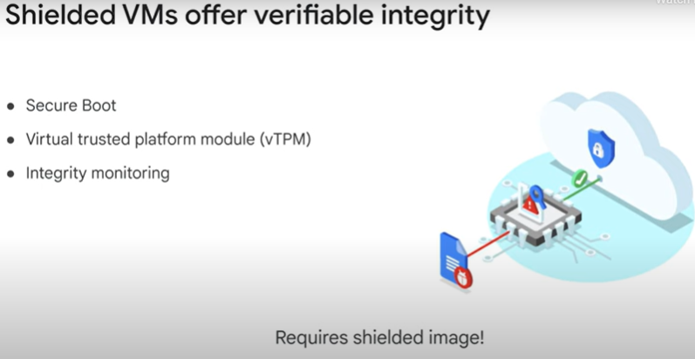

Confidential VMs
They leverage confidential computing technology to isolate data in use by using secure enclaves, ensuring that the data remains encrypted not just at rest or in transit but also during processing.
- Memory Encryption:
  - Confidential VMs use hardware-based memory encryption provided by AMD EPYC processors.
  - Data in memory is encrypted using secure keys that are generated and managed by the processor, ensuring no external access.
- Confidentiality During Processing:
  - Protects sensitive data while it is being processed in memory, preventing unauthorized access, even from privileged users, GCP administrators, or attackers with root access.
- No Code Changes:
  - Applications do not need to be rewritten or modified to take advantage of the protections offered by Confidential VMs. They work seamlessly with existing workloads.
- vTPM Integration:
  - Confidential VMs include a virtual Trusted Platform Module (vTPM) to provide cryptographic assurance of the VM's integrity.
  - vTPM ensures secure boot and protects secrets.
- Isolation from GCP and Other Tenants:
  - Confidential VMs ensure that data is not accessible to Google itself or other tenants in the cloud environment.
- Compliance and Security:
  - Confidential VMs help organizations meet stringent compliance requirements, such as GDPR, HIPAA, and other data privacy regulations.

How Confidential VMs Work
- Confidential Computing: Confidential VMs are built on confidential computing technology that encrypts data in use.
- Secure Enclaves: Secure enclaves are isolated regions of memory that are encrypted and inaccessible to the host operating system or hypervisor.
- AMD SEV (Secure Encrypted Virtualization): The technology leverages AMD Secure Encrypted Virtualization (SEV), which provides hardware-based encryption for VM memory.

Benefits of Confidential VMs
- Enhanced Data Security:
  - Protects sensitive data from unauthorized access, even during processing.
- Ease of Adoption:
  - No changes to existing applications or workflows are required.
- Zero Trust Model:
  - Helps implement a zero trust security model, where no user or process is inherently trusted.
- Regulatory Compliance:
  - Simplifies achieving compliance for workloads handling regulated data.
- Integration with Other GCP Services:
  - Works seamlessly with other GCP products like BigQuery, Google Kubernetes Engine (GKE), and Google Cloud Storage.

Use Cases
- Financial Services:
  - Protecting sensitive customer data while processing financial models or conducting transactions.
- Healthcare:
  - Safeguarding patient information during medical research or diagnostics.
- Machine Learning:
  - Ensuring the confidentiality of training data and machine learning models.
- Intellectual Property Protection:
  - Securing proprietary algorithms and data during computation.

How to Enable Confidential VMs
- Create a VM instance through the GCP Console, CLI, or API.
- When creating the VM:
  - Ensure the Enable Confidential VM Service option is selected.
  - Use machine types and images compatible with Confidential VMs.
- Deploy your workloads without the need for code changes.

You can select the Confidential VM service when creating a new VM using the Google Cloud Console, the Compute Engine API, or the gcloud command-line tool.

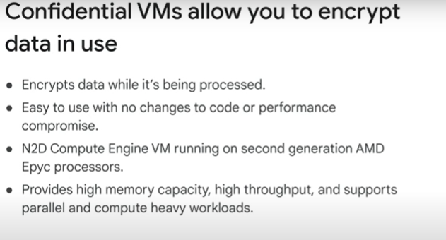

Images

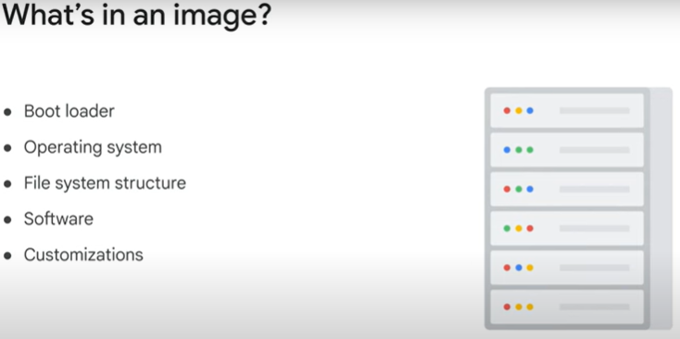

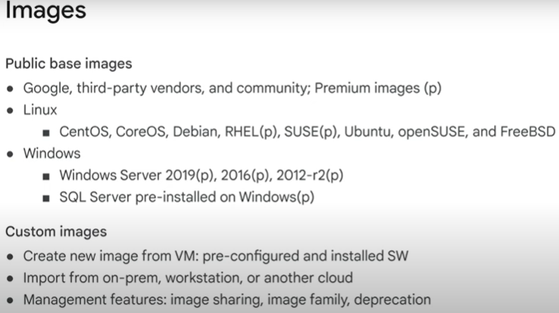

Some of these images are premium images, as indicated in parentheses with a p.
These images will have per-second charges after a 1-minute minimum, with the exception of SQL Server images, which are charged per minute after a 10-minute minimum.

A machine image is a Compute Engine resource that stores all the configuration, metadata, permissions, and data from one or more disks required to create a virtual machine (VM) instance.
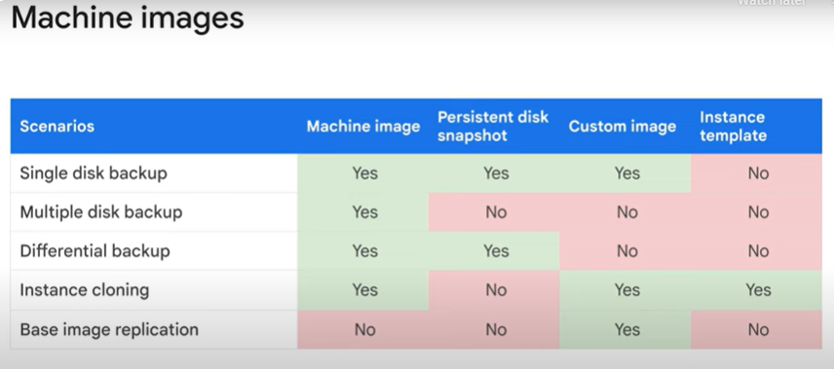

Disk options
Every single VM comes with a single root persistent disk, because you're choosing a base image to have that loaded on.
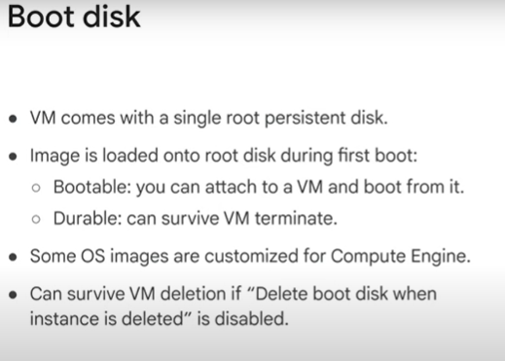

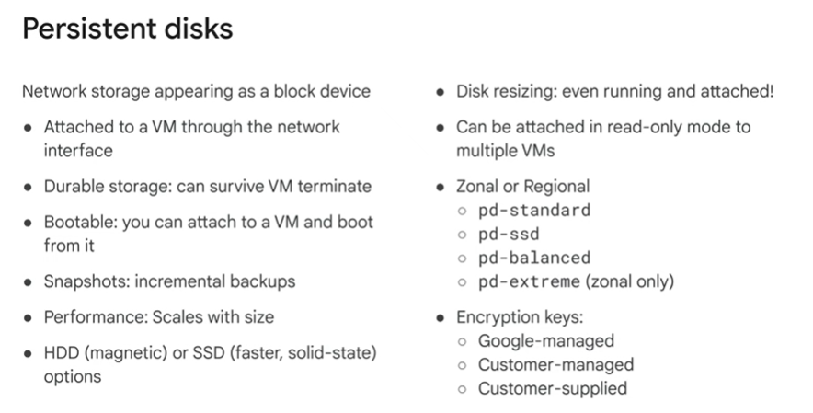

Regional persistent disks provide active-active disk replication across two zones in the same region
Regional persistent disks deliver durable storage that is synchronously replicated across zones and are a great option for high-performance databases and enterprise applications that also require high availability.
pd-satndard : Standard persistent disks are backed by standard hard disk drives and are suitable for large data processing workloads that primarily use sequential I/Os
pd-ssd - Performance SSD persistent disks are backed by solid-state drives and are suitable for enterprise applications and high-performance databases that require lower latency and more IOPS than standard persistent disks provide.
Balanced-ssd - Balanced persistent disks are also backed by solid-state drives.
They are an alternative to SSD persistent disks that balance performance and cost.

Local SSD disks

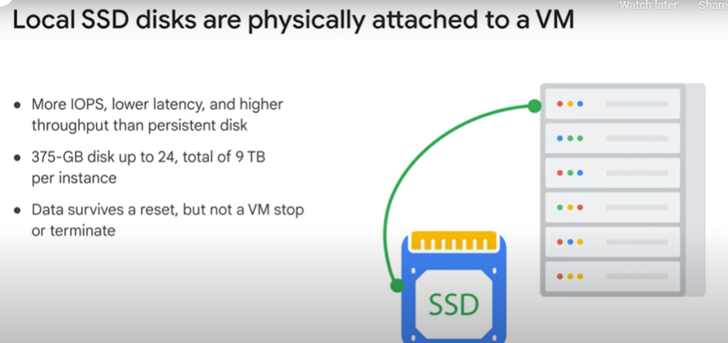

Currently, local SSDs are 375 gigabytes in size and you can attach up to to 24 local SSD partitions for a total of 9 terabytes per instance.
Data on these disks will survive a reset but not a VM stop or terminate, because these disks can’t be reattached to a different VM.
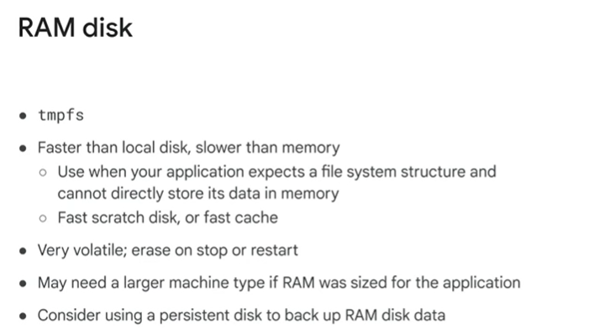

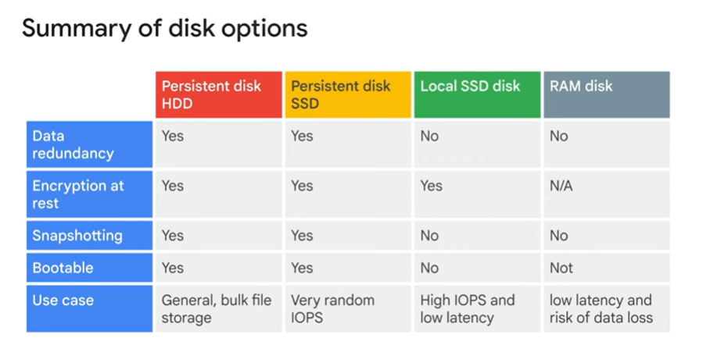
Low Latency
- Definition:
Latency refers to the time it takes for a storage device to complete a single operation (read or write).
  - Low latency means the operations are performed quickly, with minimal delay.
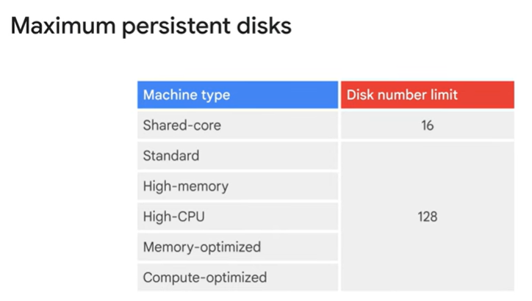
So if you plan on having a large amount of Disk IO throughput, it will also compete with any network egress or ingress throughput.
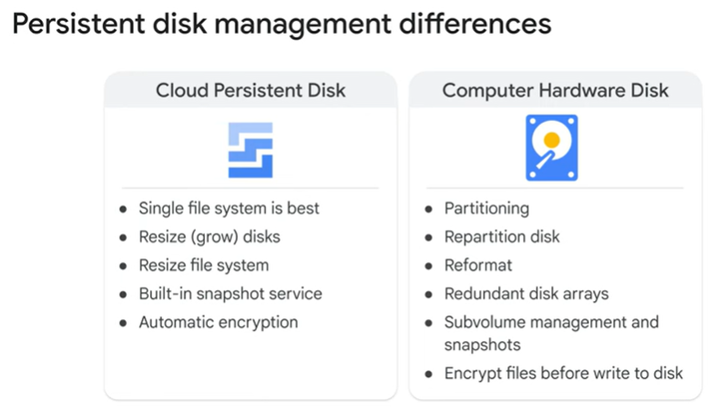

Common Compute Engine actions
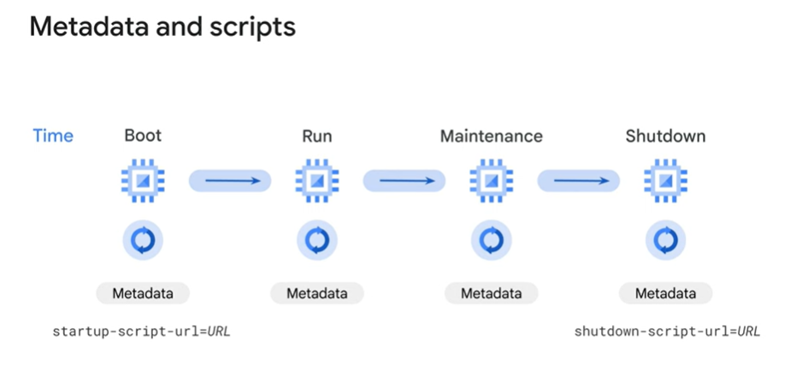

Step 1: Understand GCP Metadata Server
GCP instances can access their metadata via the metadata server at http://metadata.google.internal. The external IP address is accessible via the following metadata key:
bash
Copy code
/computeMetadata/v1/instance/network-interfaces/0/access-configs/0/external-ip
When making requests to the metadata server, you need to include a custom header:
makefile
Copy code
Metadata-Flavor: Google

Step 2: Write the Startup Script
Here’s an example startup script that retrieves the external IP address and uses it to set up a database:
bash
Copy code
#!/bin/bash
# Retrieve the external IP address of the instance
EXTERNAL_IP=$(curl -s -H "Metadata-Flavor: Google" \
http://metadata.google.internal/computeMetadata/v1/instance/network-interfaces/0/access-configs/0/external-ip)

# Use the external IP to configure a database or any other setup
echo "The external IP is $EXTERNAL_IP" > /var/log/startup-script.log

# Example: Configure a database (MySQL in this case)
sudo apt update
sudo apt install -y mysql-server

# Allow connections from the external IP
sudo sed -i "s/bind-address.*/bind-address = $EXTERNAL_IP/" /etc/mysql/mysql.conf.d/mysqld.cnf

# Restart MySQL service to apply changes
sudo systemctl restart mysql

echo "Database configured to bind to $EXTERNAL_IP" >> /var/log/startup-script.log
This script:
- Fetches the external IP from the metadata server.
- Logs the IP to a file.
- Installs MySQL.
- Updates the MySQL configuration to bind to the external IP.
- Restarts the MySQL service.

Step 3: Add the Startup Script to Your VM
You can add the startup script when creating a new VM or to an existing one.
Option A: During VM Creation
- Go to the GCP Console.
- Navigate to Compute Engine > VM Instances > Create Instance.
- In the Management, security, disks, networking, sole tenancy section, expand Management.
- In the Startup script field, paste the script.
Option B: To an Existing VM
- Go to Compute Engine > VM Instances.
- Click the name of the VM instance you want to modify.
- Click Edit.
- Scroll to the Custom metadata section.
- Add a new key-value pair:
  - Key: startup-script
  - Value: Paste the script.
- Save changes.

Step 4: Test the Startup Script
- Restart the VM.
- Verify that the startup script ran successfully by checking the logs:
bash
Copy code
sudo cat /var/log/startup-script.log

Step 5: Validate the Database Configuration
- Confirm that MySQL is bound to the external IP:
bash
Copy code
sudo netstat -plunt | grep mysql
- Test connectivity to the database using the external IP.

This approach ensures that the VM dynamically retrieves its external IP and uses it for setting up the database or other tasks.

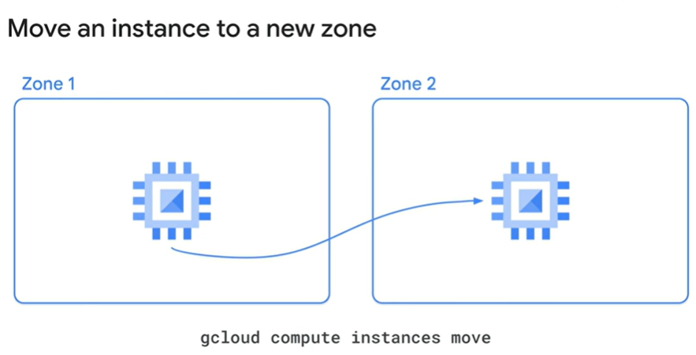
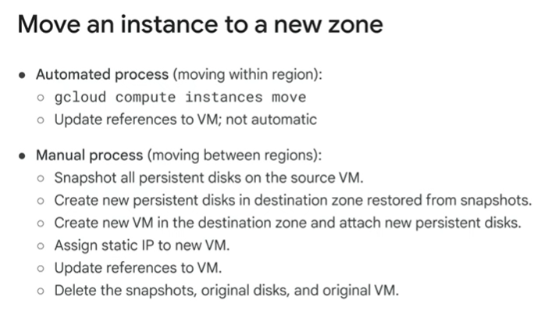
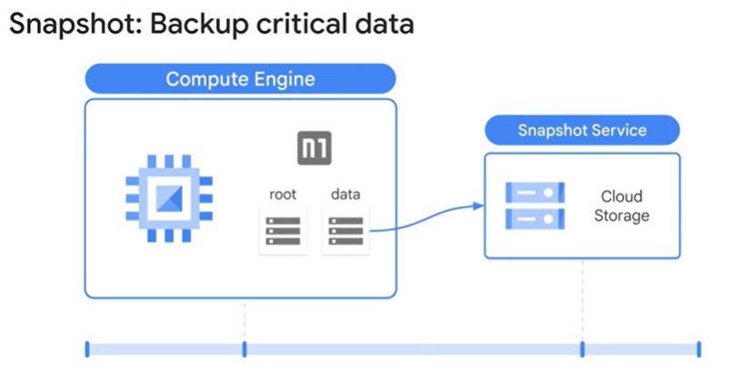

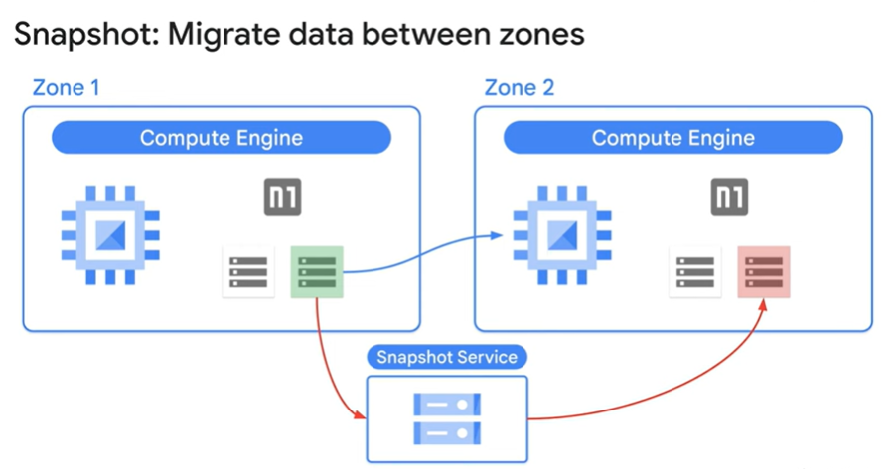

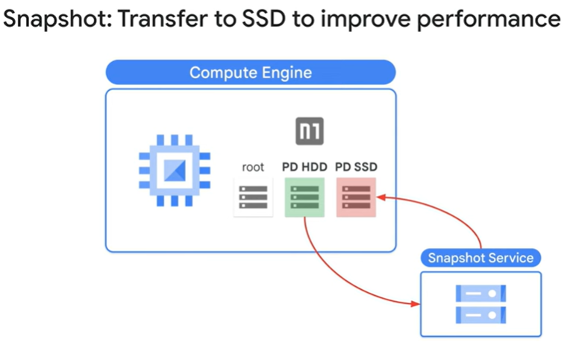

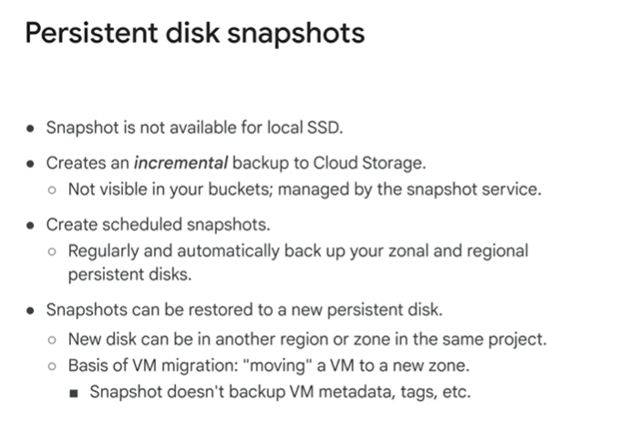
create a persistent disk snapshot, refer to the module PDF under Course Resources.
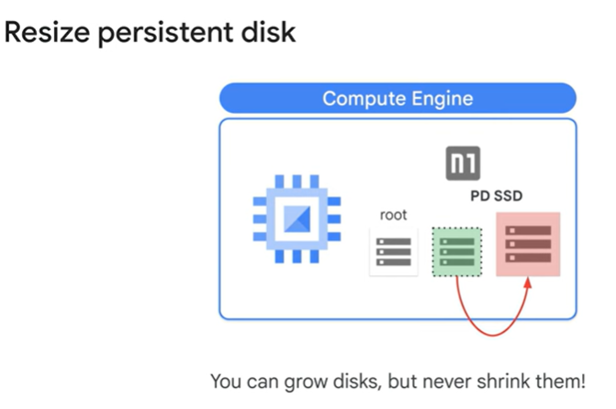

Quiz
What are sustained use discounts?
Discounts you receive by using preemptible VM instances
Automatic discounts that you get for running specific Compute Engine resources for a significant portion of the billing month
Purchase commitments for specific resources you know you will use
Per-second billing that starts after a 1 minute minimum

The correct definition of sustained use discounts is:
Automatic discounts that you get for running specific Compute Engine resources for a significant portion of the billing month.

Explanation:
- Sustained use discounts are a feature of Google Cloud's Compute Engine pricing. They automatically apply when you run certain types of resources (e.g., virtual machine instances) for a significant part of the billing month.
- These discounts do not require any prior commitment or manual activation.
- The longer you use the resource in a billing month, the larger the discount, up to a maximum percentage.
Other options describe different pricing features but do not match sustained use discounts:
- Preemptible VMs: Offer steep discounts for short-term, interruptible workloads but are unrelated to sustained use discounts.
- Purchase commitments: Refer to committed use discounts, where you prepay or commit to use a certain amount of resources for discounts.
- Per-second billing: Allows flexible billing but isn't related to sustained use discounts.

IAM
Identity Role Resource

Deploy cloudRun function
gcloud functions deploy nodejs-pubsub-function \
--gen2 \
--runtime=nodejs20 \
--region=us-east4 \
--source=. \
--entry-point=helloPubSub \
--trigger-topic cf-demo \
--stage-bucket qwiklabs-gcp-00-8be4369343fc-bucket \
--service-account cloudfunctionsa@qwiklabs-gcp-00-8be4369343fc.iam.gserviceaccount.com \
--allow-unauthenticated

Key Components
- gcloud functions deploy
  - This command is used to deploy a Cloud Function in GCP.
- nodejs-pubsub-function
  - The name of the Cloud Function being deployed.
- --gen2
  - Indicates that this is a second-generation Cloud Function. Second-generation Cloud Functions provide improved scalability, better control over networking, and tighter integration with Google Cloud services.
- --runtime=nodejs20
  - Specifies the runtime environment for the function. In this case, it’s Node.js 20.
- --region=us-east4
  - Specifies the region where the function is deployed. Here, it's us-east4 (Northern Virginia).
- --source=.
  - Indicates the source code location for the Cloud Function. A . means the current directory.
- --entry-point=helloPubSub
  - Specifies the entry point of the function. This is the name of the function in your source code that handles the Pub/Sub event.
- --trigger-topic=cf-demo
  - Sets the trigger for the function to be a Pub/Sub topic named cf-demo. When a message is published to this topic, the function is invoked.
- --stage-bucket=qwiklabs-gcp-00-8be4369343fc-bucket
  - Specifies the staging bucket used during deployment. This bucket temporarily stores files and artifacts required for the deployment process.
- --service-account=cloudfunctionsa@qwiklabs-gcp-00-8be4369343fc.iam.gserviceaccount.com
  - Specifies the service account under which the Cloud Function runs. This service account determines the permissions the function has when accessing other GCP resources.
- --allow-unauthenticated
  - Allows the function to be invoked without requiring authentication. This is generally used for publicly accessible endpoints.

Workflow of This Deployment
- Trigger Setup:
  - The function is triggered by messages published to the Pub/Sub topic cf-demo.
- Execution:
  - When a message is published to the topic, GCP invokes the function by calling the helloPubSub entry point.

Core services - W3

Introduction
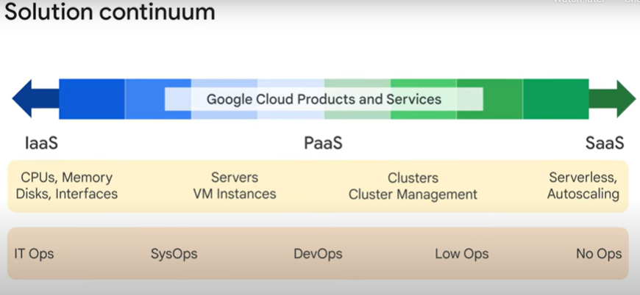

Cloud Run, a managed compute platform that lets you run stateless containers via web requests or Pub/Sub events.

IAM
G Suite or Cloud Identity super administrators
and the GCP organization admin are key roles during the setup process and for lifecycle control, for the organization resource.

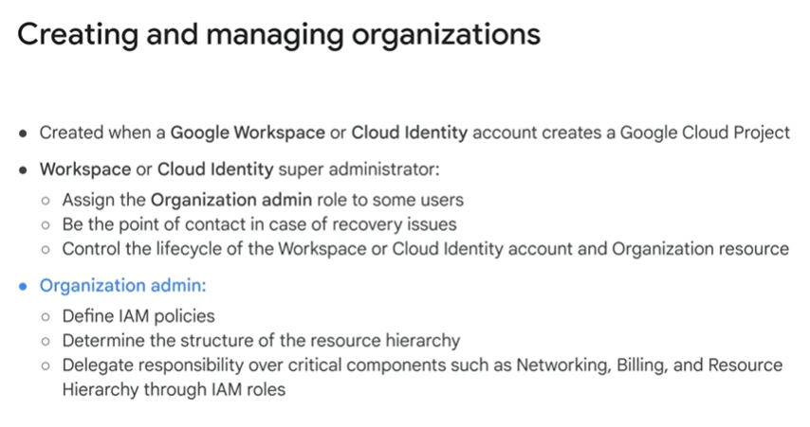

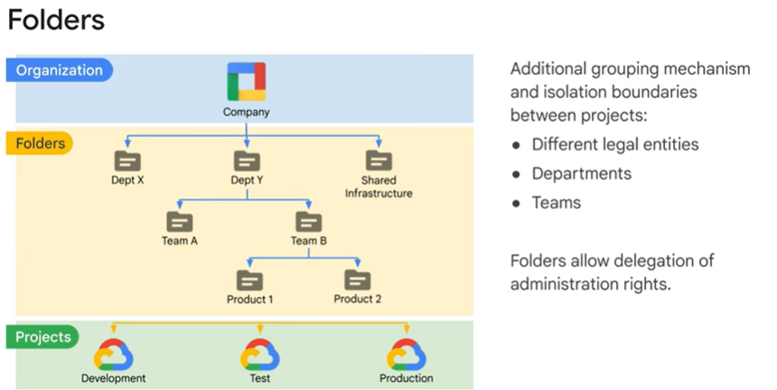
Roles: define the can do what on which resource part of Cloud IAM.

Create role -> name (i.e. instance operator) -> assigns permissions (i.e compute.instances.start) -> review
Policies:
Allow
Deny
Condition
Organization policy
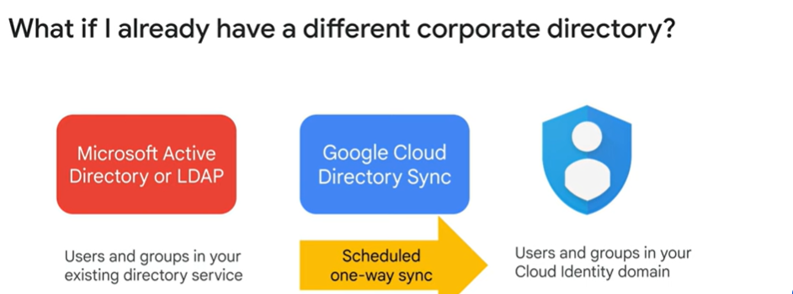

Service account
application that interacts with Google Cloud Storage,
it must first authenticate to either the Google Cloud Storage XML API or JSON API.

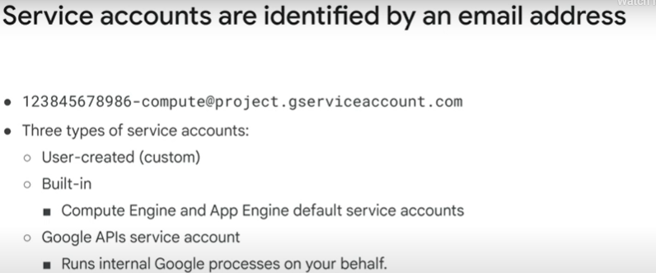
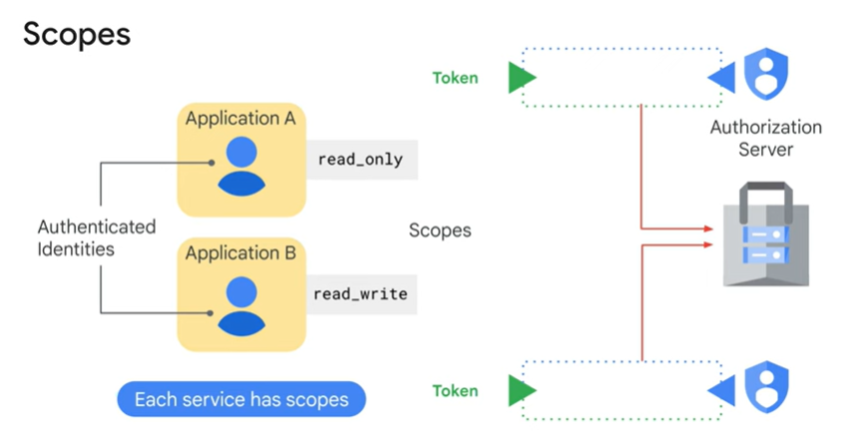
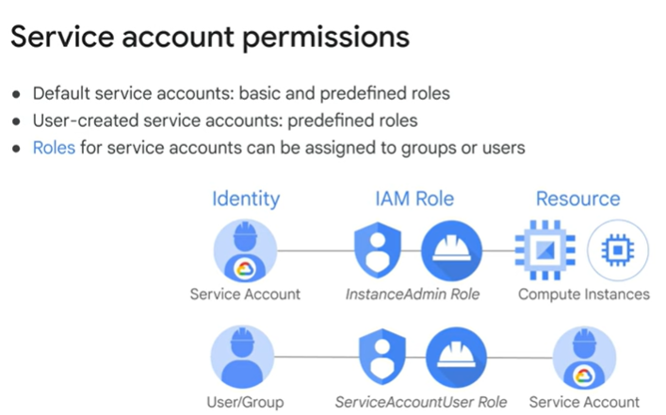

Organization retractions – important to hot spot
Why important? Cause we can restrict the machine that connect to the organization

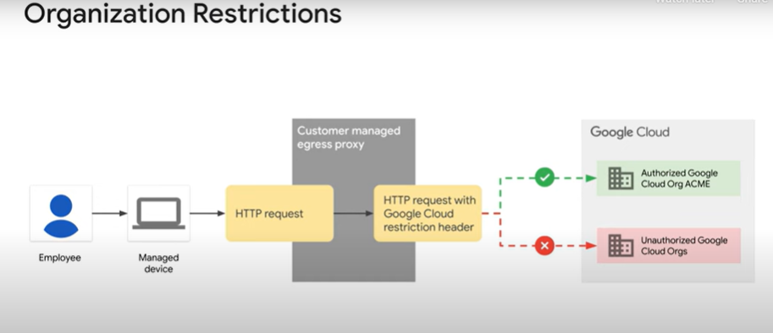

IAM Best practices
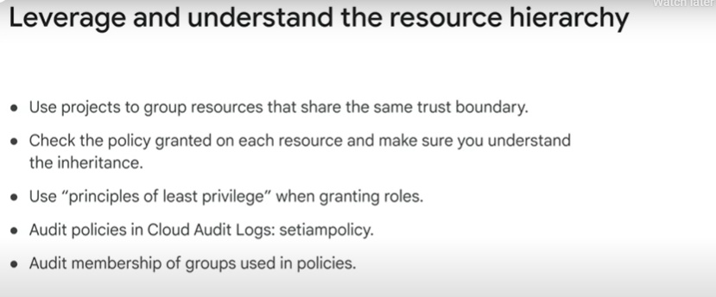

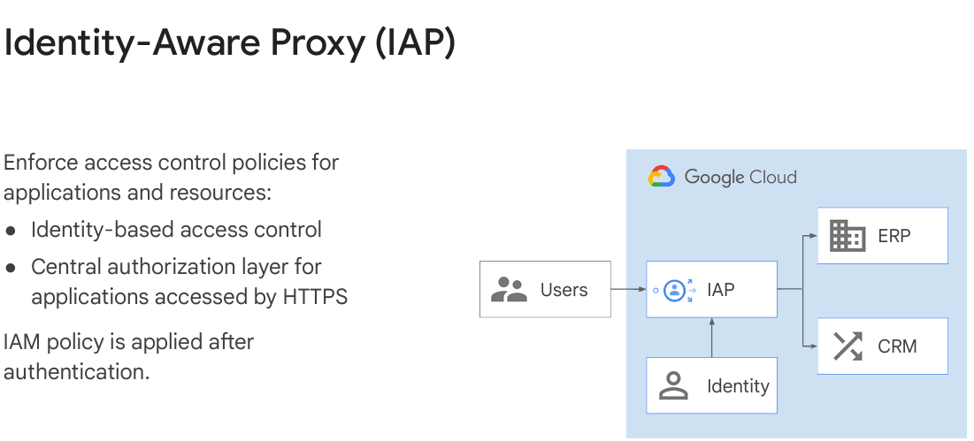
Cloud IAP lets you establish a central authorization layer for applications accessed by HTTPS.
  - So you can use an application level access control model
  - instead of relying on network level firewalls.
Create sevice account -> Grant Access. -> a domain (i.e. altostrat.com) -> Select a role Compute Engine > Compute Instance Admin (v1)
Reference:
https://www.cloudskillsboost.google/course_templates/49/labs/470022

Storage and DB storage

Storage
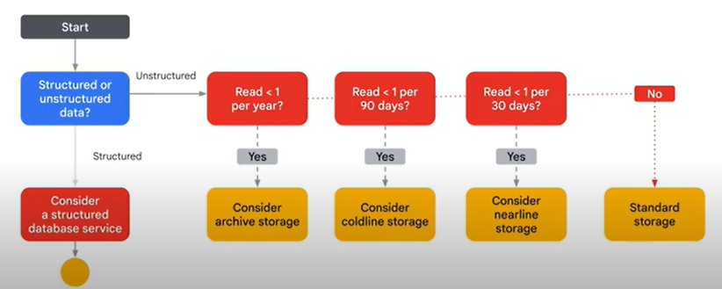

DB Storage
BigQuery service sits on the edge between data storage and data processing.
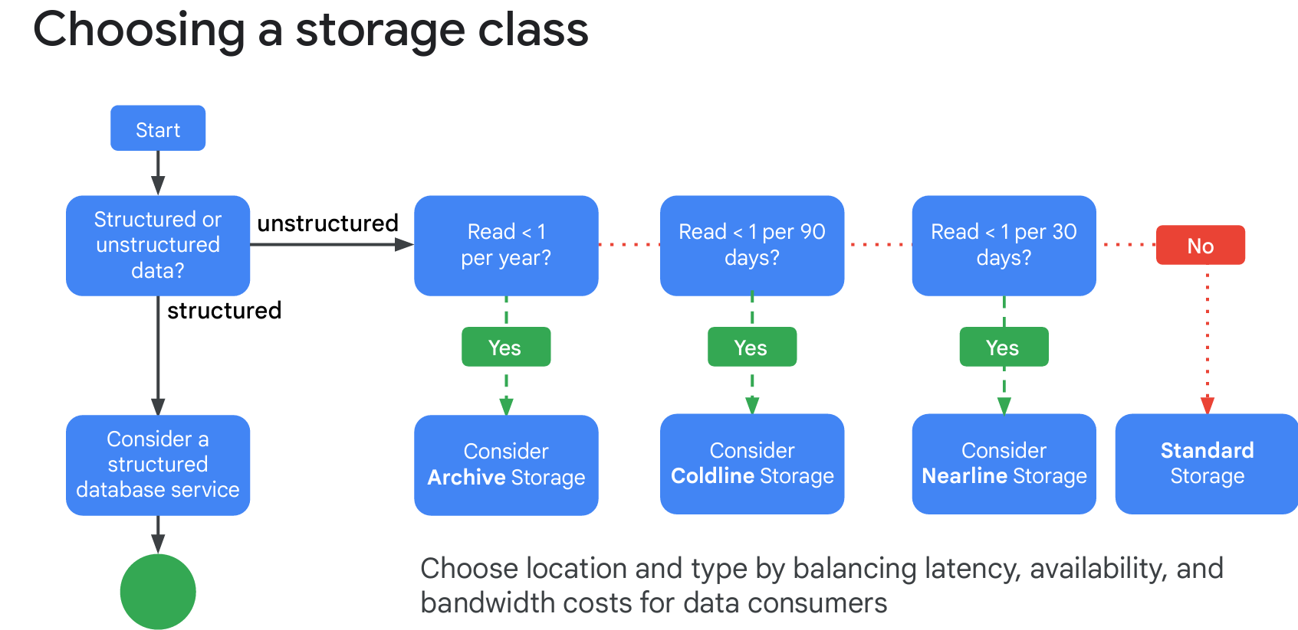

SQL Spanner
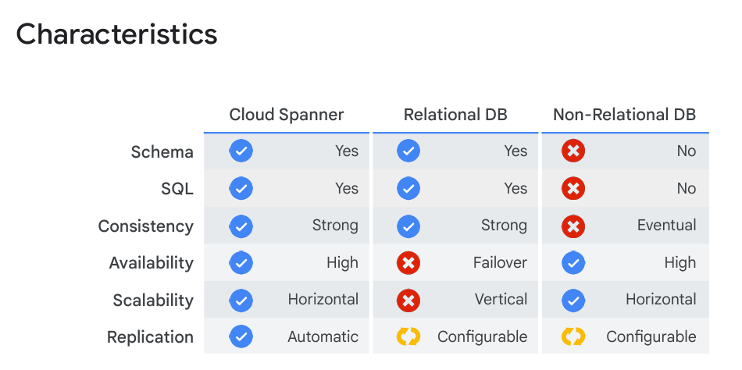

Alloy DB - PostgreSQL-compatible database
AlloyDB for PostgreSQL is a fully managed, PostgreSQL-compatible database service that's designed for demanding workloads such as hybrid transactional and analytical processing.

Firestore - highly scalable NoSQL database - for your mobile web and IOT apps

Cloud Firestore is a fast, fully managed, serverless, cloud native, NoSQL, document database that simplifies storing, synking and querying data for your mobile web and IOT apps at global scale.

ACID
ACID is a set of properties that ensure reliable processing of database transactions. The acronym stands for:
- Atomicity:
  - Ensures that all operations within a transaction are treated as a single unit.
  - Either all operations are completed successfully, or none are applied.
  - In Cloud Firestore, if one operation fails, the entire transaction is rolled back, ensuring no partial changes.
- Consistency:
  - Guarantees that a database remains in a valid state before and after a transaction.
  - For Firestore, this means any transaction ensures that all constraints and rules defined for the database are maintained, such as unique indexes and referential integrity.
- Isolation:
  - Transactions are executed in isolation from each other.
  - In Firestore, the changes made in a transaction are not visible to other transactions or queries until the transaction is successfully committed, preventing dirty reads or race conditions.
- Durability:
  - Ensures that once a transaction is committed, the changes are permanent and survive system failures.
  - Cloud Firestore writes data to multiple data centers, ensuring durability even in the case of regional failures.

Cloud Bigtable - fully managed NoSQL database with petabyte-scale and very low latency – if you don’t require transactional consistency

Cloud Storage, a fully managed object store;
Filestore, a fully managed file storage service - ACID transactions and can scale globally
Cloud SQL, a fully managed MySQL and PostgreSQL database service - needed to migrate a standard relational database running on a single machine in a datacenter to the cloud
Cloud Spanner, a relational database service with transactional consistency, global scale and high availability - ACID transactions and can scale globally
AlloyDB, a fully managed, PostgreSQL-compatible database service;
Firestore, a fully managed NoSQL document database;
Bigtable, a fully managed NoSQL wide-column database
BigQuery - provides data warehouse services for storing data but also offers an interactive SQL interface for querying the data
Memorystore, a fully managed in-memory data store service for Redis

Resource Manager
project - associated with one billing account - accumulates the consumption of all its resources.
resource belongs to only one project
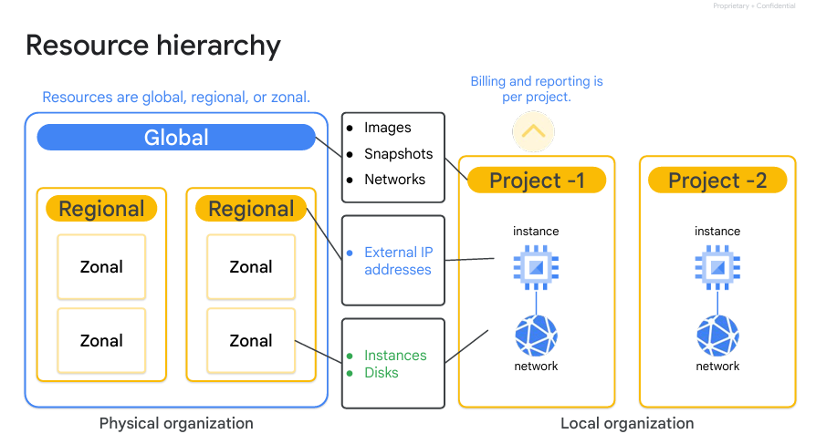

Monitoring

Trace - collects latency data from your applications and displays it in the Google Cloud console

Networking

Cloud VPN – securely connects your on-premises network to your Google Cloud VPC network
Cloud VPN gateways: HA VPN and Classic VPN

IPsec = (Internet Protocol Security)
An IPsec VPN tunnel in Google Cloud is a secure communication channel between two networks or devices over the internet. It uses the IPsec (Internet Protocol Security) protocol to encrypt and protect data transmitted between the two endpoints, ensuring confidentiality, integrity, and authenticity.
In the context of Google Cloud, an IPsec VPN tunnel is typically used to connect:
- A Google Cloud Virtual Private Cloud (VPC) to an on-premises network.
- Two separate Google Cloud VPC networks.
- A Google Cloud VPC to a different cloud provider's network.

Key Features of IPsec VPN Tunnel in GCP
- Encryption and Security:
  - Ensures data is encrypted and protected while traveling over the public internet.
  - Supports AES encryption for high levels of security.
- Hybrid Connectivity:
  - Enables hybrid cloud setups by securely connecting on-premises networks with Google Cloud resources.
- High Availability:
  - Supports high-availability VPN (HA VPN) with redundant tunnels for improved reliability.
  - Supports classic VPN with a single tunnel (less reliable than HA VPN).
- Standards-Based:
  - Uses industry-standard protocols (IKEv1/IKEv2 for key exchange and IPsec for encryption).

Components of an IPsec VPN Tunnel
- VPN Gateway:
  - A virtual device that terminates the VPN connection at each end.
  - Google Cloud provides the Cloud VPN Gateway for this purpose.
- Tunnels:
  - The logical connection between the two VPN gateways.
  - Each VPN tunnel uses IPsec encryption for secure communication.
- Routing:
  - Two main options for directing traffic through the VPN tunnel:
    - Policy-based routing: Based on specific IP address ranges (legacy approach, supported by Classic VPN).
    - Route-based routing: Uses dynamic (BGP) or static routes (supported by HA VPN).
- Peer Gateway:
  - The gateway on the other end of the tunnel (on-premises or another cloud provider).

Use Cases for IPsec VPN Tunnels
- Hybrid Cloud Architecture:
  - Connect an on-premises data center to Google Cloud for extending workloads securely.
- Inter-VPC Communication:
  - Connect multiple Google Cloud VPCs in different regions or projects securely.
- Disaster Recovery and Backup:
  - Use VPN tunnels to replicate data securely between on-premises systems and Google Cloud.
- Secure Application Access:
  - Enable private and secure access to applications hosted in Google Cloud from external environments.

How to Set Up an IPsec VPN Tunnel in GCP
- Create a Cloud VPN Gateway in a GCP region and attach it to a subnet.
- Configure a VPN tunnel:
  - Provide details of the peer gateway (IP address and shared secret).
  - Choose routing (static or dynamic with BGP).
- Establish Connectivity:
  - Ensure firewall rules are configured to allow IPsec traffic (ports 500 and 4500).
- Test the Tunnel:
  - Verify that the tunnel is established and traffic is flowing correctly.

Classic VPN doesn't support use cases where client computers need to “dial in” to a VPN using client VPN software.
What can we do ?
Google Cloud can support such use cases through third-party solutions or alternative methods.
Native GCP VPN Solutions and Their Limitations
- Classic VPN and HA VPN are designed for site-to-site VPN connections and are not built to handle remote access VPN connections where individual client computers (like laptops or phones) need to connect directly.
- These solutions work well for connecting on-premises networks or other cloud environments to a Google Cloud VPC.

Options to Enable Client VPN Access in GCP
- Third-Party VPN Servers in GCP:
  - Deploy a third-party VPN server in your Google Cloud VPC to support client devices. Examples include:
    - OpenVPN: Widely used and supports client access across multiple platforms.
    - WireGuard: Lightweight and secure VPN for modern use cases.
    - StrongSwan: An IPsec-based VPN server.
  - You install and configure these solutions on a Compute Engine instance.
Pros:
  - Full control over configuration.
  - Flexible to meet specific requirements (e.g., user authentication methods).
Cons:
  - Requires manual setup, maintenance, and monitoring.
  - Additional costs for Compute Engine instances and egress traffic.

- BeyondCorp Enterprise (Zero Trust Access):
  - A zero-trust solution from Google that replaces the need for a traditional VPN.
  - Users access applications securely based on their identity and device context, without needing to establish a VPN tunnel.
  - Ideal for organizations looking to move away from VPNs altogether.

- Cloud Identity-Aware Proxy (IAP):
  - Provides secure access to internal applications hosted on Google Cloud without a VPN.
  - Uses OAuth 2.0 for authentication and supports fine-grained access control.
  - Suitable for granting specific application-level access rather than network-level access.

- Google Workspace VPN (Enterprise Tier):
  - If you’re using Google Workspace Enterprise, there are advanced options for securing client connections using Google’s built-in infrastructure.
  - Works well with BeyondCorp principles.

IKEV1 / 2
IKEv1 and IKEv2 Ciphers
IKE (Internet Key Exchange) is a protocol used to set up secure communication between devices in IPsec-based VPNs. It negotiates cryptographic keys and security policies for the VPN. There are two versions, IKEv1 (legacy) and IKEv2 (modern), and they both use cryptographic ciphers for encryption, integrity, and authentication.

IKE Cipher Types
- Encryption Ciphers:
  - Provide confidentiality by encrypting the data exchanged between endpoints.
  - Examples: AES, DES, 3DES.
- Integrity Ciphers (Hashing):
  - Ensure data integrity by generating and verifying message digests.
  - Examples: SHA-1, SHA-2 (SHA-256, SHA-384, SHA-512).
- Authentication Mechanisms:
  - Authenticate the peers using shared secrets, certificates, or pre-shared keys.
  - Examples: RSA, ECDSA, Pre-shared key (PSK).
- Diffie-Hellman (DH) Groups:
  - Used during the key exchange process to securely derive shared keys over an insecure channel.
  - Examples: DH Groups 1, 2, 14, 19, 20, 21.

IKEv1 Ciphers
- Encryption Algorithms:
  - DES (weak, deprecated due to short key length of 56 bits).
  - 3DES (Triple DES, stronger than DES but less efficient).
  - AES-128, AES-192, AES-256 (preferred due to efficiency and security).
- Integrity Algorithms:
  - MD5 (weak, deprecated due to vulnerabilities).
  - SHA-1 (widely supported but less secure than SHA-2).
  - SHA-2 (SHA-256, SHA-384, SHA-512).
- Key Exchange:
  - Diffie-Hellman groups: 1, 2, 5 (lower groups like 1 and 2 are weak and deprecated).
Limitations:
- IKEv1 is less efficient and less secure than IKEv2.
- Does not support modern ciphers like GCM for authenticated encryption.

IKEv2 Ciphers
- Encryption Algorithms:
  - AES-GCM (Galois/Counter Mode, provides both encryption and integrity in one step).
  - AES-CBC (Cipher Block Chaining, widely supported).
  - ChaCha20-Poly1305 (lightweight and efficient, suitable for constrained devices).
- Integrity Algorithms:
  - SHA-2 family (SHA-256, SHA-384, SHA-512).
  - SHA-1 (for backward compatibility but not recommended).
- Key Exchange:
  - Diffie-Hellman groups: 14 (2048-bit), 19 (256-bit ECDH), 20 (384-bit ECDH), 21 (521-bit ECDH).
  - Stronger groups like 19–21 are recommended for high security.
- Authentication Mechanisms:
  - RSA, ECDSA, and PSK.
Advantages:
- Supports modern encryption standards.
- More efficient, with faster setup and fewer round trips than IKEv1.
- Built-in NAT traversal and enhanced resiliency.

Recommended Cipher Suites
For a secure configuration, especially with IKEv2:
- Encryption: AES-256-GCM or AES-128-GCM.
- Integrity: SHA-256 or SHA-384.
- Key Exchange: DH group 19 (256-bit ECDH) or group 21 (521-bit ECDH).
- Authentication: RSA (2048+ bits) or ECDSA (256+ bits).

Why IKEv2 is Preferred Over IKEv1
- Better security: Supports modern encryption algorithms like AES-GCM and ChaCha20-Poly1305.
- Efficiency: Faster negotiation with fewer round trips.
- Resilience: Handles network disruptions better, including NAT traversal.

Cloud Router and a VPN Gateway

The choice between using a Cloud Router and a VPN Gateway depends on your networking requirements and how you want to connect different networks. Here's a detailed breakdown to clarify when to use each:

Cloud Router
Purpose: Manages dynamic routing for hybrid and multi-cloud networking.
When to Use:
- Dynamic Routing with BGP:
  - You need to exchange dynamic routing information between Google Cloud and your on-premises or another cloud network.
  - Useful when your network topology changes frequently, as it allows automatic updates of routes without manual intervention.
- Cloud Interconnect:
  - Required if you're using Dedicated Interconnect or Partner Interconnect to connect your on-premises network to Google Cloud.
  - Ensures routing information is dynamically updated through Border Gateway Protocol (BGP).
- Hybrid Cloud Architectures:
  - When you want seamless communication between Google Cloud and on-premises networks with dynamic route updates.
- Peering Scenarios:
  - Facilitates dynamic route exchange in Network Peering setups within Google Cloud or with other clouds.

VPN Gateway
Purpose: Provides secure, encrypted communication between Google Cloud and on-premises or other cloud environments.
When to Use:
- Secure Communication:
  - When you need to establish an IPsec VPN tunnel for encrypted communication between Google Cloud and on-premises or other cloud environments.
  - Ideal for connecting smaller setups or as a backup to Interconnect.
- Static or Dynamic Routing:
  - Can work with both static and dynamic routing (via Cloud Router) for route management.
  - If dynamic routing is required, a Cloud Router is used alongside the VPN Gateway to support BGP.
- Lower Bandwidth Needs:
  - When the bandwidth requirement is relatively low compared to Interconnect solutions.
- Temporary Connections:
  - Ideal for temporary or ad-hoc connections between on-premises and cloud.
- Failover Solution:
  - As a backup solution for Cloud Interconnect to maintain connectivity during outages.

Comparison and Scenarios
Feature | Cloud Router | VPN Gateway
Routing | Dynamic with BGP (Border Gateway Protocol - automatically exchanging routing information between networks) | Static or Dynamic (if paired with BGP)
Security | No encryption (routing only) | Encrypted communication
Use Case | Route management for hybrid setups | Secure data transfer over the internet
Bandwidth | High (e.g., Interconnect scenarios) | Lower (subject to VPN limits)
Primary Role | Routing protocol (BGP) manager | Secure IPsec tunnel setup

Common Use Cases
- Use Cloud Router with VPN Gateway:
  - When you need dynamic routing for your IPsec VPN connection.
  - Example: Connecting dynamically changing on-premises subnets to Google Cloud.
- Use Cloud Router with Interconnect:
  - For high-bandwidth, low-latency private connectivity.
  - Example: Enterprise-grade workloads requiring predictable performance.
- Use VPN Gateway Alone:
  - For simple, encrypted connectivity with static routing.
  - Example: Connecting a single office to Google Cloud.

In summary, use Cloud Router when routing dynamics and route updates are crucial, and use VPN Gateway when secure, encrypted connectivity is required. Often, they are used together in scenarios requiring dynamic and secure connections.

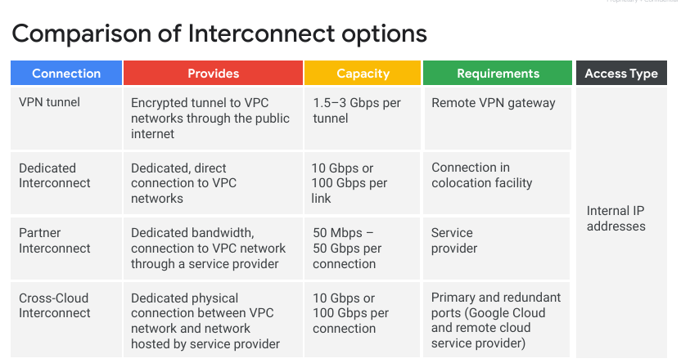

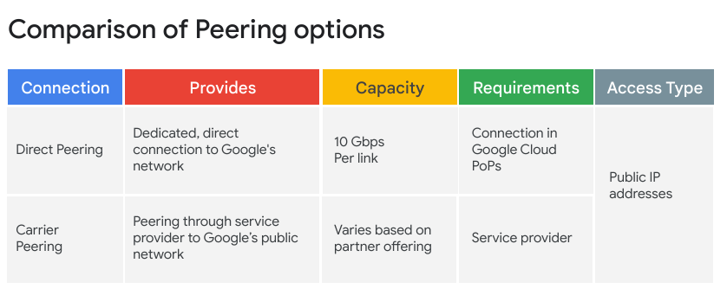

Appendix- N Networking

Set up a Global VPC environment – with 2 VMs in each subnet and firewall rules
Reference: https://www.cloudskillsboost.google/course_templates/178/labs/470286

In this task you set up a Global VPC with two custom subnets and two VM instances running in each zone.
- In Cloud Shell, create a VPC network called vpc-demo:
gcloud compute networks create vpc-demo --subnet-mode custom
Copied!
content_copy
The output should look similar to this:
Created [https://www.googleapis.com/compute/v1/projects/qwiklabs-gcp-03-cdb29e18d20d/global/networks/vpc-demo].
NAME: vpc-demo
SUBNET_MODE: CUSTOM
BGP_ROUTING_MODE: REGIONAL
IPV4_RANGE:
GATEWAY_IPV4:
- In Cloud Shell, create subnet vpc-demo-subnet1 in the region us-west1:
gcloud compute networks subnets create vpc-demo-subnet1 \
--network vpc-demo --range 10.1.1.0/24 --region "us-west1"
Copied!
content_copy
- Create subnet vpc-demo-subnet2 in the region us-east1:
gcloud compute networks subnets create vpc-demo-subnet2 \
--network vpc-demo --range 10.2.1.0/24 --region us-east1
Copied!
content_copy
- Create a firewall rule to allow all custom traffic within the network:
gcloud compute firewall-rules create vpc-demo-allow-custom \
--network vpc-demo \
--allow tcp:0-65535,udp:0-65535,icmp \
--source-ranges 10.0.0.0/8
Copied!
content_copy
The output should look similar to this:
Creating firewall...working..Created [https://www.googleapis.com/compute/v1/projects/qwiklabs-gcp-03-cdb29e18d20d/global/firewalls/vpc-demo-allow-custom].
Creating firewall...done.
NAME: vpc-demo-allow-custom
NETWORK: vpc-demo
DIRECTION: INGRESS
PRIORITY: 1000
ALLOW: tcp:0-65535,udp:0-65535,icmp
DENY:
DISABLED: False
- Create a firewall rule to allow SSH, ICMP traffic from anywhere:
gcloud compute firewall-rules create vpc-demo-allow-ssh-icmp \
--network vpc-demo \
--allow tcp:22,icmp
Copied!
content_copy
- Create a VM instance vpc-demo-instance1 in zone us-west1-a:
gcloud compute instances create vpc-demo-instance1 --machine-type=e2-medium --zone us-west1-a --subnet vpc-demo-subnet1
Copied!
content_copy
The output should look similar to this:
Created [https://www.googleapis.com/compute/v1/projects/qwiklabs-gcp-03-cdb29e18d20d/zones/us-west1-a/instances/vpc-demo-instance1].
NAME: vpc-demo-instance1
ZONE: us-west1-a
MACHINE_TYPE: e2-standard-2
PREEMPTIBLE:
INTERNAL_IP: 10.1.1.2
EXTERNAL_IP: 34.71.135.218
STATUS: RUNNING
- Create a VM instance vpc-demo-instance2 in zone us-east1-c:
gcloud compute instances create vpc-demo-instance2 --machine-type=e2-medium --zone us-east1-c --subnet vpc-demo-subnet2

LoadBalance
internal load balancer
uses
Andromeda - Google Cloud’s software-defined network virtualization stack
Maglev - a large, distributed software system.
for HTTP(S) traffic is a proxy-based, regional Layer 7 load balancer
Instance groups
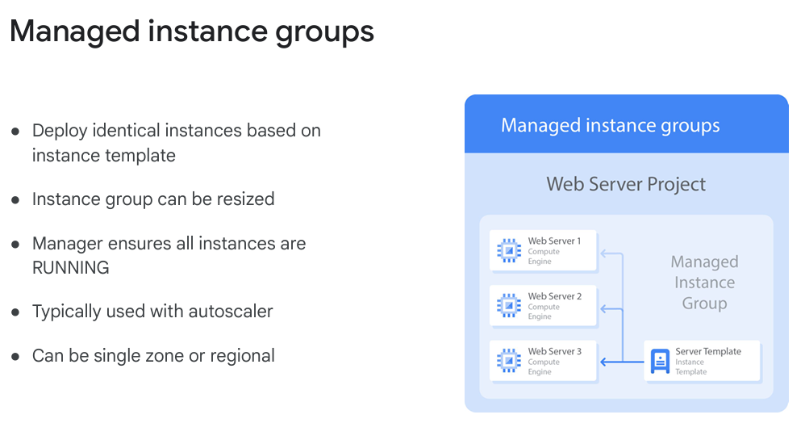
Regional managed instance groups (us-central1) better than zonal managed instance groups (us-central1-a) because allowing u to spread the application load across multiple zones (a/b/c)

Create manages instance group -> template -> instances
Examples:
stateless serving
batch workloads (website front end or image processing from a queue)
statefull applications.

HTTP(S) load balancing
acts at Layer 7 of the OSI model (application layer, which deals with the actual content of each message, allowing for routing decisions based on the URL)

EXTERNAL HTTP LOAD BALANCER with NAT and instance groups with autoscaling
https://www.cloudskillsboost.google/course_templates/178/video/470302

load balancing services support IPv6 clients are : HTTP(S), SSL proxy, and TCP proxy
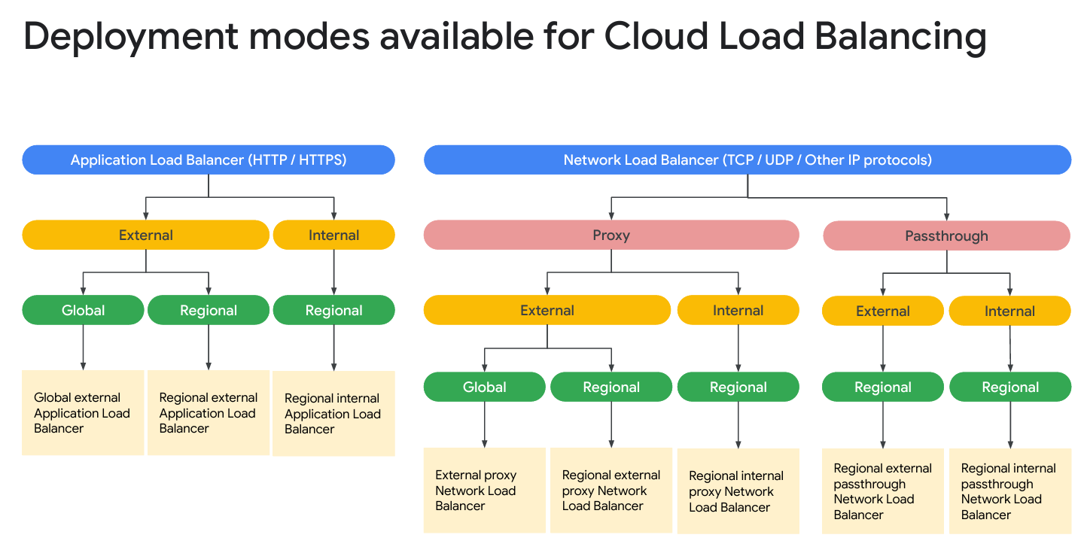
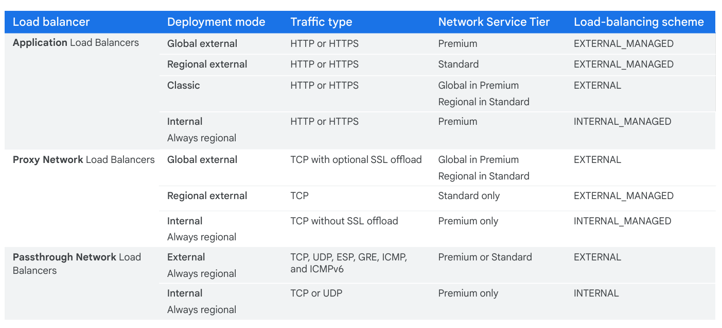

Cloud CDN - Content Delivery Network - cache HTTP(S) load-balanced content close to your users

Managed Services
BigQuery -> like db for data analyzing
DataFlow -> like Fluentd and terraform (it provision cluster )
Dataprep -> cleaning and preparing un/structured data for analysis reporting / ML
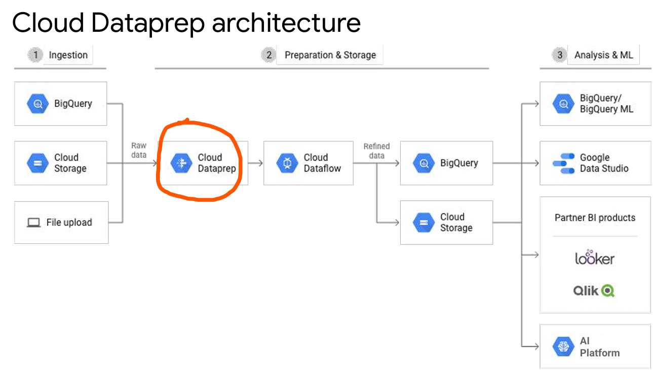
Dataproc -> like manually deploying cluster - fully managed cloud service for running Apache Spark and Apache Hadoop clusters
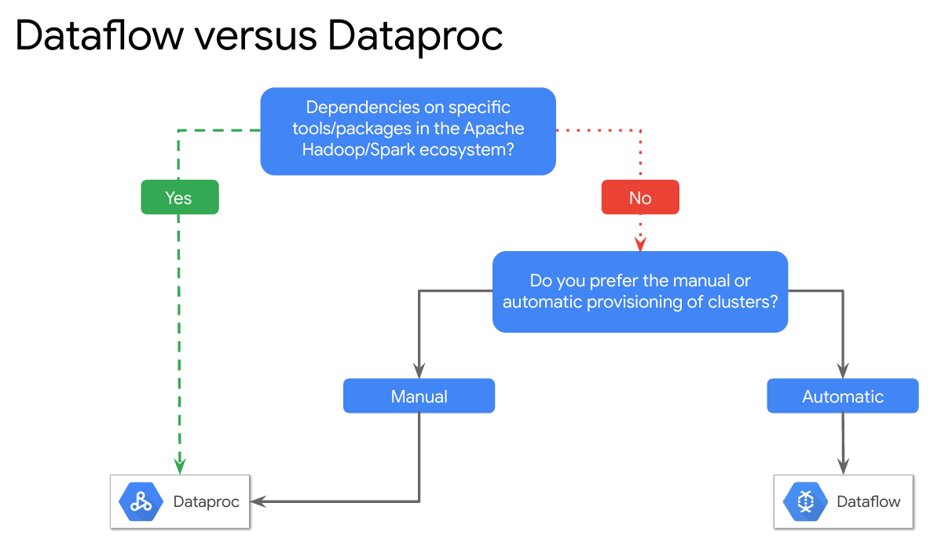

Architecture – W6
what the software is supposed to do, who your users are, and why this is important.
Do you want a relational database, a NoSQL database, or a data warehouse?
compute platform.
deploy your apps to virtual machines, a Kubernetes cluster, or an automated platform, like App Engine
Availability, durability, cost, and disaster recovery
The prerequisite for this course is
either
the Architecting with Google Compute Engine
the Architecting with Google Kubernetes Engine course.

SRE :: SLI (Service Level Indicator) and SLO (Service Level Objective)
key concepts used to define, measure, and maintain service reliability.

1. SLI (Service Level Indicator)
- Definition: A quantitative measure of service performance.
- Purpose: It helps track how well a service is meeting expectations.
- Example:
  - Availability SLI: Percentage of successful HTTP requests (e.g., 99.95% of requests return HTTP 200).
  - Latency SLI: Percentage of requests completed within 100ms.
  - Error Rate SLI: Percentage of failed requests.
SLIs are collected using Cloud Monitoring, Cloud Logging, and Cloud Trace in GCP.

2. SLO (Service Level Objective)
- Definition: A target value or range for an SLI.
- Purpose: Sets a reliability goal that the service should maintain.
- Example:
  - Availability SLO: "The API must be available 99.95% of the time over a rolling 30-day period."
  - Latency SLO: "95% of requests must have a response time under 100ms."
SLOs help balance feature development vs. reliability. If an SLO is violated, teams should prioritize fixing reliability issues.

How GCP Helps with SLI and SLO?
GCP provides Cloud Operations Suite (formerly Stackdriver) to monitor SLIs and enforce SLOs:
- Cloud Monitoring: Collects metrics for SLIs.
- Cloud Logging: Stores logs for debugging.
- Cloud Trace: Measures latency.
- Cloud Service Health API: Tracks Google Cloud services' health.
By defining SLIs and SLOs in Service Monitoring, DevOps teams in GCP can track service health, prevent outages, and ensure high availability.

Roles -> persona
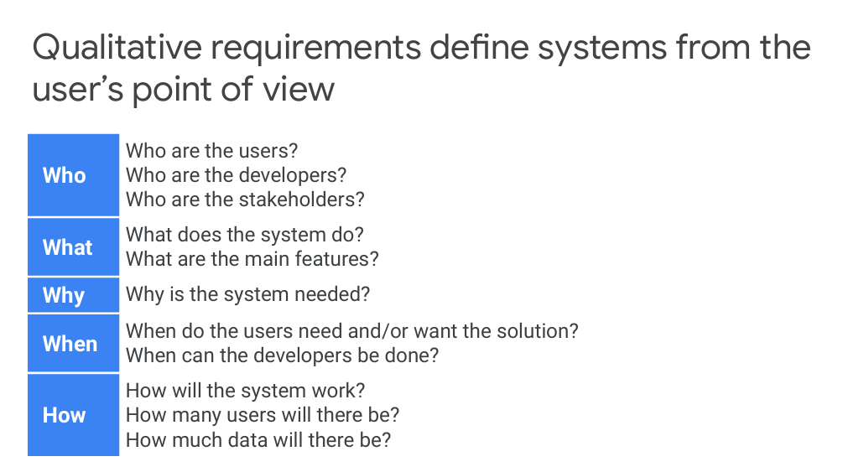
Persona:
● In a real-world application, go find your users and talk to them.
●Personas tell a story of who they are.
●Personas are not a list of job functions.
● For each role, there could be many personas

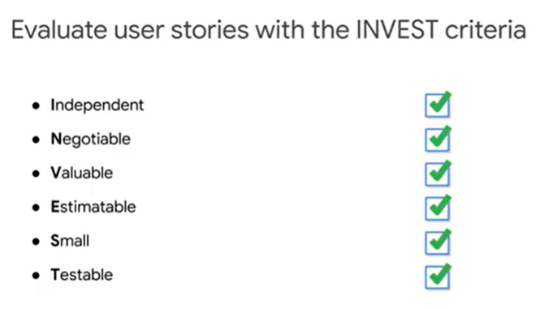

SLOs, SLIs, and SLAs
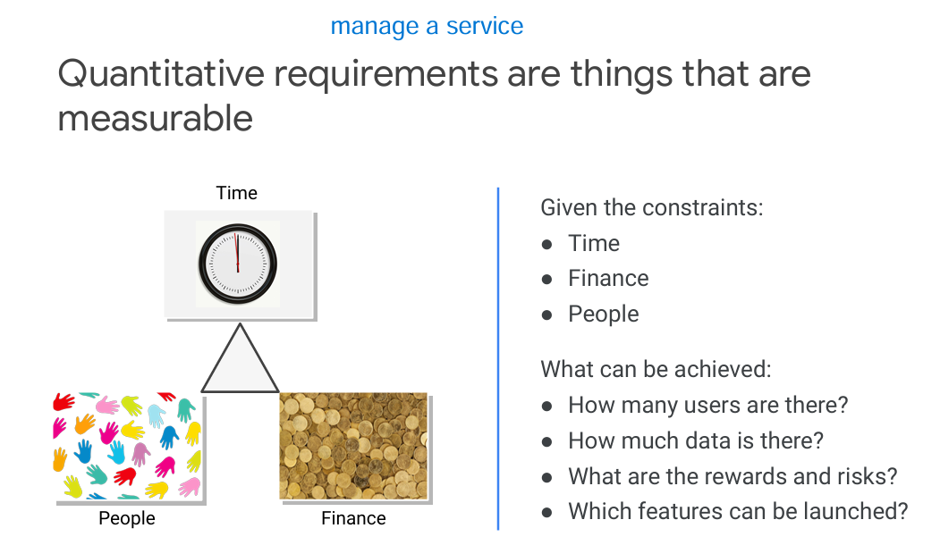

Manage service - data gathered from the services
For user-facing systems
-> was a request responded to? (availability)
-> how long did it take to respond? (latency)
-> how many requests can be handled? (throughput)

For data storage systems
-> how long does it take to read and write data? (latency)
-> Is the data there when we need it? (availability)
-> if there is a failure, do we lose any data (durability)

System Type | Means to get SLI | SLO
User-facing | Availability - was a request responded to  Example: API percentage available of the time over a rolling 30-day period | 99
 | Latency - how long did it take to respond  Example: percentage of the requests that must have a response time under 100ms | 95
 | Throughput - how many requests can be handled
Data storage | Availability - Is the data there when we need it
 | Latency - how long does it take to read and write data
 | Durability - if there is a failure, do we lose any data

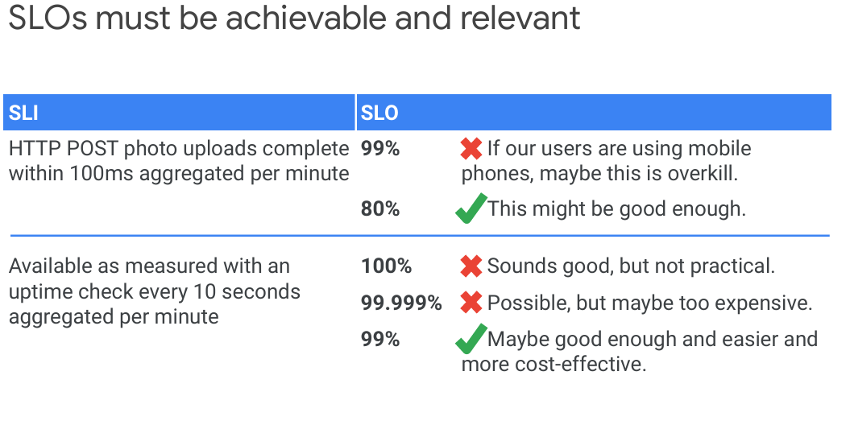
What can be achieved:
●How many users are there?
●How much data is there?
●What are the rewards and risks?
●Which features can be launched

KPI’s
In business, common KPIs include:
●Return on investment (ROI)
● Earnings before interest and taxes
(EBIT)
● Employee turnover
●Customer churn

In software, common KPIs include:
●Page views
●User registrations
●Clickthroughs
●Checkouts

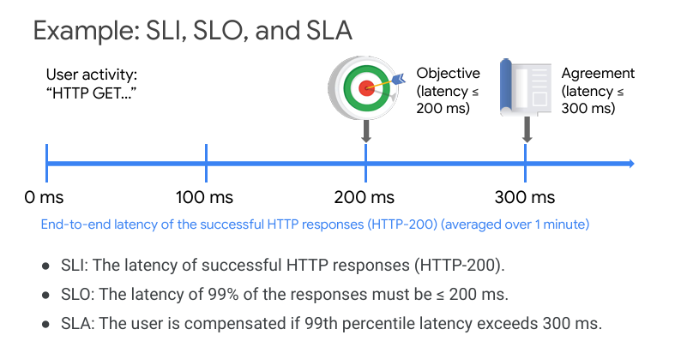

Microservice Design and Architecture

Session affinity
subsequent client requests have to be sent to the same server that the initial request was made to -> configuration of the load balancers to use sticky sessions -> which in Google Cloud is referred to as session affinity.

Best practices
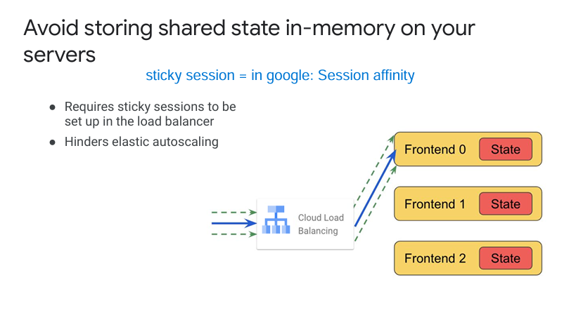

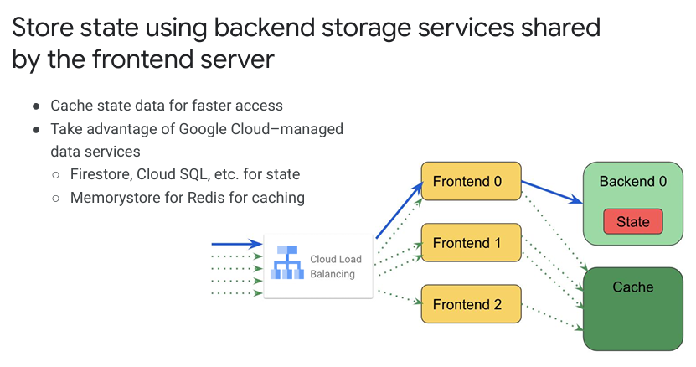

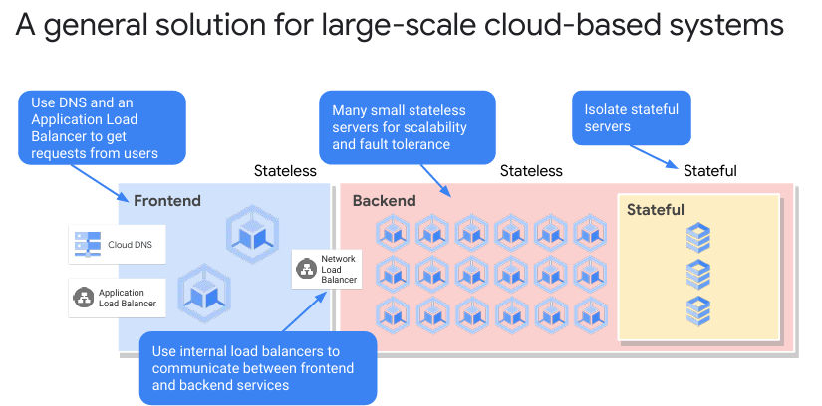

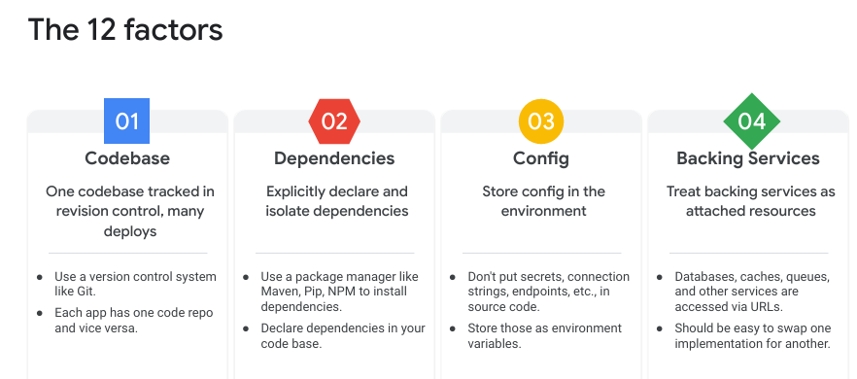
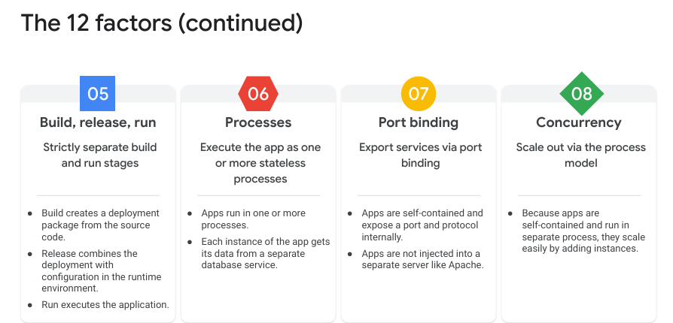

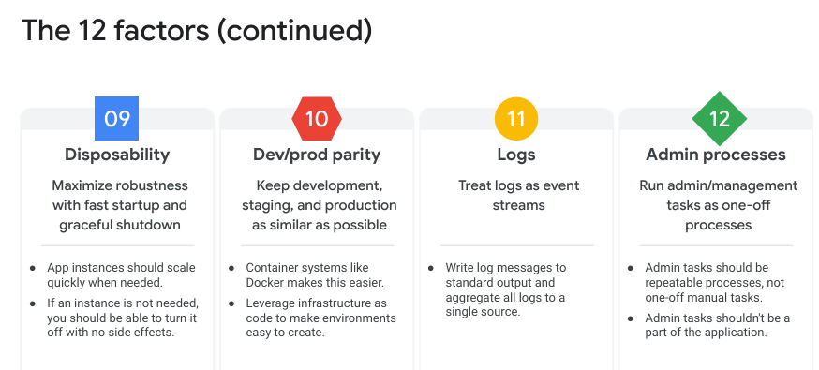

API’s
It’s important to design consistent APIs for services
● Each Google Cloud service exposes a REST API
Functions are in the form:
service.collection.verb
Parameters are passed either in the URL or in the request body in JSON format
● For example, the Compute Engine API has…
A service endpoint at: https://compute.googleapis.com
Collections include instances, instanceGroups, instanceTemplates, etc.
Verbs include insert, list, get, etc.
● So, to see all your instances, make a GET request to:
https://compute.googleapis.com/compute/v1/projects/{project}/zones/{zone}/instances
It is important to design consistent APIs for services

API design guide | Cloud API Design Guide | Google Cloud

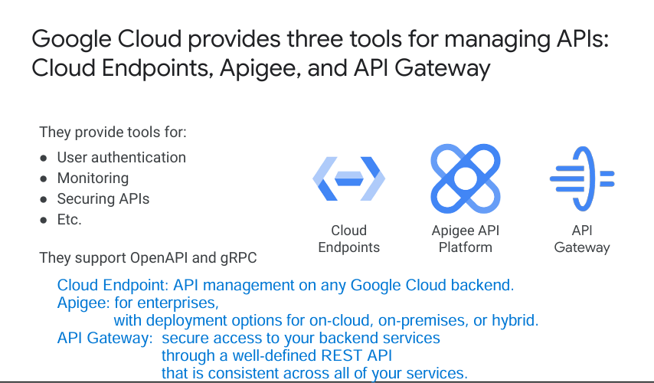

For a UI service, we might return HTML.
For backend service might return JSON or XML.

Choosing storage Solution

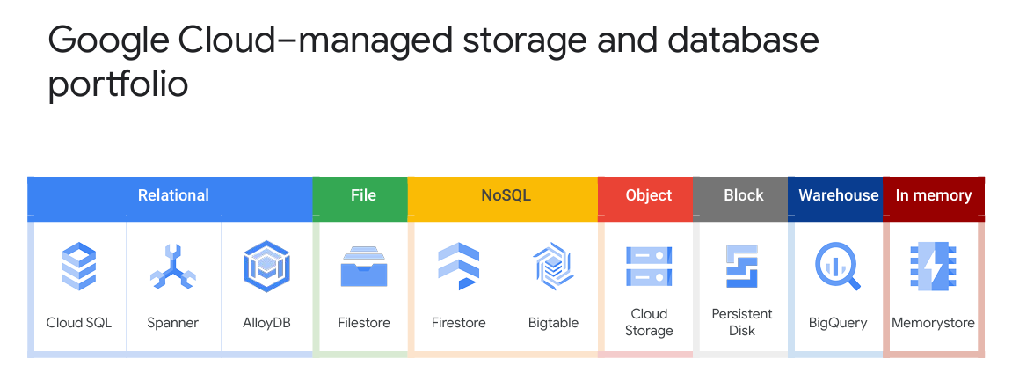

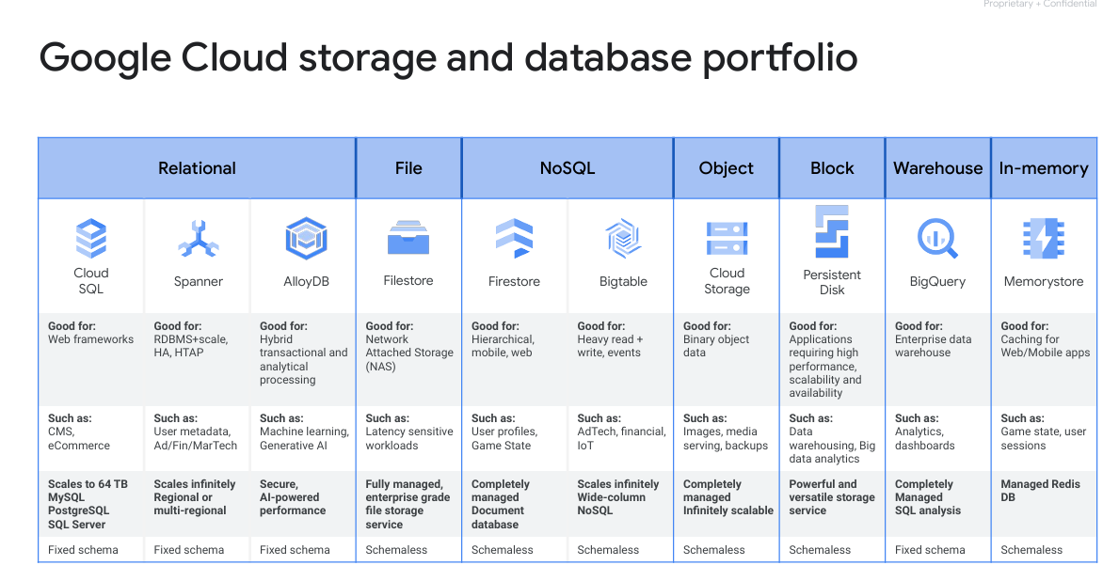

If I want
FINANCE (structured data) -> Spanner
WEB (structured data) -> Cloud SQL
AI & ML (structured data) -> Alloy DB
NAS -> FileStore
FIN (NO STRUCTURE) -> BigTable
Images (google images) -> Cloud Storage
Big Data Analytics -> Persistent Disk
Datawarehouse -> Big Query
Cache -> MemoryStore DB
CloudSQL can be implemented in ONLY in one (1) REGION

For a relational database with extremely high availability (99.999%) that must run uninterrupted even during a regional outage, the best option is:
✅ Google Cloud Spanner
- Global distribution → Can replicate across multiple regions.
- 99.999% SLA (Five 9’s Availability) → Ensures uptime even during regional failures.
- Strong consistency → ACID-compliant transactions.
- Auto-sharding & scaling → Handles massive workloads without downtime.

web application storage architecture
Firestore – NoSQL storage such as product data (being able to synchronize with client applications)
cloudSQL - structured relational data such as customer data and sales data
cloudstorage – images (backend will retrieve data)

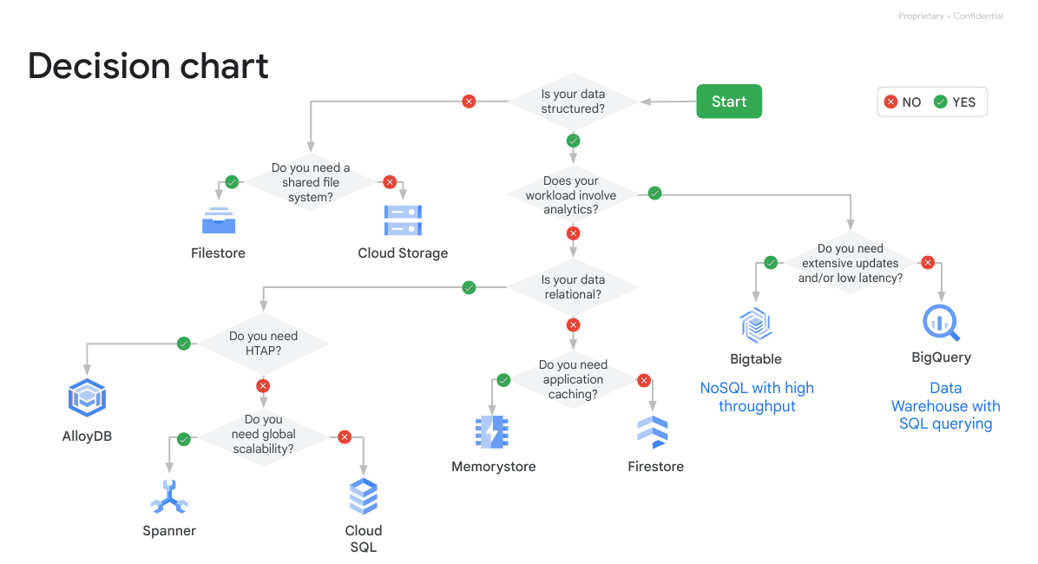

PRODUCT to use Firestore (like mongodb)
Product can be from many manufactors , each has its own attribute , (chees can be with lowerfat attribute, while other will write just the fat percentage), so , better to use like a document
Hence, product better to be kept as firestore DB and not structured db

Key Differences: Firestore vs. Cloud SQL
Feature | Firestore (NoSQL, Document DB) | Cloud SQL (SQL, Relational DB)
Data Model | Document-based (JSON-like) | Relational (Tables, Rows, Columns)
Scalability | Auto-scales globally | Vertical & Horizontal Scaling
Schema | Schema-less, flexible | Strict schema, predefined
Querying | Limited queries, no joins | SQL queries, complex joins
Transactions | Limited multi-document transactions | ACID-compliant transactions
Performance | Fast for key-value lookups | Optimized for structured queries
Real-time Sync | Yes, built-in | No, needs polling/webhooks
Replication | Multi-region, auto-managed | Regional & manual replication
Use Case | Web & mobile apps, flexible schema  (ike product) | Enterprise, structured apps  (like registered customer)

Questions:
1. You are a global financial services company with users all over the world. You need a database service that can provide low latency worldwide with strong consistency. Which service might you choose?
Firestore
BigQuery
Spanner - correct
Cloud SQL
Spanner - A key feature of Spanner is scale for relational data with strong consistency, and it is globally distributed to provide low latency. The high availability and automatic replication are also strong features for financial services.
- You need to store user preferences, product information, and reviews for a website you are building. There won't be a huge amount of data. What would be a simple, cost-effective, managed solution?
BigQuery.
Firestore - correct
Cloud SQL
Spanner
Firestore provides automatic scale ACID transactions and live synchronization and is integrated with Google Cloud and Firebase. It also has a free tier.

- You want to analyze sales trends. To help achieve this, you want to combine data from your on-premises Oracle database with Google Analytics data and your web server logs. Where might you store the data so it is both easy to query and cost-effective?
  - Spanner
  - Firestore
  - BigQuery - correct
  - Cloud SQL
BigQuery is a data warehouse used for data analytics, and so is built for this type of use case. It provides the infrastructure to ingest data from many different sources, which is a requirement too. The cost model of paying for storage and then only for queries run is attractive too.
- Currently, you are using Firestore to store information about products, reviews, and user sessions. You'd like to speed up data access in a simple, cost-effective way. What would you recommend?
  - Move the data to Spanner.
  - Cache the data using Memorystore. - correct
  - Move the data to BigQuery.
  - Move the data to Bigtable.
e best option for speeding up data access in a simple, cost-effective way while using Firestore is:
✅ Cache the data using Memorystore
- Memorystore (Redis or Memcached) provides an in-memory cache to reduce Firestore read latencies.
- Firestore bills per read operation, so caching frequent queries significantly reduces costs.
- Low-latency access (~sub-millisecond) for commonly accessed data.
- No schema changes or migration required—just add caching to existing Firestore queries.

Why Not the Other Options?
- ❌ Move the data to Spanner
  - Google Spanner is a globally distributed, high-availability database but is expensive and best for high-volume OLTP workloads.
  - Firestore is already scalable; Spanner is overkill for simple caching.
- ❌ Move the data to BigQuery
  - BigQuery is for analytics (OLAP), not fast transactional lookups.
  - Optimized for batch querying and aggregations, not low-latency real-time queries.
- ❌ Move the data to Bigtable
  - Bigtable is best for massive, time-series data (IoT, logs).
  - Not a direct replacement for Firestore; complex to migrate.

Final Recommendation: Use Memorystore (Redis)
- Cache frequently read Firestore data in Memorystore (Redis).
- Reduce Firestore reads, improving both performance and cost-efficiency.
- TTL (Time-to-Live) caching ensures data remains fresh without manual invalidation.
- Minimal changes required—just update the app to check Redis cache first, then fallback to Firestore.

W6 – Network

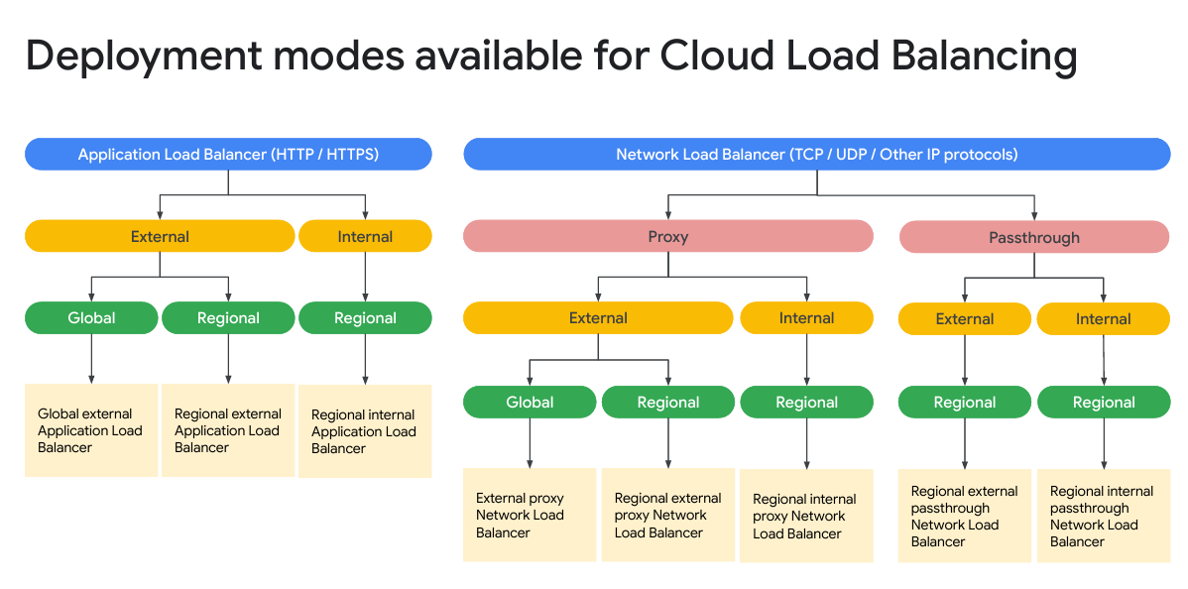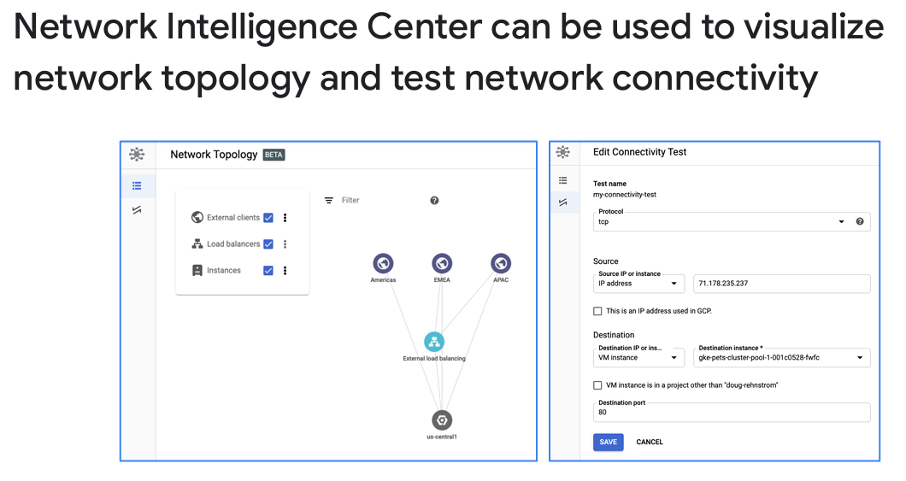

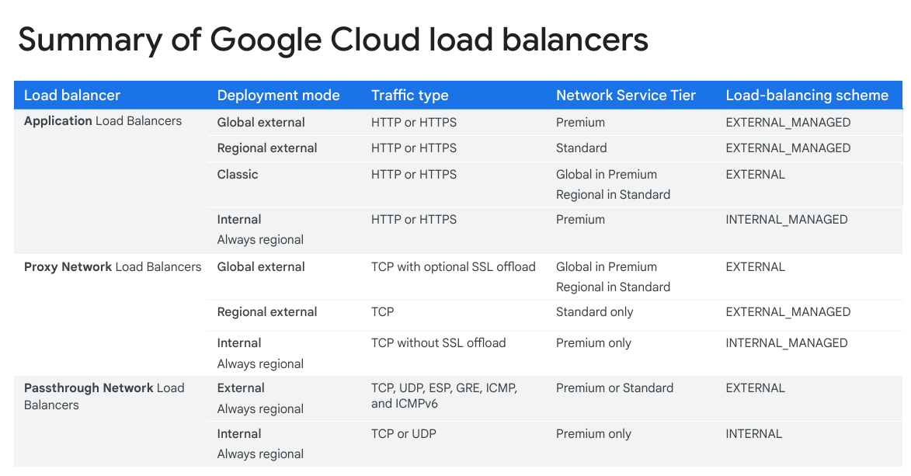

Network questions
You want a secure, private connection between your network and a Google Cloud network. There is not a lot of volume, but the connection needs to be extremely reliable. Which configuration below would you choose? VPN Cloud Interconnect VPN with high availability and Cloud Router. VPC peering

ChatGPT said:
ChatGPT
The best choice for a secure, private, reliable connection between your on-premises network and Google Cloud with low volume but high reliability is:

✅ VPN with High Availability and Cloud Router
- High-availability VPN (HA VPN) ensures 99.99% uptime, providing reliability and redundancy.
- Cloud Router dynamically exchanges BGP routes, ensuring optimal path selection and failover.
- Ideal for low-to-medium bandwidth needs with strong encryption (IPSec VPN).

Why Not the Other Options?
- ❌ VPN (Standard)
  - Standard VPN is not as reliable as HA VPN.
  - Single tunnel means no automatic failover.
  - Less suitable for mission-critical workloads.
- ❌ Cloud Interconnect
  - Provides higher bandwidth (10 Gbps or more) but requires expensive physical fiber connections.
  - Not cost-effective for low-volume traffic.
- ❌ VPC Peering
  - Used for connecting two VPCs within Google Cloud, not for connecting to an on-premises network.
  - Does not provide a private hybrid connection.

Final Recommendation:
Use VPN with High Availability + Cloud Router for: ✅ Reliable connectivity (99.99% uptime).
✅ Automatic failover in case of tunnel failure.
✅ Private, secure traffic with IPSec encryption.
✅ Dynamic routing using Cloud Router.
Would you like guidance on setting up HA VPN + Cloud Router? 🚀
4o

You said:
You have a contract with a service provider to manage your Google VPC networks. You want to connect a network they own to your VPC. Both networks are in Google Cloud. Which Connection option should you choose? VPN with high availability and Cloud Router. VPC peering Cloud Interconnect VPN

ChatGPT said:
ChatGPT
The best choice for connecting a service provider's network to your VPC within Google Cloud is:

✅ VPC Peering
- VPC Peering allows direct, private connectivity between two VPCs in Google Cloud.
- Low-latency, high-bandwidth connection with no additional cost for data transfer within the same region.
- Simple to configure and does not require external VPNs or physical links.
- Traffic stays within Google’s internal network, ensuring high performance and security.

Why Not the Other Options?
- ❌ VPN with High Availability and Cloud Router
  - Used for hybrid connections (connecting an on-prem network to GCP), not for two GCP VPCs.
  - Adds unnecessary encryption overhead for internal traffic.
- ❌ Cloud Interconnect
  - Used for on-premises to Google Cloud connections, requiring a physical link.
  - Not needed when both networks are inside GCP.
- ❌ VPN
  - Unnecessary complexity for VPC-to-VPC communication.
  - Higher latency due to encryption overhead.

Final Recommendation: Use VPC Peering
✅ Secure, private, and high-performance connection.
✅ No bandwidth bottlenecks (as with VPN).
✅ Low-cost (no extra egress charges within the same region).
✅ Simplifies management by using Google Cloud's internal networking.
Would you like assistance in configuring VPC Peering? 🚀
4o

You said:
You are a large bank deploying an online banking service to Google Cloud. The service needs high volume access to mainframe data on-premises. Which connectivity option would likely be most suitable? VPN Cloud Interconnect HTTPS Peering

Best Choice: ✅ Cloud Interconnect
For a large bank deploying an online banking service that requires high-volume access to on-premises mainframe data, the most suitable option is Cloud Interconnect.

Why Cloud Interconnect?
- Dedicated, High-Bandwidth Connection: Supports 10 Gbps or 100 Gbps links, making it ideal for high-volume banking transactions.
- Low Latency & High Reliability: Provides a direct, private connection between your data center and Google Cloud, ensuring minimal delays.
- More Secure than VPN: Since the traffic does not travel over the public internet, it's more secure and compliant with banking regulations (e.g., PCI DSS).
- Hybrid Cloud Flexibility: Perfect for banks that need real-time access to on-prem mainframe data from cloud-based applications.

Why Not the Other Options?
- ❌ VPN
  - Limited bandwidth (~3 Gbps per tunnel with HA VPN).
  - Higher latency due to internet routing.
  - Not ideal for high-volume banking transactions.
- ❌ HTTPS
  - HTTPS is an application-layer security protocol, not a network connectivity solution.
  - Does not provide direct on-prem to cloud connectivity.
- ❌ Peering
  - VPC Peering is for connecting two GCP networks, not for on-prem to cloud connectivity.
  - Direct Peering (Google’s peering service) requires a public IP and still relies on the internet.

Final Recommendation:
Use Cloud Interconnect for: ✅ Reliable, low-latency hybrid banking workloads.
✅ High security & compliance for banking regulations.
✅ Efficient, high-volume mainframe data access.
✅ Scalability for future banking service expansion.
Would you like help with setting up Cloud Interconnect for your bank? 🚀
4o

You said:
ou are deploying a large-scale web application with users all over the world and a lot of static content. Which load balancer configuration would likely be the most suitable? Network Load Balancer with SSL configured. close Network Load Balancer with SSL configured and the CDN enabled. Application Load Balancer with SSL configured and the CDN enabled. Application Load Balancer with SSL configured. This answer is not correct. The traffic type is not UDP.

ChatGPT said:
ChatGPT

Best Choice: ✅ Application Load Balancer with SSL configured and the CDN enabled
For a large-scale web application with global users and a lot of static content, the most suitable option is:

✅ Application Load Balancer (HTTP(S)) + SSL + Cloud CDN
- Application Load Balancer (ALB) is designed for HTTP(S) traffic, which is typical for web applications.
- Cloud CDN caches static content at Google’s global edge locations, reducing latency and offloading traffic from backend servers.
- SSL/TLS termination improves security and performance by handling encryption at the load balancer level.

Why Not the Other Options?
- ❌ Network Load Balancer with SSL configured
  - Network Load Balancers (NLBs) are for TCP/UDP traffic, not HTTP(S).
  - Does not support Cloud CDN, so static content delivery would be slow.
  - Not optimized for web applications.
- ❌ Network Load Balancer with SSL configured and the CDN enabled
  - Same issue as above: NLB is for lower-level TCP/UDP traffic, not layer 7 (HTTP/S).
  - Cloud CDN does not integrate with Network Load Balancer.
- ❌ Application Load Balancer with SSL configured (No CDN)
  - While ALB + SSL ensures secure and scalable application delivery, without Cloud CDN, static content (images, CSS, JavaScript, etc.) must be served directly from origin servers, increasing latency and backend load.

Final Recommendation:
Use Application Load Balancer (ALB) with SSL and Cloud CDN for: ✅ Global scalability & load balancing for HTTP(S) traffic.
✅ Faster content delivery via CDN edge locations.
✅ Secure connections with managed SSL certificates.
✅ Lower backend costs by caching static assets.
Would you like help setting up ALB + Cloud CDN on Google Cloud?

Deploying applications

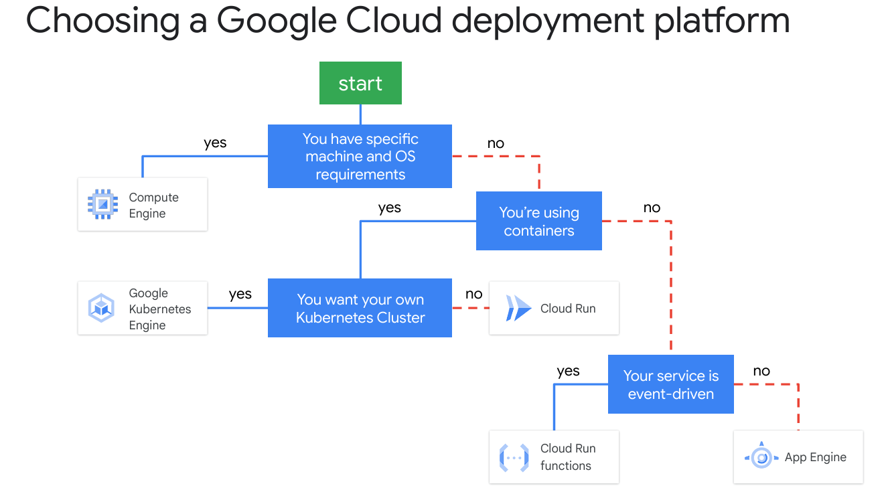

App engine
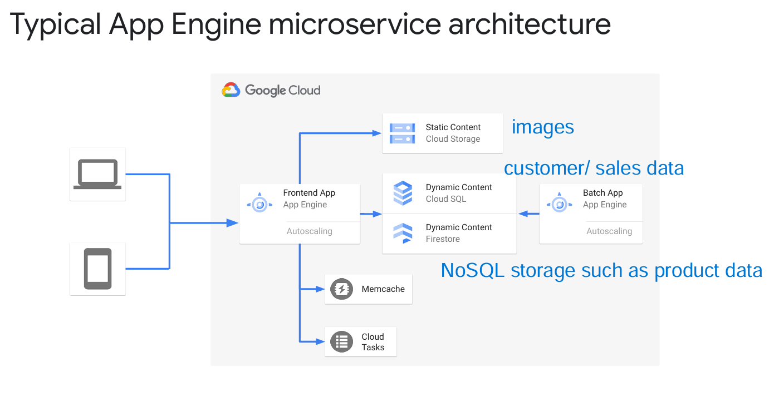
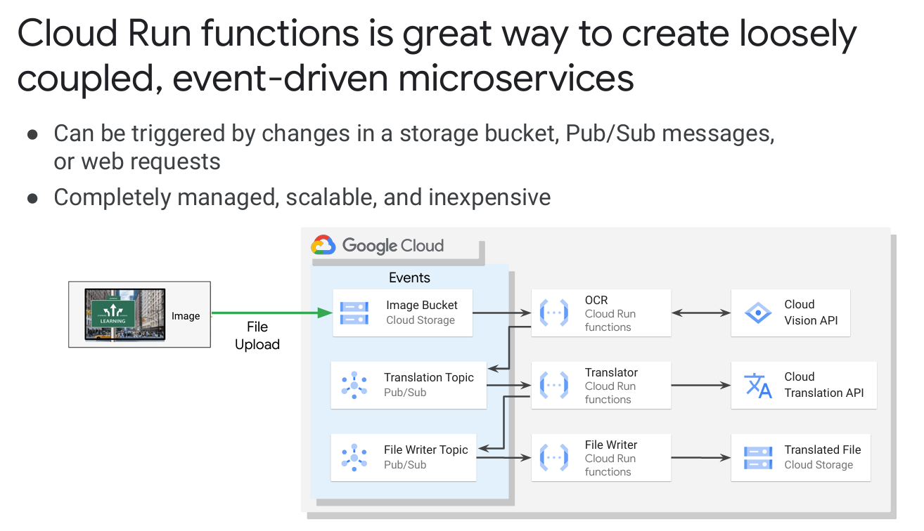

App Engine vs. Compute Engine: Key Differences
Both Google App Engine (GAE) and Google Compute Engine (GCE) are services that allow you to deploy applications, but they serve different purposes.
Feature | App Engine (GAE) | Compute Engine (GCE)
Type | Fully managed PaaS (Platform-as-a-Service) | IaaS (Infrastructure-as-a-Service)
Management | Google manages everything (serverless) | You manage the VM, OS, and configurations
Use Case | Web apps, APIs, serverless workloads | Custom applications, VMs, databases, legacy apps
Scaling | Auto-scales based on demand | Manual or auto-scaling for VMs
OS Control | No control over OS, runtime only | Full control over OS (Windows, Linux)
Customization | Limited to supported languages | Any software, any OS
Pricing | Pay-per-use (per request) | Pay for VM uptime
Best For | Web apps, REST APIs, microservices | Windows/Linux workloads, .NET apps, DBs

Designing Reliable Systems

concepts

Concept | Definition | Example GCP Services | Example Use Case
Availability | Ensures uptime & access | Load Balancer, Cloud SQL HA, GKE | Web app running in multiple regions
Durability | Ensures data is never lost | Cloud Storage, Snapshots, BigQuery | Backing up user files securely
Scalability | Handles growing traffic efficiently | Autoscaler, GKE, Cloud Run | E-commerce site handling Black Friday traffic

CloudSQL can be implemented in ONLY 1 REGION !!!!!

Security
Separation of duties
Prevention of conflicts of interests
Detection of control failure

For example, security breaches and information theft:
no one person can change or delete data without being detected.
Tools:
- Integrated firewall in your VPC network.
- Cloud Armor
- hardened versions of Linux
- secure boot
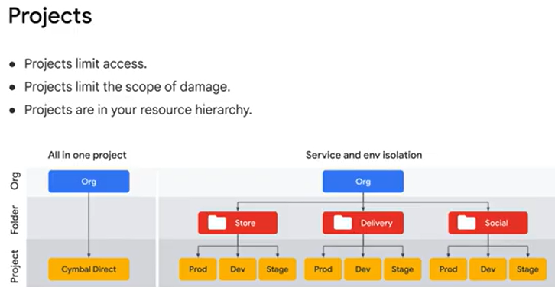

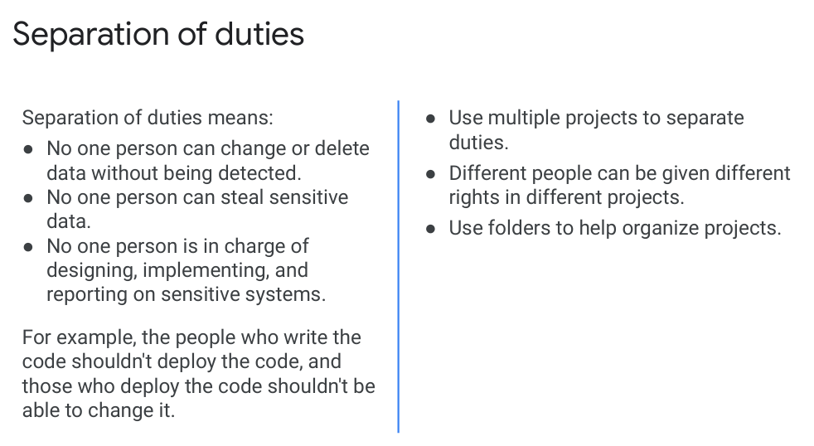

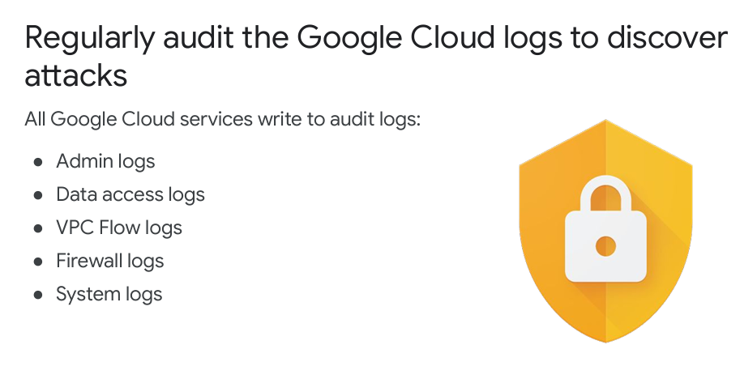
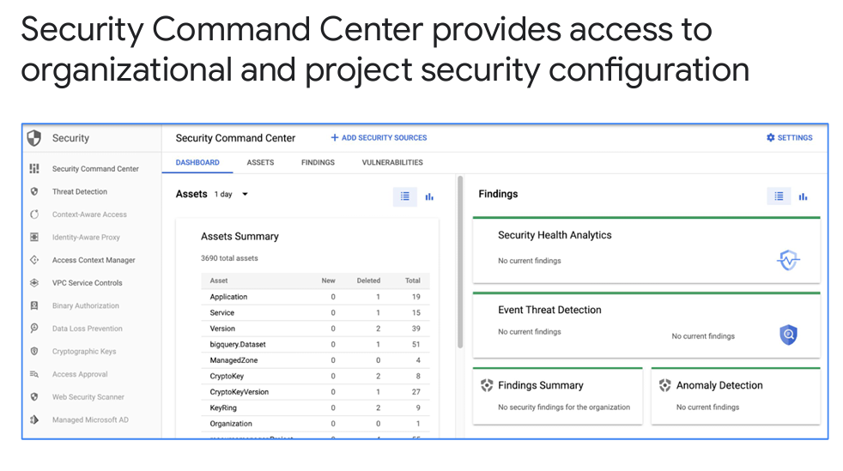
Grant people access: Project -> Member -> Roles
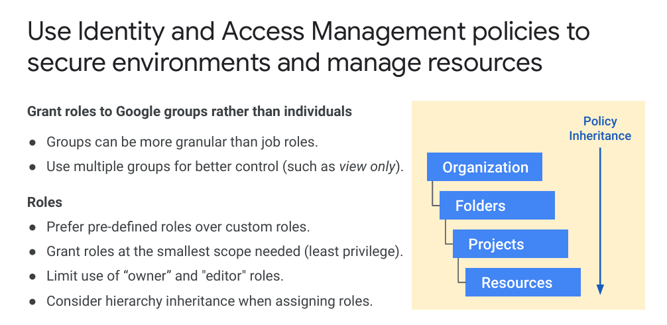
Cloud Identity-Aware Proxy (Cloud IAP)
is a zero-trust security service that controls user access to applications and services running on Google Cloud.
IAP sits in front of your application and ensures that only authenticated and authorized users can access it, regardless of whether it's deployed on App Engine, Compute Engine, GKE, or Cloud Run.

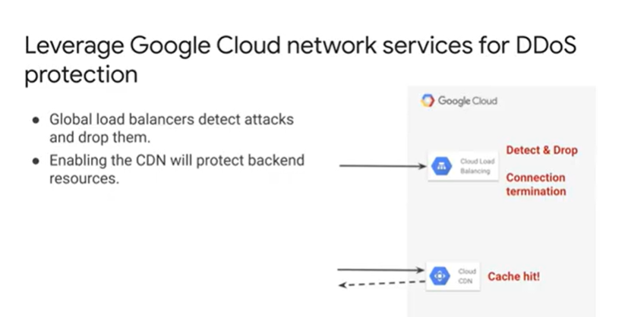
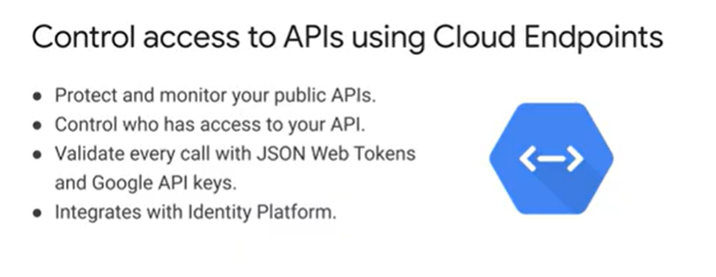

Google Cloud Armor - DDoS protection and Web Application Firewall (WAF) service
Google Cloud Armor is a DDoS protection and Web Application Firewall (WAF) service that helps secure applications from cyber threats, malicious traffic, and large-scale attacks.
🔹 It works with Google Cloud HTTP(S) Load Balancers to filter and block unwanted traffic before it reaches your backend services.

🔹 Key Features of Google Cloud Armor
✅ DDoS Protection → Defends against Layer 3 (network) & Layer 7 (application) attacks.
✅ Web Application Firewall (WAF) → Blocks SQL injection, XSS, and OWASP Top 10 threats.
✅ IP-Based Access Control → Allows or denies access based on IP address or geolocation.
✅ Adaptive Protection → Uses machine learning to detect and mitigate zero-day threats.
✅ Custom Security Policies → Define rules to allow, deny, or rate-limit requests.
✅ Real-Time Logging & Monitoring → Integrates with Cloud Logging & Security Command Center.

Cloud Armor vs. Other Security Solutions
Feature | Google Cloud Armor | Firewall Rules | Cloud IAP
DDoS Protection | ✅ Yes | ❌ No | ❌ No
WAF for Web Apps | ✅ Yes | ❌ No | ❌ No
IP/Geo-based Rules | ✅ Yes | ✅ Yes | ❌ No
User Identity Control | ❌ No | ❌ No | ✅ Yes
Integrates with HTTP(S) Load Balancer | ✅ Yes | ❌ No | ✅ Yes

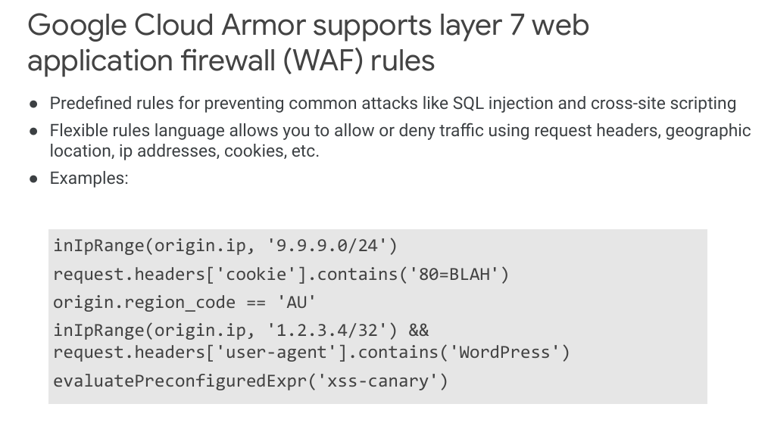

Encryption

DEK & KEK
Google Cloud follows a two-layer encryption model to protect your data:
1️⃣ Data Encryption Key (DEK) 🔑 → Encrypts the actual data using AES-256 (symmetric encryption).
2️⃣ Key Encryption Key (KEK) 🔐 → Encrypts the DEK itself for additional security.

How Each Feature Helps Against DDoS Attacks
Feature | How It Helps Mitigate DDoS?
✅ Google Cloud Armor | Primary DDoS defense → Detects and blocks large-scale attack traffic (L3/L4 DDoS, OWASP Top 10 threats).
✅ Global External Application Load Balancer | Absorbs high traffic loads and distributes requests across multiple backend instances.
✅ Cloud CDN | Reduces origin server load by caching static content, preventing exhaustion attacks on your backend.

You don't want programmers to have access to production resources. What's the easiest way to do this in Google Cloud?
Create a firewall rule that blocks developer access to production servers and databases.
checkCreate development and production projects, and don't give developers access to production.
Use different service accounts for production and development resources with your project.
Set up private access and Identity-Aware Proxy.
This is the correct answer, because the simplest way is to have separate projects and not give developers access to the production project.
check
2.
What Google Cloud service can you use to enforce the principle of least privilege when using Google Cloud?
Encryption keys
checkIAM members and roles
SSL certificates
Firewall rules
This is the correct answer, because the principle of least privilege requires user permissions that are just enough to do what they need, and no more. IAM provides this level of control.
check
3.
Which Google Cloud features could help reduce the risk of DDoS attacks?
Global external Application Load Balancer
checkAll of these
Google Cloud Armor
Cloud CDN
This answer is correct, because a global external Application Load Balancer mitigates and absorbs many layer 4 below attacks such as SYN flood, IP fragment floods, and port exhaustion. Cloud CDN caches cacheable content at points of presence close to users. In the event of a DDoS attack for cacheable content, the requests are sent to points of presence, not to your servers/infrastructures, thus increasing the likelihood of the attack being absorbed. Google Cloud Armor is built for DDos mitigation, working with Cloud Load Balancing to detect DDoS attacks.
check
4.
What do you have to do to enable encryption when using Cloud Storage?
Enable encryption and upload a key.
Check Nothing as encryption is enabled by default.
Create an encryption key using Cloud Key Management Service, and select it when creating a Cloud Storage bucket.
Simply enable encryption when configuring a bucket.
This answer is correct, because Cloud Storage always encrypts data on the server side before it is written to disk. For server side encryption there are options of customer supplied or customer managed encryption keys, but these are only usually used for compliance reasons and are not necessary.

Maintenance and Monitoring

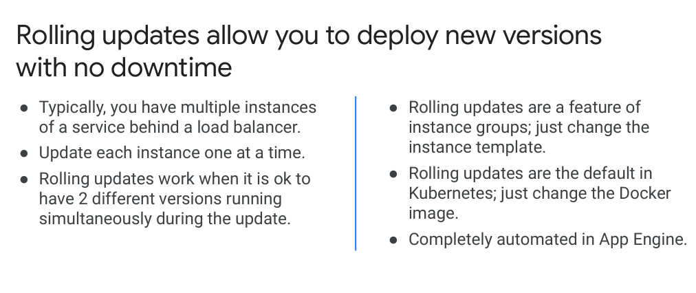
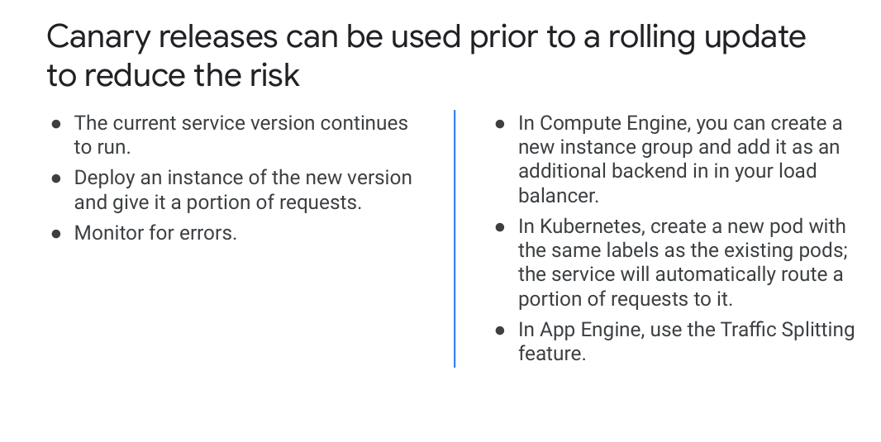
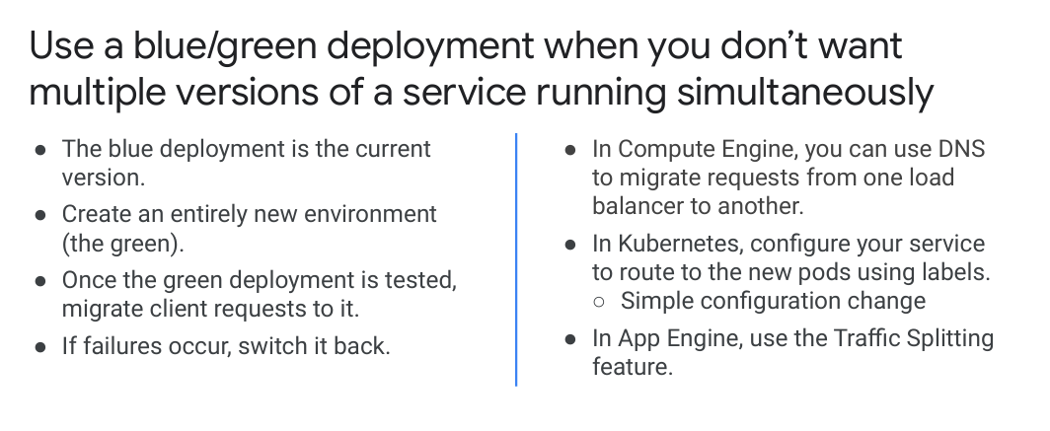
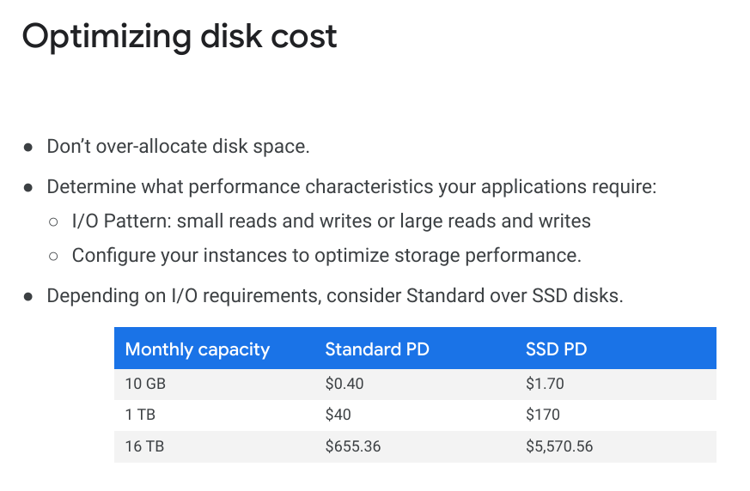
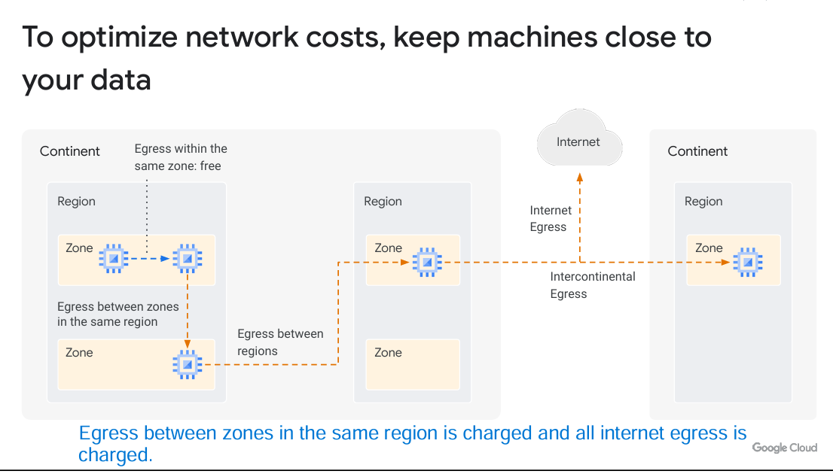

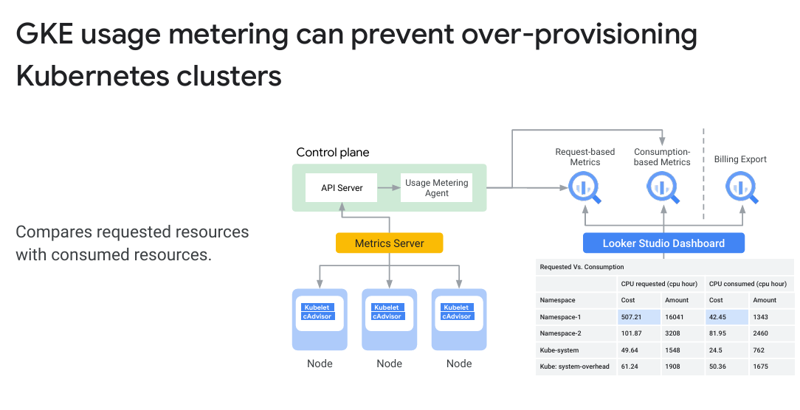

Terraform – W7
Lab: https://www.cloudskillsboost.google/course_templates/636/labs/464836
- Import existing infrastructure into your Terraform configuration.
- Build and reference your own Terraform modules.
- Add a remote backend to your configuration.
- Use and implement a module from the Terraform Registry.
- Re-provision, destroy, and update infrastructure.
- Test connectivity between the resources you've created.

Initial Configuration files
main.tf
variables.tf
modules/
└── instances
├── instances.tf
├── outputs.tf
└── variables.tf
└── storage
├── storage.tf
├── outputs.tf
└── variables.tf
Create structure – run commands:

variables.tf
variable "project_id" {
description = "The ID of the project to create the bucket in."
type = string
default = ""
}
variable "region" {
description = "The region of the project."
type = string
default = "us-central1"
}
variable "zone" {
description = "The zone of the project."
type = string
default = "us-central1-f"
}
main.tf – Adding provider
terraform {
required_providers {
google = {
source = "hashicorp/google"
version = ">= 4.64.0, < 6.0.0" }
}
required_version = ">= 1.0.0"
}

provider "google" {
project = var.project_id
region = var.region
zone = var.zone
}

Import infrastructure –
create in console 2 VM’s - tf-instance-1 and tf-instance-2
import these 2 vms to terraform module – here
Add the module reference into the main.tf
Create structure
cd ~
mkdir -p ~/modules/instances
mkdir -p ~/modules/storage
cd ~/modules/instances
touch instances.tf outputs.tf variables.tf
cd ~/modules/storage
touch storage.tf outputs.tf variables.tf

Adding in main.tf (project root)
module "instances" {
source = "./modules/instances"
zone = var.zone
}
module " storage" {
source = "./modules/ storage"

name = var.name
project_id = var.project_id
region = var.region
zone = var.zone
}

Initiate after modules:
Run command: terraform init

Import 2 instances to existing modules
Update template with the existing VM’s
Google reference here
Add resources in file: ~/modules/instances/instances.tf
resource "google_compute_instance" "tf-instance-1" {
name = "tf-instance-1"
machine_type = "e2-micro"
zone = var.zone

tags = ["generated", "terraform"]

boot_disk {
initialize_params {
image = "debian-11-bullseye-v20250123"
labels = {
my_label = "value"
}
}
}

network_interface {
network = "default"
}

metadata_startup_script = <<-EOT
#!/bin/bash
EOT
allow_stopping_for_update = true

}

Run command: terraform import to the State

terraform import module.instances.google_compute_instance.tf-instance-1 projects/qwiklabs-gcp-04-95e26805f4df/zones/us-east1-d/instances/tf-instance-1
module.instances.google_compute_instance.tf-instance-1: Importing from ID "projects/qwiklabs-gcp-04-95e26805f4df/zones/us-east1-d/instances/tf-instance-1"...
module.instances.google_compute_instance.tf-instance-1: Import prepared!
Prepared google_compute_instance for import
module.instances.google_compute_instance.tf-instance-1: Refreshing state... [id=projects/qwiklabs-gcp-04-95e26805f4df/zones/us-east1-d/instances/tf-instance-1]

Import successful!

The resources that were imported are shown above. These resources are now in
your Terraform state and will henceforth be managed by Terraform.

student_04_0b3586da56c8@cloudshell:~ (qwiklabs-gcp-04-95e26805f4df)$ terraform import module.instances.google_compute_instance.tf-instance-2 projects/qwiklabs-gcp-04-95e26805f4df/z
ones/us-east1-d/instances/tf-instance-2
module.instances.google_compute_instance.tf-instance-2: Importing from ID "projects/qwiklabs-gcp-04-95e26805f4df/zones/us-east1-d/instances/tf-instance-2"...
module.instances.google_compute_instance.tf-instance-2: Import prepared!
Prepared google_compute_instance for import
module.instances.google_compute_instance.tf-instance-2: Refreshing state... [id=projects/qwiklabs-gcp-04-95e26805f4df/zones/us-east1-d/instances/tf-instance-2]

Import successful!

The resources that were imported are shown above. These resources are now in
your Terraform state and will henceforth be managed by Terraform.

Summarize: | Action

1 | Run terraform import to add the VM to Terraform state.

2 | Run terraform plan to detect differences.

3 | Use gcloud compute instances describe to get missing attributes.

4 | Manually update instances.tf with the correct attributes.

5 | Run terraform apply to align Terraform with the imported VM.

Task 3. Configure a remote backend
Add bucket resource in storage.tf – reference: here
In storage/main.tf – use attributes:
- location = "US"
- force_destroy = true
- uniform_bucket_level_access = true

cat modules/storage/storage.tf
resource "google_storage_bucket" "bucket-for-state" {
name = var.storage_name
location = "US"
uniform_bucket_level_access = true
}student_01_6892095d335f@cloudshell:~ (qwiklabs-gcp-01-7fd624ea2f41)$ cat modules/storage/variables.tf
variable "storage_name" {
description = "Storage name"
type = string
}student_01_6892095d335f@cloudshell:~ (qwiklabs-gcp-01-7fd624ea2f41)$ tail variables.tf
variable "zone" {
description = "The zone of the project."
type = string
default = "us-east4-a"
}
variable "storage_name" {
description = "Storage name"
type = string
default = "tf-bucket-070479"
}

Configure this storage bucket as the remote backend inside the main.tf file. Be sure to use the prefix terraform/state
Add in main.tf:
terraform {
backend "gcs" {
bucket = "tf-bucket-070479"
prefix = "terraform/state"
}
}
# terraform {
# backend "local" {
# path = "terraform/state/terraform.tfstate"
# }
# }

Adding output:
In file ~/modules/instances/outputs.tf
output "instance_id" {
description = "The ID of the created VM instance"
value = google_compute_instance.tf-instance-1.id
}

output "instance_name" {
description = "The name of the VM instance"
value = google_compute_instance.tf-instance-1.name
}

output "instance_zone" {
description = "The zone where the VM instance is deployed"
value = google_compute_instance.tf-instance-1.zone
}

output "instance_external_ip" {
description = "The external IP address of the VM instance"
value = google_compute_instance.tf-instance-1.network_interface[0].access_config[0].nat_ip
}

output "instance_internal_ip" {
description = "The internal IP address of the VM instance"
value = google_compute_instance.tf-instance-1.network_interface[0].network_ip
}

Reference Outputs in main.tf Root Module
module "instances" {
source = "./modules/instances"
region = var.region
zone = var.zone
}

module "storage" {
source = "./modules/storage"
project_id = var.project_id
}

output "vm_name" {
value = module.instances.instance_name
}

output "vm_ip" {
value = module.instances.instance_external_ip
}

output "bucket_url" {
value = module.storage.bucket_url
}

Use a module from the Registry – Create Firewall and attach to the network

cat main.tf
terraform {
required_providers {
google = {
source = "hashicorp/google"
version = ">= 4.64.0, < 6.0.0" }
}
required_version = ">= 1.0.0"

backend "gcs" {
bucket = "tf-bucket-675385" # Replace with your actual GCS bucket name
prefix = "terraform/state" # Required prefix for grading
}

}

provider "google" {
project = var.project_id
region = var.region
zone = var.zone
}

module "instances" {

source = "./modules/instances"

}

module "storage" {

source = "./modules/storage"

}

module "network" {

source = "terraform-google-modules/network/google"

version = "7.5.0"

project_id = var.project_id

network_name = "tf-vpc-528386"

routing_mode = "GLOBAL"

subnets = [

{

subnet_name = "subnet-01"

subnet_ip = "10.10.10.0/24"

subnet_region = "us-east1"

},

{

subnet_name = "subnet-02"

subnet_ip = "10.10.20.0/24"

subnet_region = "us-east1"

}

]

}

resource "google_compute_firewall" "tf-firewall" {

name = "tf-firewall"

network = "tf-vpc-528386"

allow {

protocol = "tcp"

ports = ["80"]

}

source_ranges = ["0.0.0.0/0"]

}
student_04_0b3586da56c8@cloudshell:~ (qwiklabs-gcp-04-95e26805f4df)$

cat modules/instances/instances.tf
resource "google_compute_instance" "tf-instance-1" {
name = "tf-instance-1"
machine_type = "e2-standard-2"
zone = var.zone

tags = ["generated", "terraform"]

boot_disk {
initialize_params {
image = "debian-11-bullseye-v20250123"
labels = {
my_label = "value"
}
}
}

network_interface {
network = "tf-vpc-528386"
subnetwork = "subnet-01" # Connect to subnet-01
}

metadata_startup_script = <<-EOT
#!/bin/bash
EOT
allow_stopping_for_update = true

}
resource "google_compute_instance" "tf-instance-2" {
name = "tf-instance-2"
machine_type = "e2-standard-2"
zone = var.zone

tags = ["generated", "terraform"]

boot_disk {
initialize_params {
image = "debian-11-bullseye-v20250123"
labels = {
my_label = "value"
}
}
}

network_interface {
network = "tf-vpc-528386"
subnetwork = "subnet-02"
}

metadata_startup_script = <<-EOT
#!/bin/bash
EOT
allow_stopping_for_update = true

}

student_04_0b3586da56c8@cloudshell:~ (qwiklabs-gcp-04-95e26805f4df)$

cat modules/storage/storage.tf
resource "google_storage_bucket" "bucket-for-state" {
name = var.storage_name
location = "US"
uniform_bucket_level_access = true
}

student_04_0b3586da56c8@cloudshell:~ (qwiklabs-gcp-04-95e26805f4df)$ cat modules/instances/variables.tf
variable "project_id" {
description = "The ID of the project to create the bucket in."
type = string
default = "qwiklabs-gcp-04-95e26805f4df"
}
variable "region" {
description = "The region of the project."
type = string
default = "us-east1"
}
variable "zone" {
description = "The zone of the project."
type = string
default = "us-east1-d"
}

resource "google_storage_bucket" "terraform_state" {
name = "tf-bucket-675385"
location = var.location
force_destroy = var.force_destroy
uniform_bucket_level_access = var.uniform_bucket_level_access
}

W8 – EKS

What is cloud
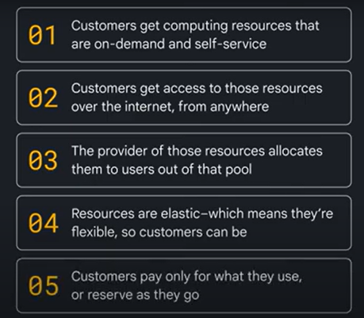

Computing services
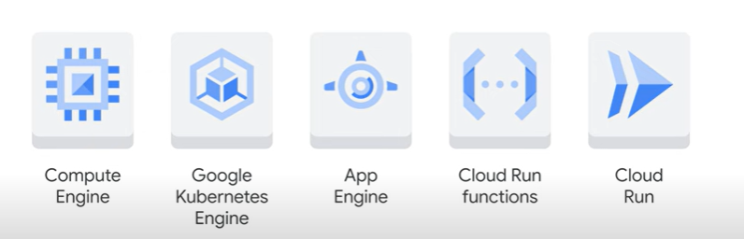

Compute Engine
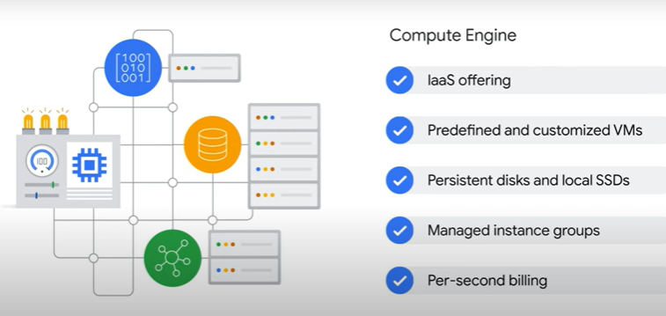

App Engine – PaaS mainly for web app

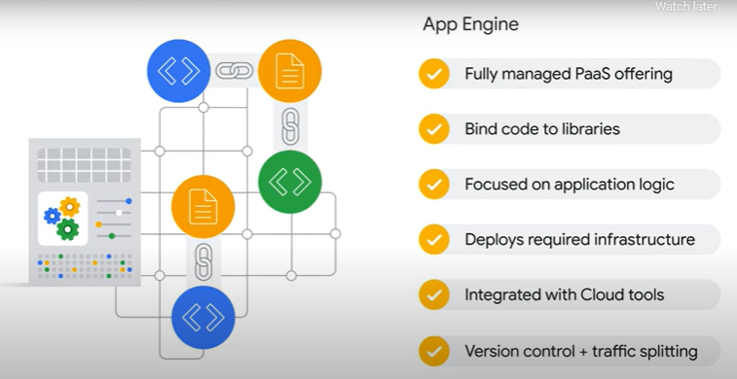

Cloud Run – container based
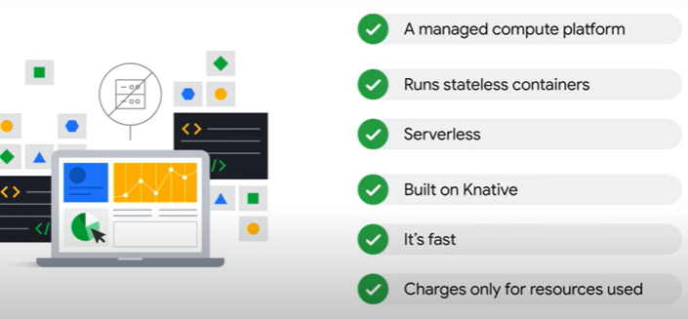

Feature | Cloud Run – Container based | App Engine – PaaS mainly for web dev
Deployment Model | Containerized workloads (Docker containers) | PaaS (Platform-as-a-Service) for web apps
Runtime Environment | Any runtime, as long as it runs in a container | Standard (predefined runtimes) & Flexible (custom runtimes)
Scaling | Scales to zero, automatically scales up based on traffic | Standard: scales to zero, automatic scaling; Flexible: VM-based, slower scaling
Traffic Splitting | Supports traffic splitting | Supports traffic splitting
Customization | Full control over dependencies | Limited in Standard, more flexible in Flexible
Networking | Fully private networking via VPC connectors | Standard: restricted networking, Flexible: VPC integration
Pricing | Pay-per-use (per request and execution time) | Standard: Pay-per-use, Flexible: VM-based pricing
Use Case | Best for APIs, microservices, event-driven workloads | Best for web applications with automatic scaling
Vendor Lock-in | Low (standard containers can run anywhere) | Higher (Standard runs only on GCP)
DevOps Integration | Works well with CI/CD pipelines (Cloud Build, GitHub Actions, Jenkins) | Limited in Standard, better in Flexible

Security Responsibilities
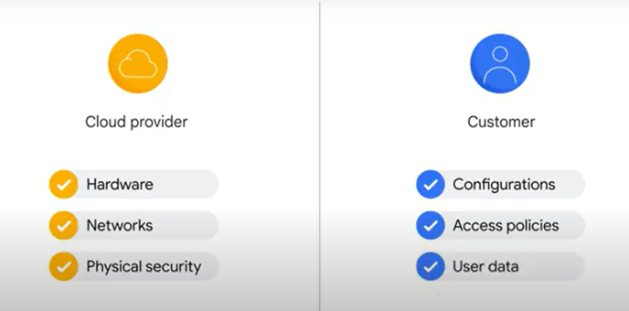

Billing
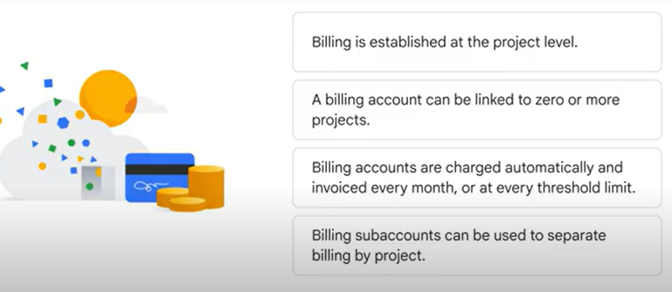

Budget : helps you monitor and control spending once you're using Google Cloud.
a fixed limit, or it can be tied to another metric; for example, a percentage of the previous month’s spend.
Quote helps you predict costs before deploying resources.

Quote
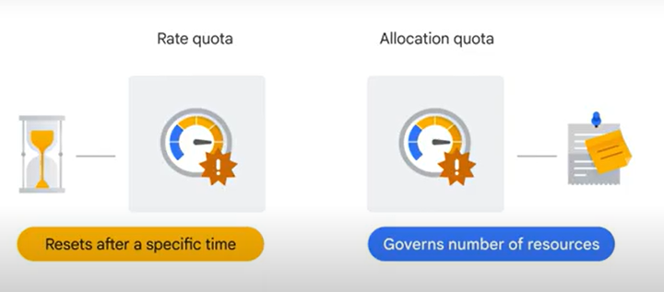

K8S – GKE

K8S object:
A Kubernetes object is defined as a persistent entity that represents the state of something running in a cluster: its desired state and its current state.
Various kinds of objects represent:
containerized applications, the resources available to them, and the policies that affect their behavior.
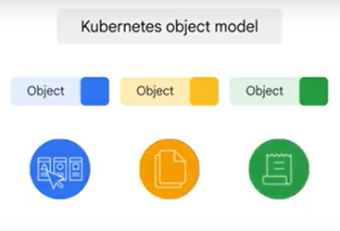
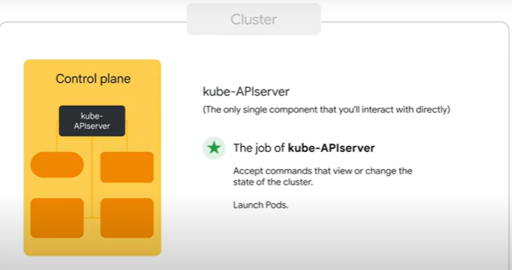
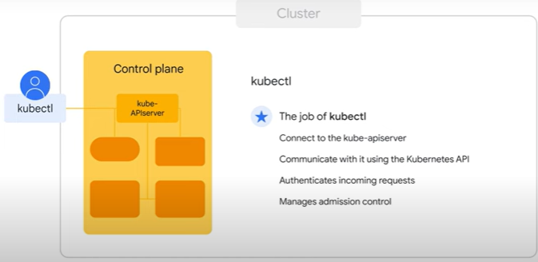
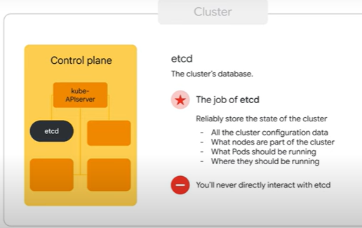
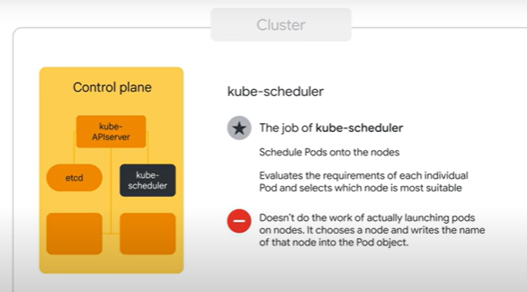
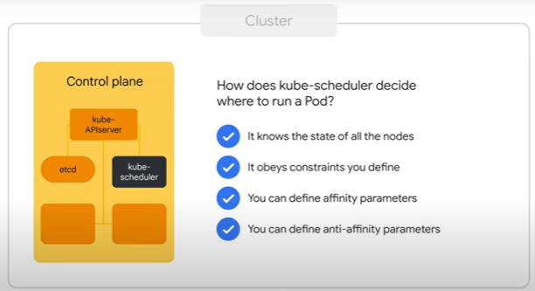
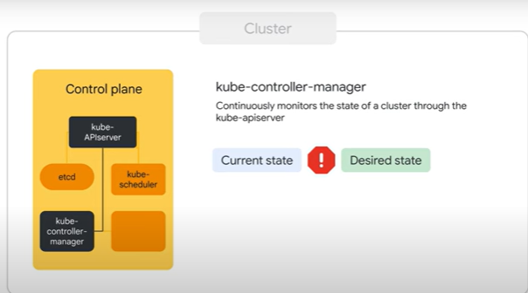
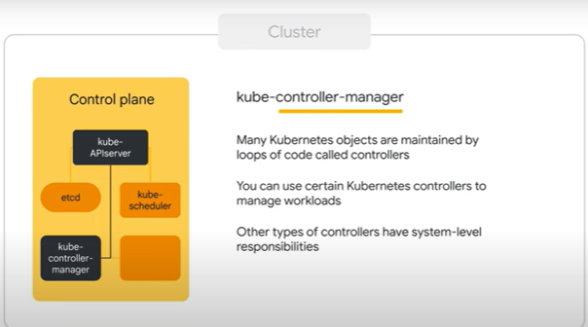
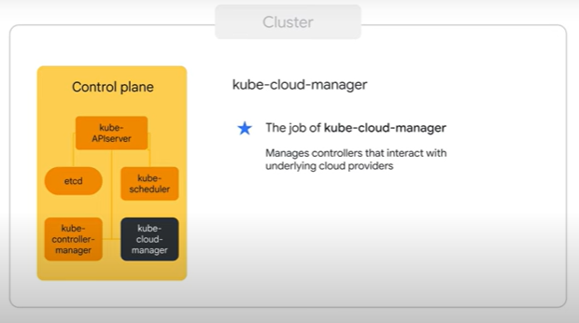

GKE Autopilot
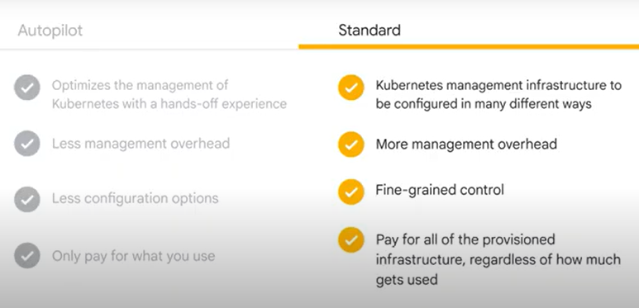

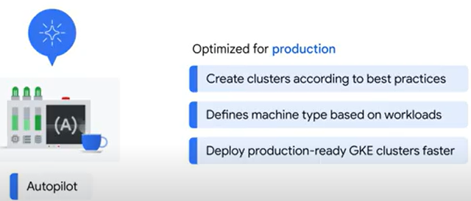
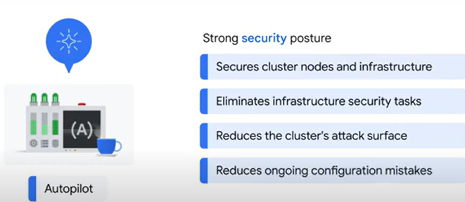
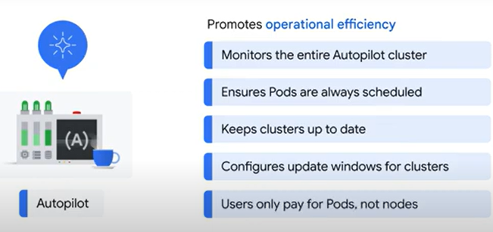
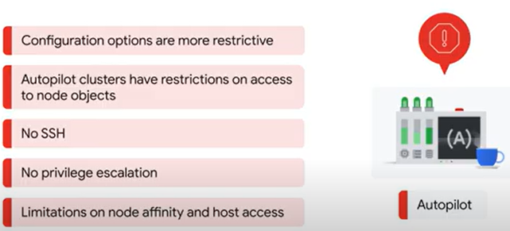

PODS etc.
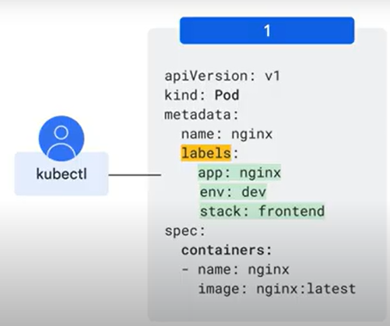

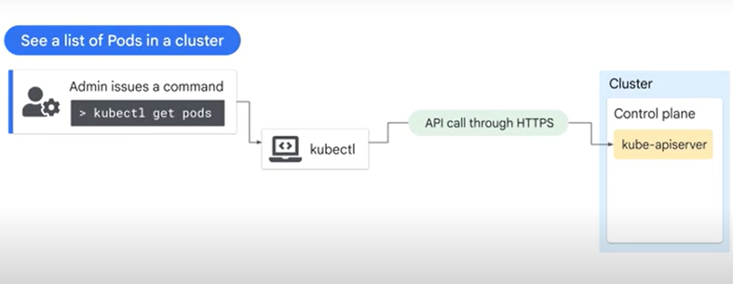
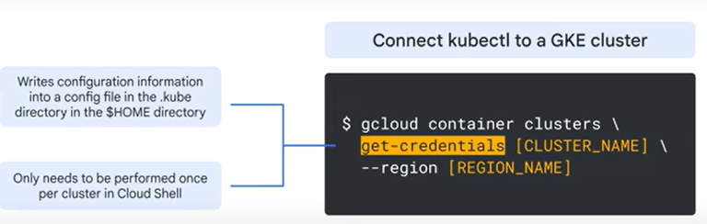
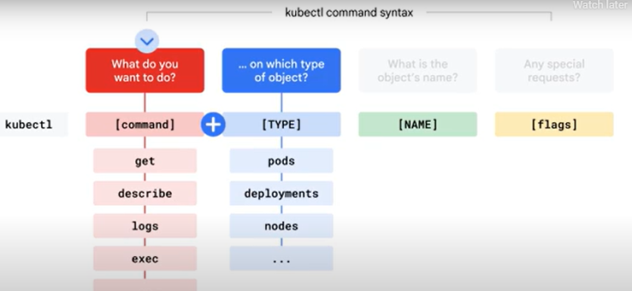
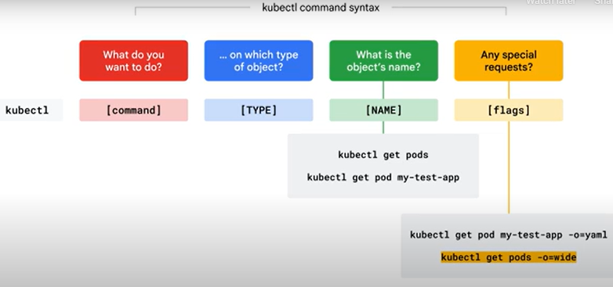

Introspection - how to debug problems when an application is running
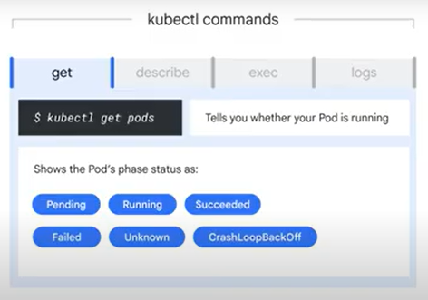
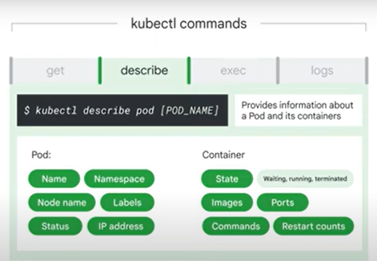

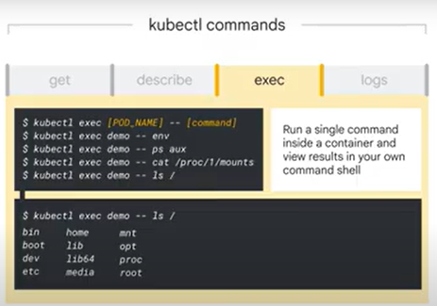
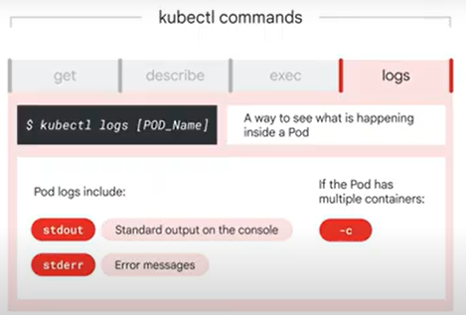

Logging and Monitoring
3 parts
- Cloud Logging
- Cloud Monitoring
- APM

Cloud Logging collects and stores all of your application logs
Cloud Monitoring collects metrics and traces -> track applications performance & identify bottlenecks.
APM provides a unified view of your application's performance -> quickly identify & fix problems.

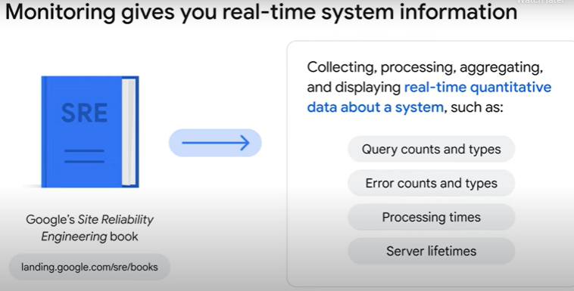

4 signals:
- Latency - measures how long it takes a particular part of a system to return a result (affect UI)
- Traffic - how many requests are reaching your system
- Saturation - indicator of current system demand (how full the service is) -
- Errors

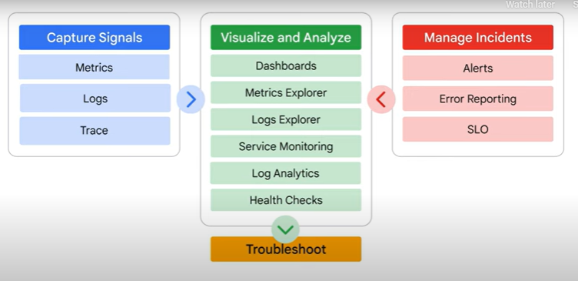

Tools
Trace: Best for latency issues and tracking request flows, but not directly for debugging data corruption.
Error Reporting: Detects and aggregates errors, but garbage data may not trigger an exception.
Profiler: Used for performance bottlenecks and CPU/memory profiling, not debugging functional issues.

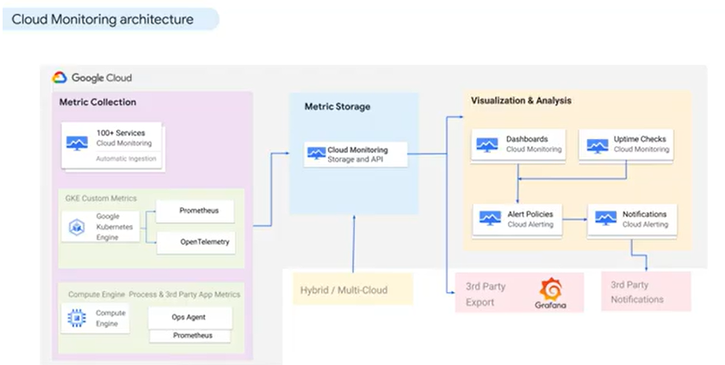
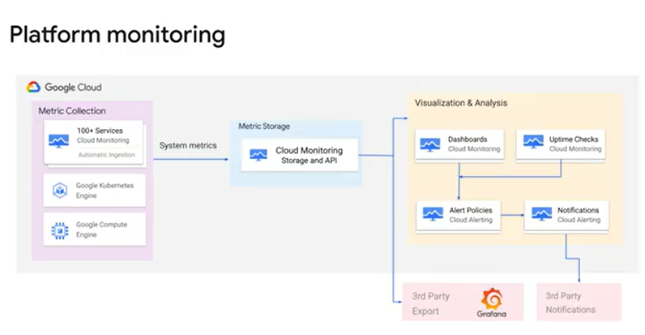
Google Cloud Monitoring is the recommended solution for Platform monitoring.
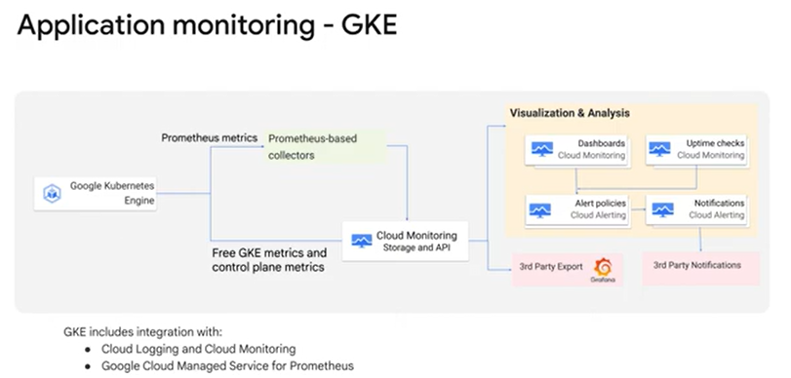
For application workloads in GKE, we recommend that customers use Google Managed Prometheus.
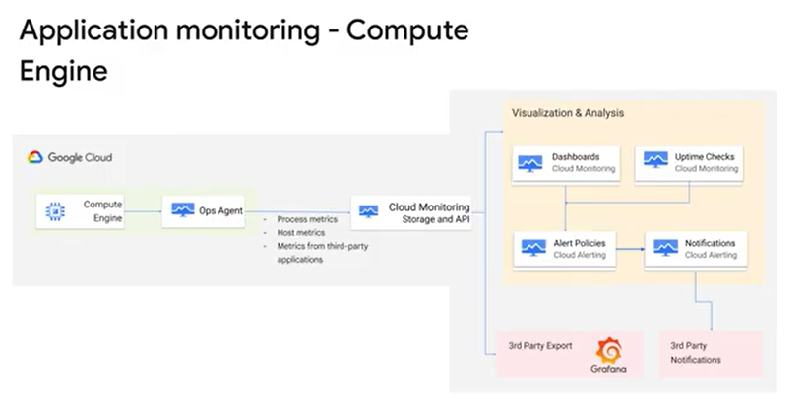
For applications or workloads deployed in Compute Engine, customers should use the Ops Agent
Other 3rd parties like NewRelic OR DataDog
they can collect system metrics using native API-based integrations With Google's partner BindPlane by Blue Medora,

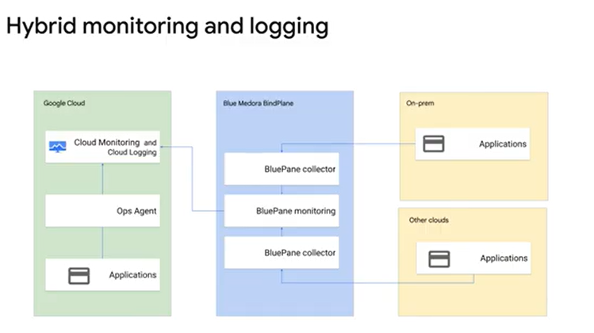
There are no additional licensing costs for using BindPlane

Cloud monitoring

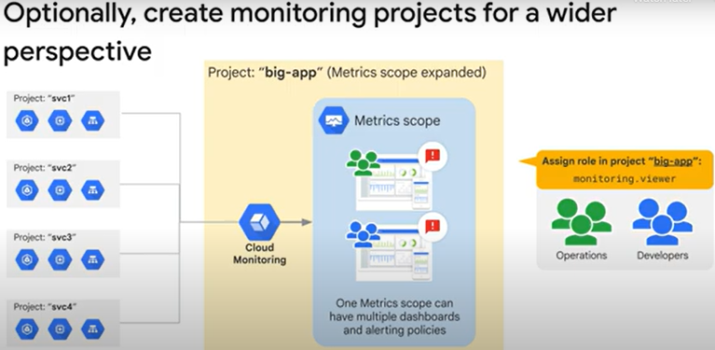

Best practice for production deployments is
create a dedicated project to host monitoring configuration data
use its metrics scope to set up monitoring for the projects that have resources.
Advantage:
  - should a project not be necessary anymore and get deleted, the monitoring configuration for all the other projects won't be impacted.
  - provides a single pane of glass
Disadvantage:
  - Anyone with IAM permissions to access Cloud Monitoring will be able to see metrics for all environments.
  - Does not preserve separation of teams in production.
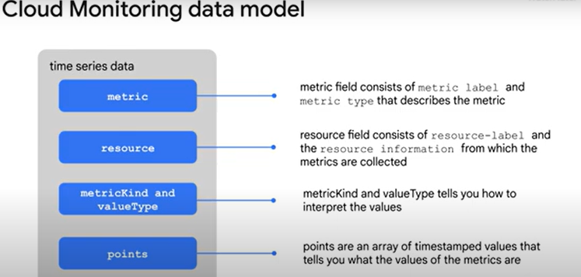

SLI = Service Level Indicator: monitoring metrics that measure one aspect of a service's reliability. - Metric
SLO: combines SLI with a target reliability. (Does it matter to the user?) - Thresholds
SLA: minimum levels of service that you promise to provide to your customers and what happens when you break that promise. - contract
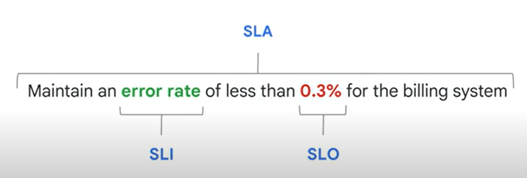
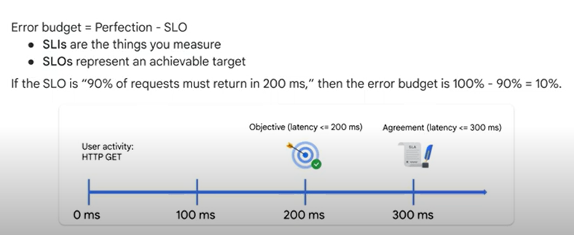

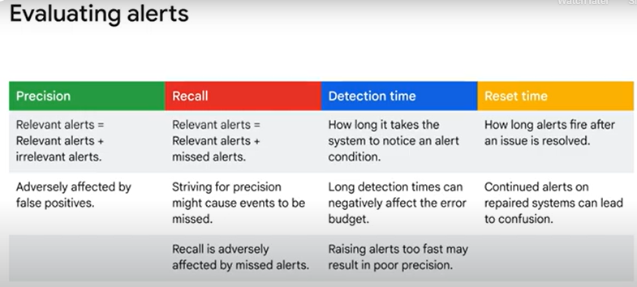
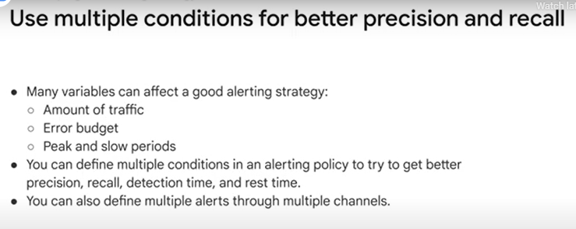

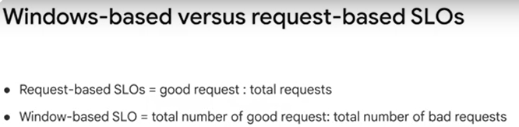

Precision in Alerting - how many of the alerts actually indicate real problems
- Definition: Precision measures how many of the alerts actually indicate real problems (i.e., true positives).
- Formula:
Precision= True Positives (alerts detected)
----------------------------------------
True Positives + False Positives (relevant and irrelevant alerts)
​Impact:
  - High Precision (Good): Most alerts are actionable; engineers trust the system.
  - Low Precision (Bad): Many false alarms; engineers start ignoring alerts (alert fatigue).

Error Budget
- Definition: An error budget is the allowable amount of downtime or failures a service can have within a specific period while still meeting its Service Level Objectives (SLOs).
- Formula:
Error Budget = 1−SLO Target
If your SLO is 99.9% availability, the error budget is 0.1% downtime per month (~43.2 minutes).
- Purpose:
  - It helps balance reliability and feature development.
  - If the service exceeds its error budget, development must slow down until stability improves.
  - If the service is well within its error budget, teams can take more risks (e.g., deploy new features).

Burn Rate
- Definition: Burn rate measures how quickly your service consumes its error budget.
- Formula:
Burn Rate= Allowed Error Budget Rate
-------------------------------------
Error Rate
​

  - Burn Rate = 1 → Consuming the budget exactly on pace.
  - Burn Rate > 1 → Consuming the budget too fast.
  - Burn Rate < 1 → Consuming the budget slowly (safe zone).

Recall - captures actual incidents
measures how well an alerting system captures actual incidents, ensuring that real problems are detected. It is defined as:

Recall = True Positives (alerts detected)
--------------------------------
True Positives + False Negatives (relevant alerts and missed alerts)
​
Where:
- True Positives (TP): Correctly detected incidents.
- False Negatives (FN): Real incidents that were missed.
Thus, recall focuses on how many real issues are caught versus those that go unnoticed.

Precision vs. Recall Trade-off
Metric | Focus | Impact of Low Value | How to Improve
Precision | Avoiding false alerts | Too many false positives (alert fatigue) | Adjust thresholds, use multi-condition alerts
Recall | Catching all real incidents | Too many false negatives (missed incidents) | Lower alert thresholds, use redundant monitoring
- High Precision, Low Recall → Fewer alerts, but may miss incidents.
- High Recall, Low Precision → Many alerts, but lots of false alarms.

Questions on monitor
eck
- In the statement “Maintain an error rate of less than 0.3% for the billing system”, what is an SLI?
Less than 0.3%
0.3%
checkError rate - correct
Billing system

- In evaluating your alerting policies, which below best describes precision?
The proportion of events detected that were significant. - Correct
How long it takes to send notifications in various conditions.
How long alerts take to be acknowledged.
How long alerts fire after an issue is resolved.
- Explain error budget.
How long alerts fire after an issue is resolved.
How long it takes to send notifications in various conditions.
The proportion of alerts detected that were relevant to the sum of relevant and irrelevant alerts.
The proportion of alerts detected that were relevant to the sum of relevant alerts and missed alerts. - Correct

LOGS
Types
Platform logs –
Example: VPC Flow Logs record a sample of network flows sent from / received by VM’s.
Component logs –
Example: GKE provides software components
that users can run on their own VM or in their own data center
Security logs - "who did what, where, and when."
Cloud Audit Logs - information about administrative activities
and accesses within your Google Cloud resource
User-written logs - written to Cloud Logging by using Ops Agent (on the VM)
or Cloud Logging API
or Cloud Logging client libraries
Examples:
GKE or Container-Optimized OS, the agents automatically collect logs from stdout and stderr
VMs - the agents collect logs from known file locations or logging services like the Windows Event Log, journald, or syslogd.

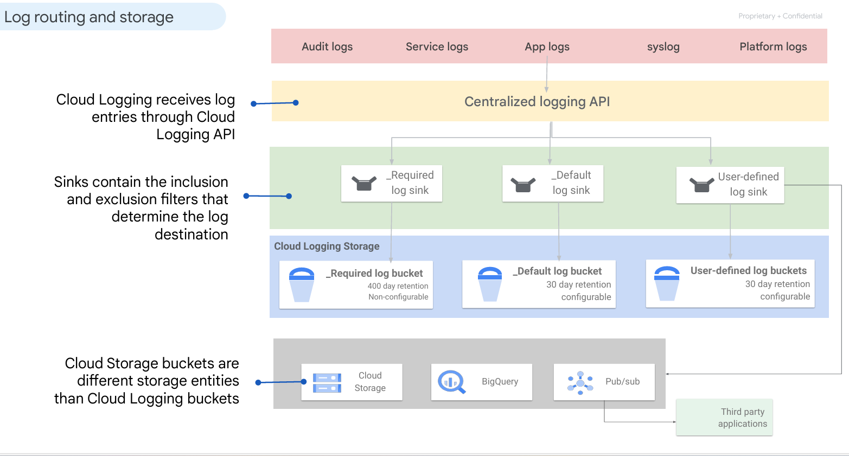
On each gcp project,
Logging automatically creates two logs buckets:
_Required
_Default,
corresponding log sinks with the same names.
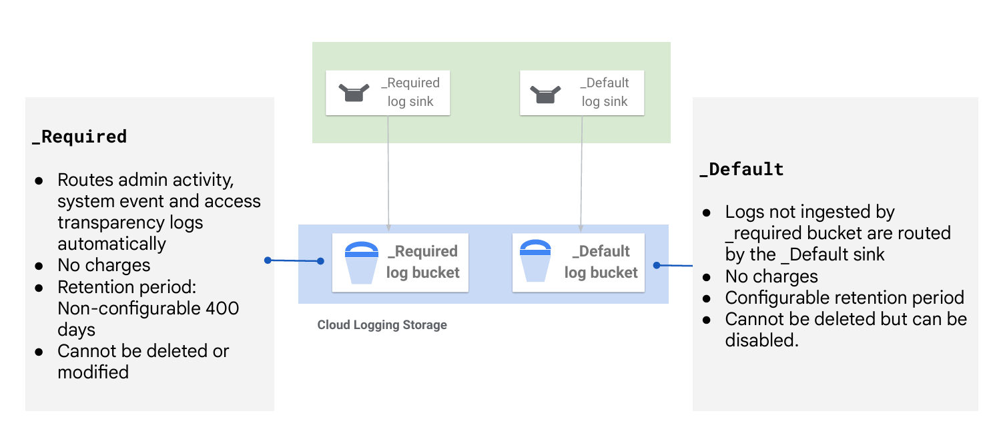
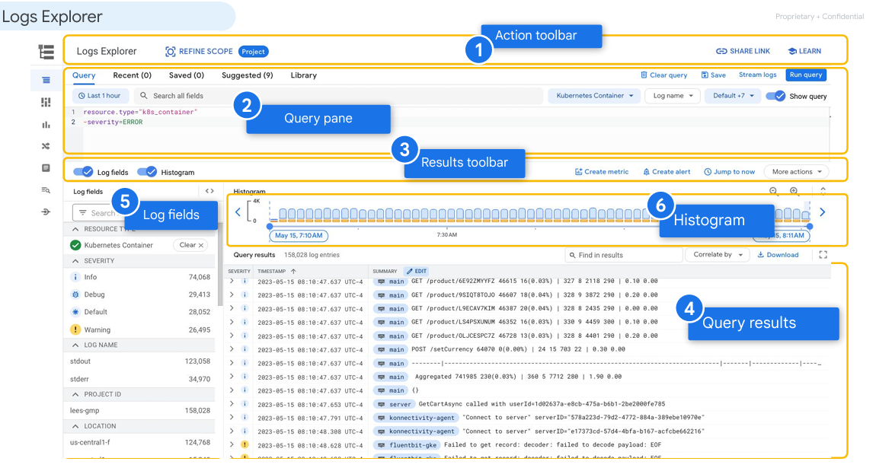
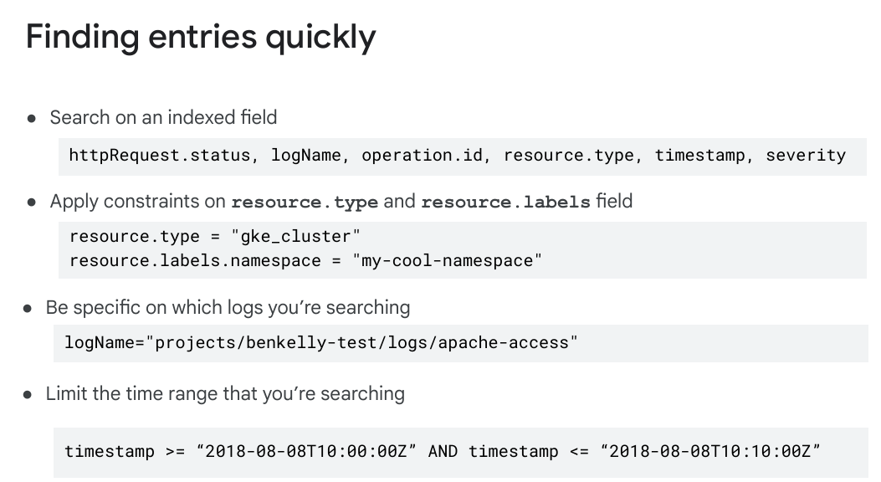
Logs-metrics
two types of log-based metrics:
● System-defined log-based metrics
Created by gcp, System-defined log-based metrics are calculated only from logs that have
been ingested by Logging. If a log has been explicitly
by Cloud Logging, it isn't included in these metrics.
excluded from ingestion
● User-defined log-based metrics
created by you to track things in your Google
Cloud project that are of particular interest to you.
Example, log-based metric to count the number of log entries that match a
given filter

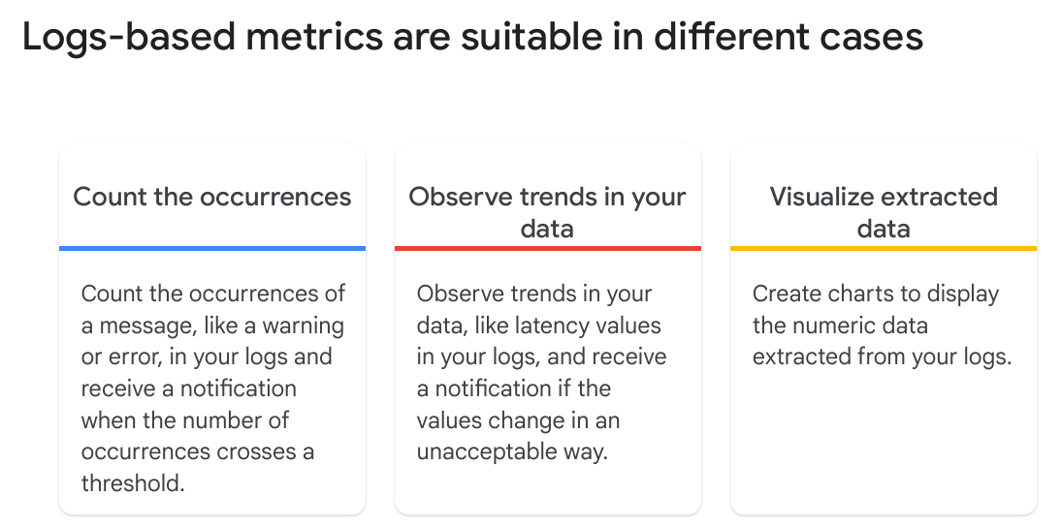
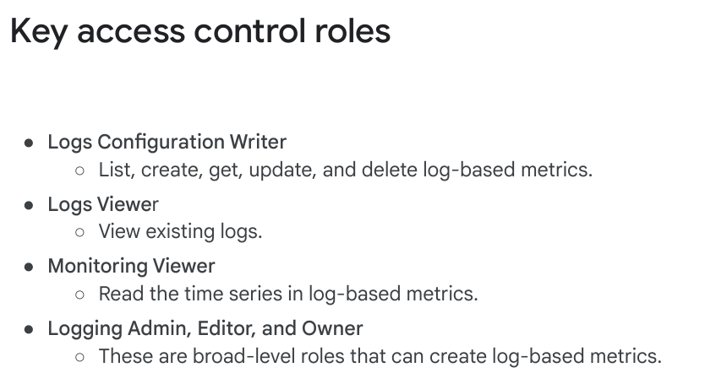

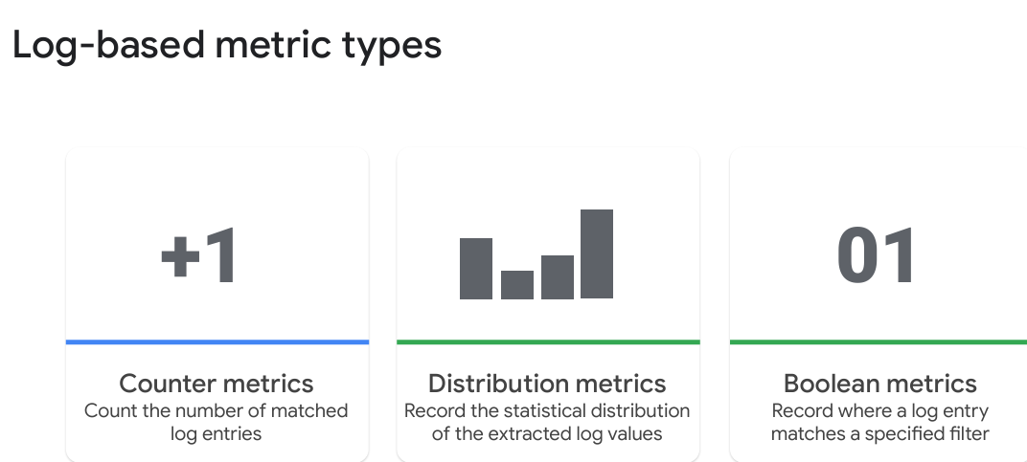

Log Analytics
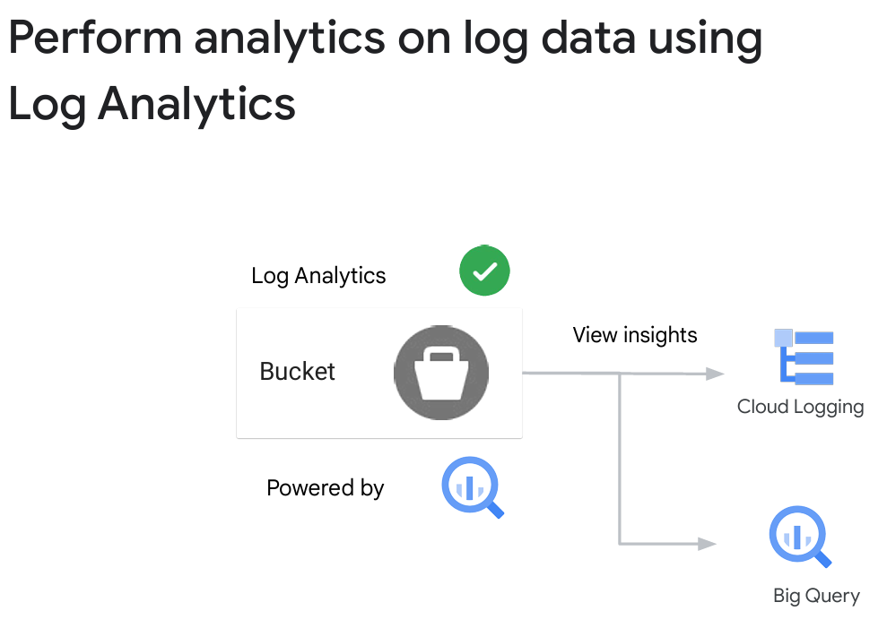
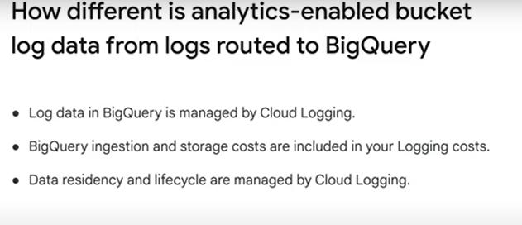

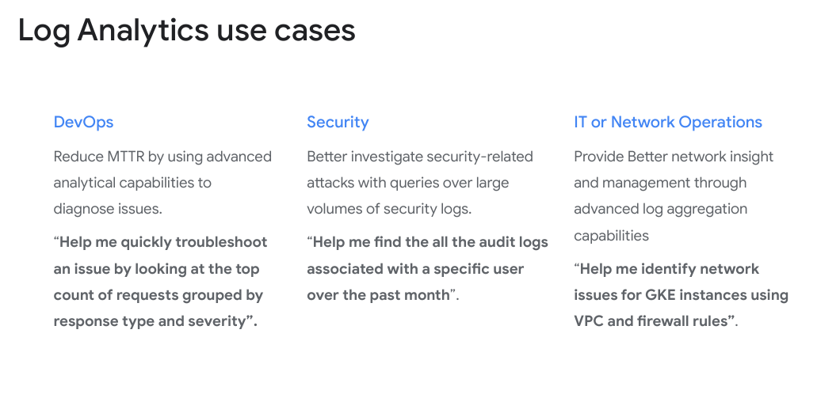

Audit Logs - Who did what, where, and when
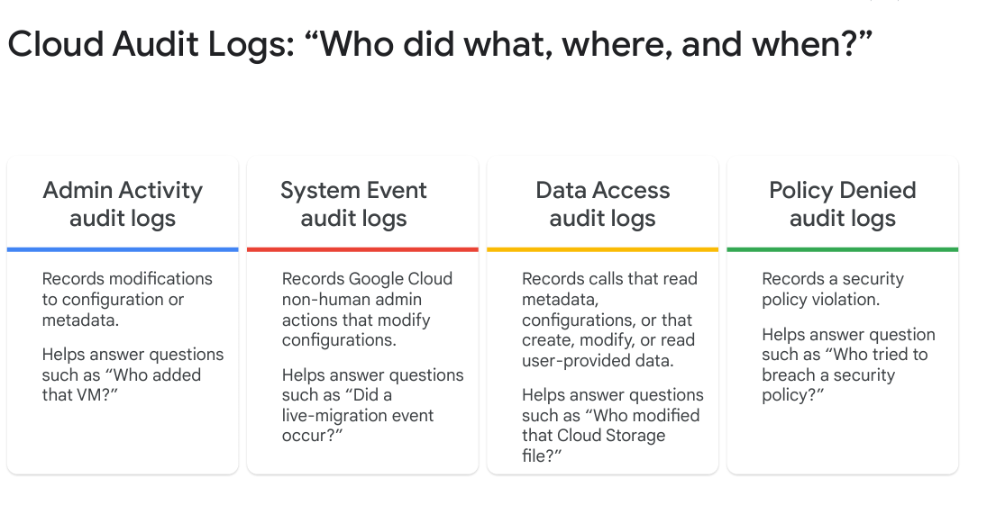
Admin:
log entries for API calls or other administrative actions
retained for 400 days, no charge
IAM role: Logging/Logs Viewer or Project/Viewer.
Example: create VM

System Event audit logs:
Google Cloud administrative actions that modify the configuration of resources.
enerated by Google systems; they are NOT driven by direct user action.
always on, retained for 400 days, no charge.
IAM roles: Logging/Logs Viewer or Project/Viewer.

Data Access audit logs:
API calls that read the configuration or metadata of resources.
user-driven API calls that create, modify, or read user-provided resource data.
don’t record the data-access operations on resources that are publicly shared
don’t record the data-access operations on resources that can be accessed without logging into Google Cloud.
disabled by default (except for BigQuery),
when enabled, default retention is 30 days.
IAM roles Logging/Private Logs Viewer or Project/Owner.
Policy Denies Audit logs:
When a security policy is violated,
Records when access to a user or service account is denied by Google Cloud service
Generated by default, Google Cloud project is charged for the logs storage.
can't disable Policy Denied audit logs.
can use exclusion filters to prevent these logs from being ingested and stored in Cloud Logging

Access Transparency logs
Very similar to Cloud Audit logs
Providing logs of accesses to your data by human Googlers (as opposed to automated systems).
Enterprises with appropriate support packages can enable the logs, and receive the log events in near-real time.

Data Access audit logs

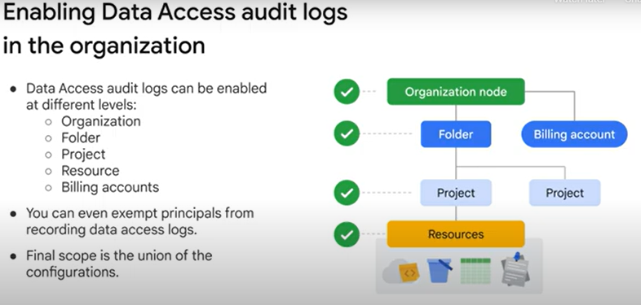
The added logging does add to the cost, currently: $0.50 per gigabyte for ingestion.

Observability

Configuring Google Cloud Services for Observability
Compute service - VM’s -> install ops agent
Why OPS Agent?
The hyper visor (Hyper-V) cannot tell the memory usage inside each vm, just the memory allocated on the Hyper-V itself
Can be installed using cli/ policy/ automated tools (ansible / puppet/ chef)

Non VM resources - Server less services – automatic monitoring by default
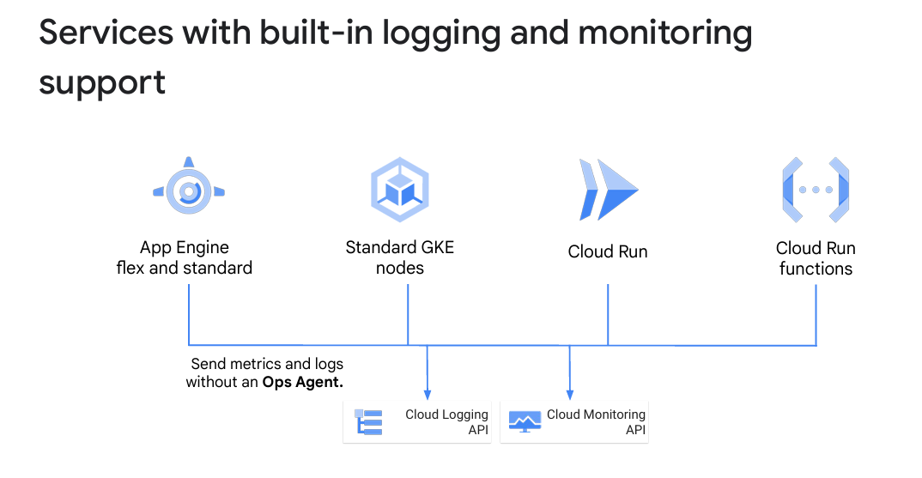

GKE monitoring using Prometheus
Based on Monarch
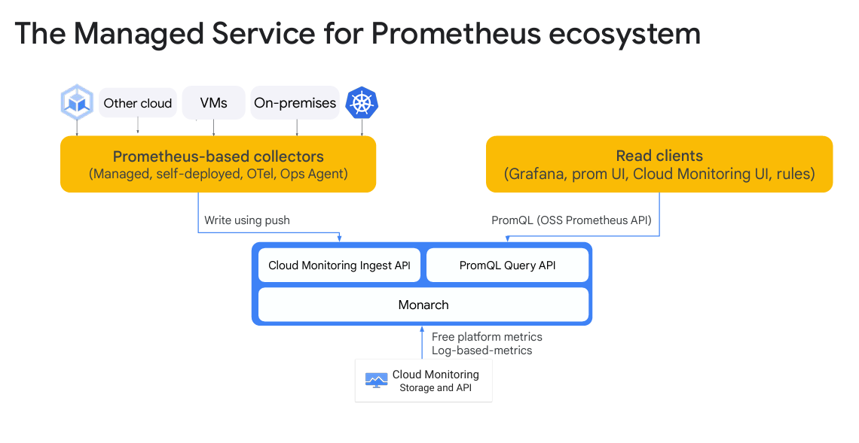
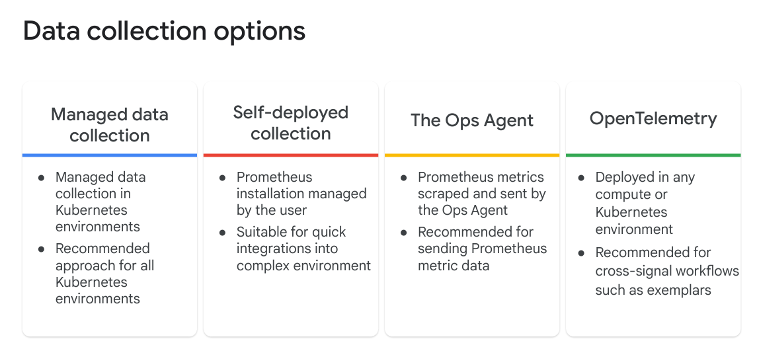
Managed Data Collection refers to using cloud-native services to automatically collect, process, and store telemetry data (logs, metrics, traces) from Kubernetes clusters (GKE or self-managed) without requiring manual setup.
In Google Cloud, Managed Data Collection is provided by Cloud Operations (formerly Stackdriver) and can be integrated with GKE out of the box.
Eventually the cheapest !! (better than get Prometheus on 2 dedicates servers (~ 400 a month)

Monitoring Network

VPC Flow Logs

Packet Mirroring
Packet Mirroring consumes additional bandwidth on the hosts.
Packet Mirroring is useful when you need to monitor and analyze your security status.
Good for security and monitoring.

Comparison of GCP Network Monitoring Logs
Feature | VPC Flow Logs | Packet Mirroring | Firewall Rules Logs | Load Balancer Logs | Cloud NAT Logs
Purpose | Monitors network flows (traffic between VMs, GKE nodes, external sources) | Captures full packets for deep inspection | Tracks allow/deny actions of firewall rules | Logs requests handled by GCP Load Balancers | Monitors traffic using Cloud NAT
Traffic Type | Metadata-only (src/dst IP, bytes, protocol) | Full packet capture (deep packet inspection) | Firewall rule evaluation results | HTTP(S), TCP, UDP, SSL traffic through load balancers | Outbound traffic through Cloud NAT
Use Cases | Performance monitoring, troubleshooting, anomaly detection | Advanced security analysis, forensics, intrusion detection | Debugging dropped connections, rule validation | Analyzing load balancer traffic, debugging performance issues | Monitoring outbound NAT usage, troubleshooting connectivity
Logs Storage | Cloud Logging, BigQuery, Pub/Sub | Sent to a packet analysis system (e.g., IDS, SIEM) | Cloud Logging | Cloud Logging | Cloud Logging
Visibility | Per VPC network interface | Per VM NIC (Network Interface Card) | Per firewall rule action | Per load balancer request | Per NAT gateway instance
Performance Impact | Low impact (sampling available) | High impact (copies all packets) affect bandwidth | Low impact (logs only allow/deny events) | Moderate impact (depends on traffic volume) | Low impact (logs NAT activity only)
Cost Considerations | Moderate cost (storage cost for logs) | High cost (full packet capture, high data volume) | Low cost (firewall logs are lightweight) | Moderate cost (depends on request volume) | Low cost (small amount of log data)

When to Use Each?
Scenario | Recommended Log Type
Monitor network traffic patterns, performance | VPC Flow Logs
Investigate security threats, malware, advanced troubleshooting | Packet Mirroring
Identify blocked or allowed traffic due to firewall rules | Firewall Rules Logs
Analyze load balancer performance, traffic distribution | Load Balancer Logs
Troubleshoot Cloud NAT outbound traffic issues | Cloud NAT Logs

Key Takeaways
- VPC Flow Logs are best for general network monitoring and troubleshooting.
- Packet Mirroring is for deep packet inspection and security forensics (high cost).
- Firewall Rules Logs help debug access issues due to firewall rules.
- Load Balancer Logs provide insight into traffic served through GCP Load Balancers.
- Cloud NAT Logs help analyze outbound internet traffic from private VMs.

APM - Application Performance Management
Tools
- Error Reporting
- Cloud Trace
- Cloud Profiler

Feature | Error Reporting | Cloud Trace | Cloud Profiler
Purpose | Detects, analyzes, and aggregates application errors | Tracks request latency across microservices | Measures CPU and memory usage to optimize performance
Best For | Debugging application errors (e.g., exceptions, crashes) | Analyzing request latency in microservices | Optimizing resource usage in production
Data Captured | Stack traces of errors from logs | End-to-end request latency data | CPU and memory profiling per function
Use Case | Find frequent application errors, debug stack traces | Identify slow API calls, bottlenecks, and dependencies | Optimize hot functions consuming CPU or memory
Integration | Works with Cloud Logging, GKE, App Engine, Cloud Run, Cloud Functions | Works with GKE, App Engine, Cloud Run, Compute Engine | Works with GKE, App Engine, Compute Engine
Performance Impact | Minimal (only processes logs with errors) | Minimal (sampling-based tracing) | Low impact (sampling-based profiling)
Retention Period | Depends on Cloud Logging storage | 30 days by default | 30 days by default
Visualization | Cloud Console UI | Latency charts, heatmaps | Call graphs, flame charts
Cost | Free for basic use (pricing based on Cloud Logging ingestion) | Free up to 2.5M spans/month, then $0.20 per million spans | Free up to 5MiB/s, then usage-based pricing

When to Use Each?
Scenario | Recommended Tool
Debugging application crashes, stack traces, or common errors | ✅ Error Reporting
Analyzing API response time, microservices performance bottlenecks | ✅ Cloud Trace
Optimizing resource consumption, CPU/memory profiling | ✅ Cloud Profiler

Key Takeaways
- Use Error Reporting for detecting and debugging application errors.
- Use Cloud Trace to analyze request latency and find slow services.
- Use Cloud Profiler to reduce CPU/memory overhead and improve performance.

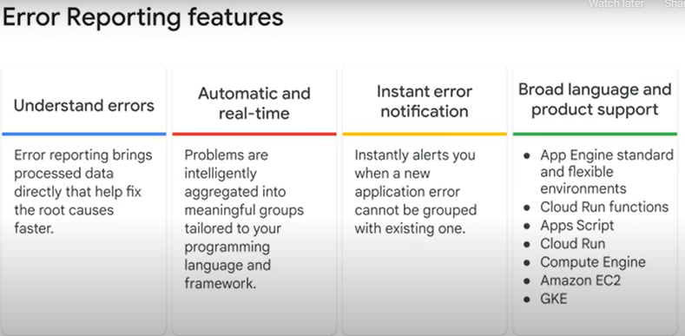

For App Engine flexible environment and standard environment, Cloud Run, Cloud Run functions, and Apps Script, Error Reporting is automatically enabled.
For Google Kubernetes Engine, add cloud-platform access scope during cluster creation.
For Compute Engine, ensure the service account used has the Error Reporting Writer role.
Outside Google Cloud, provide the Google Cloud project ID and service account credentials to the Error Reporting library for Node.js.

Questions
- You deployed a new version of a service and all of a sudden significantly more instances are being created in your Kubernetes cluster. Your service scales when average CPU utilization is greater than 70%. What tool can help you investigate the problem?
Trace
Logging - correct
Profiler
Error Reporting

- You have an SLO that states that 90% of your http requests need to respond in less than 100 ms. You want a report that compares latency for your last two versions. What tool would you use to most easily create this report? (why not trace?)
Profiler
Error Reporting
Logging - correct
Trace

- Which profile signifies the amount of memory allocated in the heap of the program?
Wall time
Allocated heap (allocated + freed – this is why it is not correct!)
CPU time
Heap – correct

Optimizing the Costs for Google Cloud Observability
Logging incurs cost when using:
- Cloud Load Balancing logs
- Custom logs
- Error reporting costs (if your errors are ingested by Cloud Logging)
- The write operation in the Cloud Logging API
- Logs stored beyond 30 days will incur a retention charge for
non-required buckets.

Questions
- What is Cloud Logging pricing based on?
Read operation in the Cloud Logging API
Profiler Usage
Number of uptime checks
Volume of chargeable logs - Correct

- What is one of the best practices to reduce monitoring costs?
Reduce Ops Agents usage - Correct
Increasing custom metric usage.
Increase label usage
Reduce the number of time series

IAP - Identity-Aware Proxy (IAP)?

IAP is a Google Cloud security feature that allows secure access to applications and resources (like Compute Engine VMs) without requiring a VPN or exposing external IPs. It enforces identity-based access control by verifying users' identities and permissions before allowing a connection.
How IAP Works
- Acts as a gateway: It sits between the user and the resource (like a VM) and ensures only authorized users can access it.
- Uses IAM policies: Access is controlled via Google IAM roles and permissions.
- Avoids public IP exposure: You don’t need to assign an external IP to a VM; IAP tunnels the connection securely over Google’s private network.

Use Cases of IAP
✅ Secure VM Access (Linux SSH, Windows RDP)
✅ Protect Web Applications (without requiring VPN)
✅ Enforce Zero Trust Security (Google’s BeyondCorp model)
✅ Granular Access Control via IAM policies

Bastion
Lab url: https://www.cloudskillsboost.google/course_templates/654/labs/464661
From this:
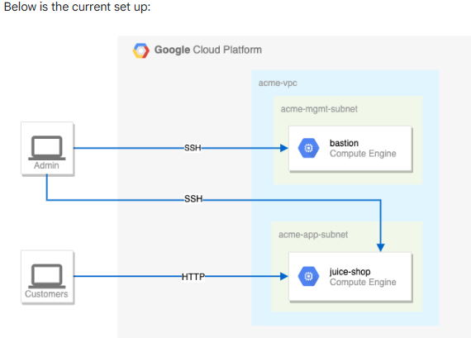

To this:
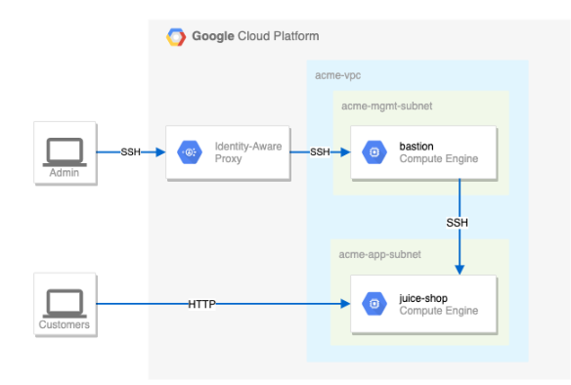

Steps:
- Check the firewall rules. Remove the overly permissive rules.
  - Remove firewall rule on ssh from all addresses (0.0.0.0.0/0) on port22 to bastion and juice-shop servers (network tag ? name ? )
- Create a firewall rule that allows SSH (tcp/22) from the IAP service.
  - Enable IAP TCP forwarding in your Google Cloud project
  - Open the Navigation Menu and select APIs and Services > Library.
  - Search for IAP and select Cloud Identity-Aware Proxy API.
  - Click Enable.
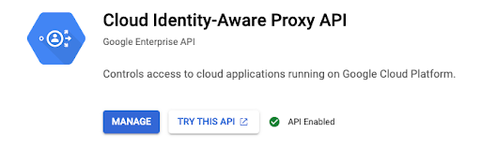
  - gcloud compute firewall-rules create allow-ssh-from-iap \
--network=default \
--direction=INGRESS \
--action=ALLOW \
--rules=tcp:22 \
--source-ranges=35.235.240.0/20 \
--target-tags=ssh-iap
3.

